


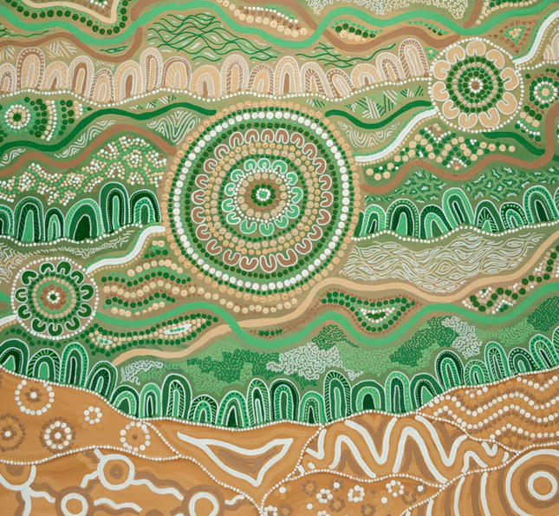

Australian Capability Catalogue

First Nations Businesses for the United Arab Emirates



Acknowledgement of Country
The Australian Government acknowledges the Traditional Owners and Custodians of Country throughout Australia and acknowledges their continuing connection to land, waters and community.
We pay our respects to the people, the cultures and the Elders past and present and acknowledge all First Nations people that shared their knowledge and expertise in the development of this booklet.

Artwork
Moortung. @Kehaan Lange-McGuire, 2025. Used under licence.
Kehaan Lange-McGuire is an Aboriginal artist and musician from Noongar Wardandi Country in the South West of Western Australia. He is the owner of Djiti Djiti Designs, where he creates, sells, and commissions Aboriginal artwork, as well as playing and performing the didgeridoo.
Kehaan developed a passion for painting and artistic expression from a young age. He was taught to play the didgeridoo by his Pop and other family members at the age of ten and has been playing and performing ever since.
His painting skills come from within, shaped by his deep connection to culture and Country. Both his artwork and music reflect his heritage and the stories of his people.
For the past three years, Kehaan has been living in the United Arab Emirates, working as a freelance Aboriginal artist and musician. During this time, he has travelled throughout the Middle East, including Oman, Saudi Arabia, Kuwait, Qatar, and Jordan, collaborating with Australian embassies to promote and celebrate Australia’s Indigenous culture on an international stage.
Deeply passionate about his heritage, Kehaan uses both his art and music to stay connected to his culture, even while living abroad. Through his creative practice, he seeks to educate, inspire, and foster greater understanding of Aboriginal culture around the world, bridging communities through storytelling, sound, and design.


Who are Australia’s First Nations People?

Australia's First Nations people, or Aboriginal and Torres Strait Islander people, are one of the world's oldest continuous living cultures, with an enduring connection to Australia’s land, water, and skies.
Aboriginal and Torres Strait Islander Australia is made up of many different and distinct groups, each with their own culture, customs, language and laws.
For more information on Australia’s First Nations people and their culture, please visit the Australian Institute of Aboriginal and Torres Strait Islander Studies (AIATSIS) website.

Message from HE Ridwaan Jadwat, Australia’s Ambassador to the United Arab Emirates & Bryony Hilless, Consul-General Dubai and the Northern Emirates
Innovation rooted in Culture: Sharing First Nations excellence with the UAE
Aboriginal and Torres Strait Islander peoples are our first traders, diplomats, and innovators. Their continuing legacy of exchange spans centuries, from trading goods with Makassan seafarers from Indonesia, to today exporting native botanicals, art, design and technology across the globe.
The Australian Government is proud to partner with First Nations businesses to share their stories with the world. We are embedding First Nations business interests into our trade agreements, global engagements and export strategies to ensure their voices are represented in international markets.
Australia’s First Nations businesses are uniquely positioned to meet the UAE’s growing demand for premium, sustainable, and culturally rich goods and services. From native botanicals used in wellness products to ethically sourced foods, innovative designs, and clean energy solutions rooted in traditional knowledge, these businesses provide authentic offerings that align with the UAE’s vision for innovation, sustainability, and cultural exchange.
First Nations businesses combine traditional knowledge with modern innovation, creating training and employment opportunities for Indigenous Australians and reinvesting trade benefits into their communities.
The Australia-UAE Comprehensive Economic Partnership Agreement (CEPA) is Australia’s first trade deal with a dedicated chapter on First Nations business. It supports joint initiatives to help First Nations businesses expand into the UAE and the broader region, while embedding Indigenous perspectives in sustainability, agriculture, and intellectual property.
The Australian Government has set out an action plan to support First Nations businesses realise the opportunities of CEPA by strengthening cultural and economic ties with UAE buyers and investors. This includes participation in trade delegations and promotional activities across industries such as energy, fashion and beauty, health and wellness, food and beverages, and technology.
This business guide provides a snapshot the diversity of First Nations offerings and highlights opportunities for partnership in the UAE.


HE Ridwaan Jadwat Australia’s Ambassador to the United Arab Emirates
Bryony Hilless

Consul-General Dubai and the Northern Emirates, General Manager for the Middle East and Africa for Austrade

1

2

Message from Australia’s Ambassador for First Nations People, Mr Justin Mohamed

Australia’s First Nations businesses, often weaving traditional knowledge and practice with innovation, are forging new trading pathways across the globe. From green economy to sustainable agricultural practices, these businesses are contributing their expertise to help address some of our biggest challenges. They are also capitalising on emerging market opportunities in First Nations creative industries like art and fashion, agrifood, and services such as environmental conservation, tourism and health.
This success is grounded in over 60,000 years of continuing connection to Culture and Country, embodying values of trust, respect and reciprocity.
The businesses in this booklet are some of Australia’s cutting-edge First Nations businesses who are ready to launch into this new and exciting market, and to contribute their expertise and excellence to the UAE.


Justin Mohamed
Ambassador for First Nations People




Australian Trade and Investment Commission (Austrade)

Australia’s global trade and investment agency
The Australian Trade and Investment Commission (Austrade) promotes Australia on the global stage, grows and diversifies trade and helps build Australia’s economic security and prosperity. With over 100 offices at home and worldwide, Austrade helps Australian businesses achieve diverse export outcomes and win investment needed to grow our economy
Austrade facilitates exports of Australian goods and services. We help overseas buyers connect with Australian companies that can help them achieve their business ambitions. We can source suppliers and partners from our extensive network and provide introductions. This saves buyers and customers time and money and ensures they work with the right business for their needs.
Austrade is also responsible for Australia’s tourism policy, programs and the national strategy for the visitor economy’s long term sustainable growth.
Austrade also promotes Australia’s education institutions and capabilities to the world.
For more information, please contact Dubai@austrade.gov.au

3

The Australia-United Arab Emirates Comprehensive Economic Partnership Agreement

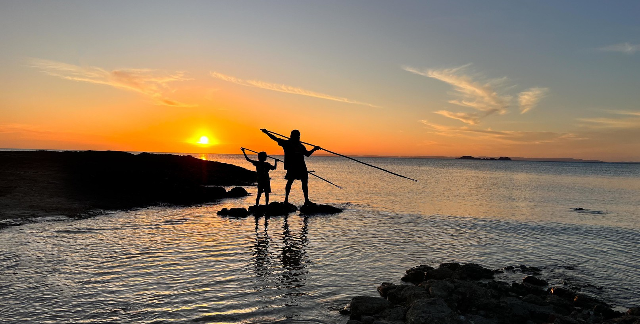
The Australia-United Arab Emirates Comprehensive Economic Partnership (CEPA) is historic, containing the first standalone Indigenous trade and economic cooperation chapter in an Australian free trade agreement.

Chapter 17 of CEPA delivers a framework for cooperation activities and information exchanges to occur through relevant joint trade and investment promotion activities for Indigenous businesses. It identifies priority areas, including the environment and the transition to net zero, sustainable agriculture, investment and intellectual property protection.

CEPA also provides a framework to share experiences and views with regards to counterfeit goods purporting to derive from traditional knowledge or traditional cultural expressions and the resale royalty rights of artists, including First Nations artists.

4

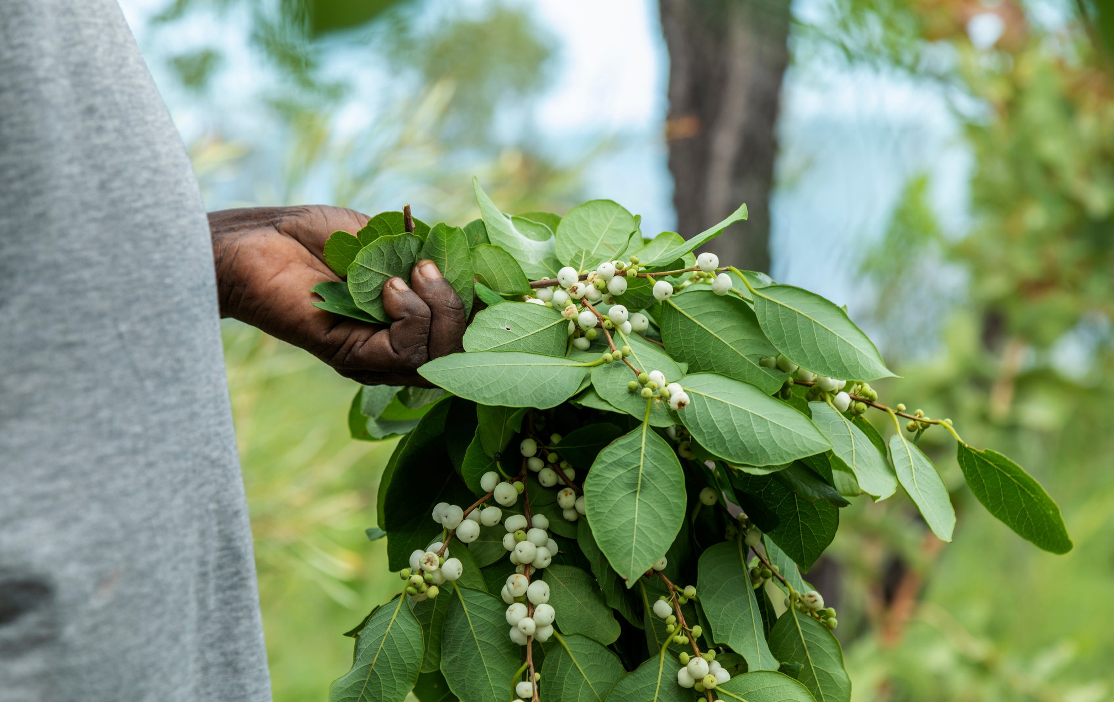

Protecting the Indigenous Knowledge of Australia’s First Nations people
Indigenous Cultural and Intellectual Property (ICIP) is a term that includes all aspects of Aboriginal and Torres Strait Islander peoples’ Traditional Knowledge and Traditional Cultural Expressions.

ICIP includes both tangible and intangible property, such as cultural objects, arts and crafts, stories and knowledge. ICIP is often held in a collective context, passed down through generations and managed in accordance with cultural protocols.
Some ICIP is regarded as secret and sacred and is not meant for commercial use. ICIP can reflect and identify a community’s history, cultural and social identity, and values, and has important cultural as well as economic value.

Protections for ICIP

Australia supports the United Nations Declaration on the Rights of Indigenous Peoples, which upholds the right of Indigenous peoples to maintain, protect and develop their cultures.

Aspects of Aboriginal and Torres Islander peoples’ Traditional Knowledge and Traditional Cultural Expressions can be protected by copyright or through the registered IP rights system. Other ways to protect ICIP include ICIP protocols, contracts, non-disclosure agreements and trade secrets.

Learn more about ICIP here:
Respectful use of Indigenous Knowledge | IP Australia

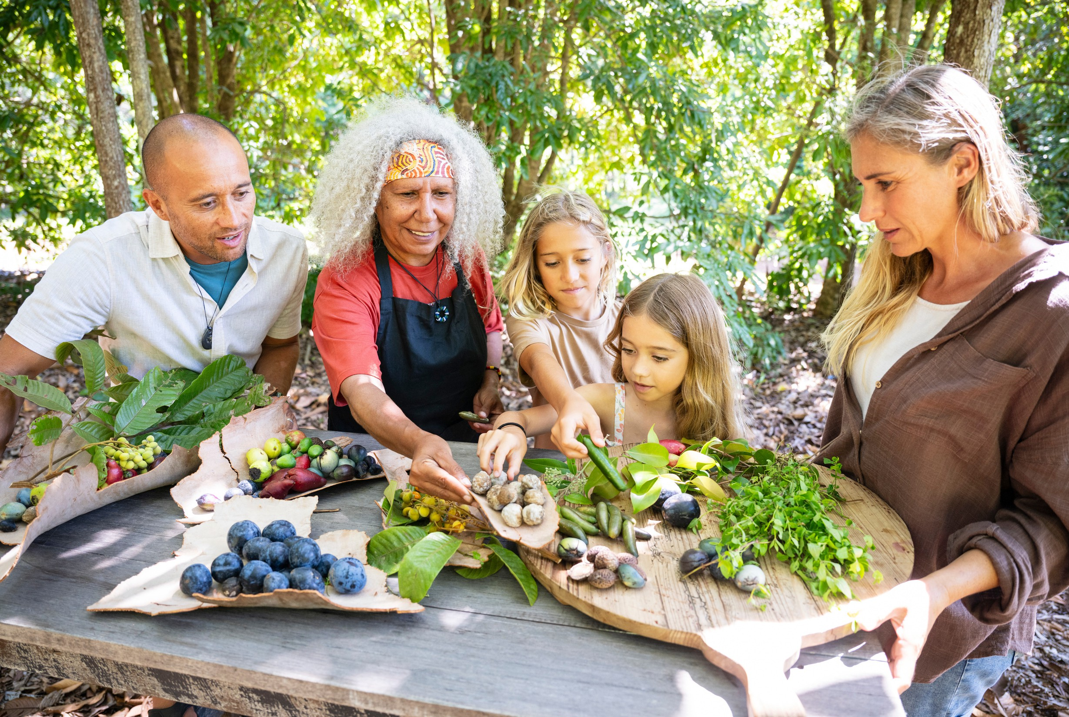

First Nations tourism in Australia

First Nations tourism in Australia showcases the enduring connections of the world’s oldest continuing culture. It is central to Australia’s national story and identity.

As travelers seek more meaningful and authentic experiences, there is a growing demand for First Nations owned and operated tourism businesses that celebrate and share First Nations culture across Australia.

These businesses encompass a wide range of activities, from bush tucker tours and dance performances to rock art site visits and wildlife experiences. Such experiences not only educate and inspire visitors but also empower First Nations entrepreneurs and communities by creating new employment and start-up business opportunities, while simultaneously showcasing and sharing culture.[1]

If you are planning a trip to Australia and want to find an authentic First Nations tourism experience, visit Discover Aboriginal Experiences.

[1] Queensland Tourism Industry Council and the University of Queensland, Queensland First Nations Tourism Plan, 2026-2023 Consultation, Discussion Paper, May 2025


Investing in Australia:
Engaging Australia’s First Nations people
Australia’s First Nations people welcome opportunities to engage with overseas investors on commercial opportunities relevant to their land holdings, traditional knowledge and cultural heritage. Effective engagement can deliver significant benefits to both investors and First Nations communities, supporting sustainable, equitable, and culturally appropriate outcomes.

The insights and traditions of Australia’s First Nations people offer significant value for major projects in Australia, in areas such as environmental management, sensitive management of cultural values, along with land management and remediation.

Why engage with First Nations Australians?
Investor benefits
Stronger Social Licence: Early engagement builds trust, ensures alignment with Environmental, Social, and Governance (ESG) goals, and helps ensure smooth project approvals. This is particularly important where projects are on Australian land or waters where Traditional Owners have a legal interest or right.

Access to capital: First Nations participation - particularly in clean energy projects - can provide greater access to, and potentially lower the cost of, project capital. The recent EY and First Nations Clean Energy Network report noted that socially responsible projects often attract broader pools of capital. First Nations participation can decrease a project’s risk profile due to the faster access to land and other components of the development cycle, resulting in greater likelihood of obtaining capital.

Sustainable Innovation through Traditional Knowledge
Wisdom of Country: Projects can benefit from First Nations peoples' deep connection to Country, offering millennia-long knowledge of land and water management.

Climate Resilience: Engaging Traditional Owners can enhance strategies for environmental sustainability, informed by their intimate understanding of climate adaptation.


How do you engage?

Equitable Partnership Models
Co-Design and Ownership: First Nations organisations are increasingly involved in co-design, co-ownership, and benefit-sharing of renewable energy projects, such as the East Kimberley Clean Energy Project and the Yindjibarndi Energy Corporation's collaboration with ACEN.

Local workforce benefits: Partnering with local First Nations groups can support access to the local workforce and engaging local First Nations-owned businesses in supply chains. This aids community support for the project, by supporting job creation, skills development, and intergenerational economic independence in First Nations communities.
Community engagement is key to success in investing in markets around the world.
In Australia, this includes engagement with the right First Nations stakeholders particularly when Traditional Owners have a cultural or legal interest or right in the relevant land. Collaboration typically begins at the local level, guided by State or Territory government agencies.

You can find out more information here [Investing in Australia: Engaging our First Nations People | Australian Government Department of Foreign Affairs and Trade] or through Austrade Dubai.


Directory
1
Commission
3

Opening messages
Australian Trade and Investment (Austrade)
Scene setting 4
Food and Beverage 11
Australian Native Bush Co 12
Blak Brews 13
Dutjahn Sandalwood Oils Pty Ltd 14
Fletcher International Exports 15
Ilan Style 16
Jala Jala and Only Mine 17
Kakadu Organics 18
Land And Sea Aboriginal Corporation Tasmania 19
Red Centre Enterprises Pty Ltd 20
Yaala Sparkling 21
Beauty and Wellness 22
Baagi Milaygiin 23
Bush Clinicians Group Pty Ltd 24
Helen Rose Pty Ltd 25
Native Secrets Australia 26
Nood Australia 27
Yaye 28
Yulay Protect 29
Creative Industries 30
Aboriginal Steel Art 31
Birrunga Gallery Cultural Hub 32
Blackfisch 33
Garuwa 34
Konstantina Aboriginal Art 35
Magabala Books 36
Ngali 37


Directory
Energy, Infrastructure and Sustainability 38
Aldridge Railway Signals 39
Bunbara 40
DICE Australia 41
Electric Power Conversions Australia 42
Forces Group Australia 43
Red Rock Services 44
WRL Shipping Pty Ltd 45
Professional Services 46
Elephant in the Room Consulting 47
Gilimbaa 48
Indigenous Emerging Business Forum Aboriginal Corporation 49
Sustainative 50
Technology 51
Australian Indigenous Ai Solutions 52
Centre for Appropriate Technology Satellite Enterprises 53
The Imagination Collaborative 54
WV Technologies 55
Contact us 56




Food and Beverage

11


Australian Native Bush Co

Australian Native Bush Co. is an Indigenous-led food and beverage enterprise dedicated to showcasing the depth and diversity of Australia’s native botanicals. Founded on Ngunnawal Country in Canberra, we combine traditional knowledge with contemporary innovation to create distinctive low- and no-alcohol beverages that resonate with global markets.
Our flagship products include agrowing portfolio of native bush iced teas and functional energy drinks infused with botanicals such as banksia, emu bush, and quandong. Each product tells a cultural story while delivering high quality, sustainable alternatives to mainstream beverages.
Sustainability is at the heart of our business model. We are building regenerative agrifood supply chains with Indigenous growers and foragers, ensuring benefits return to Country and community. Our operations prioritise environmental responsibility, ethical sourcing, and scalable production that meets international standards.
As part of the agrifood, creative industries, and green economy sectors, we are positioned to deliver premium Australian products to the United Arab Emirates and wider GCC region. By blending cultural heritage, health-focused innovation, and sustainable production, Australian Native Bush Co. offers trusted partnerships and unique consumer experiences for forward-looking markets.


Jeff Wilson Shipley
Director


 jeff.wilson-shipley@cypherbrewing.com.au  +61 423622541
Www.cypherbrewing.com.au

Scan here for more information

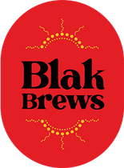
Blak Brews

Blak Brews is an Australian Indigenous-owned and operated company specialising in premium native Australian teas and ethically sourced, sustainable organic coffee. Founded by husband-and-wife team Troy and Cerisa Benjamin, Blak Brews combines centuries-old Indigenous knowledge of native botanicals with modern craftsmanship to deliver products that are both distinctive and globally relevant.
Our award-winning teas are crafted using the finest native Australian ingredients, carefully sourced through sustainable and ethical supply chains. Each blend showcases Australia’s unique biodiversity and cultural heritage, offering international partners a premium product that is rich in flavour, function, and story.
Blak Brews is rapidly establishing itself as one of Australia’s most exciting beverage brands. Since winning Gordon Ramsay’s Food Stars in 2024, we have gained international recognition and mentorship from Gordon Ramsay himself, accelerating our growth into global markets. Our streamlined wholesale platform supports quick and efficient international trade, ensuring reliable service to retail and hospitality partners worldwide.
At Blak Brews, our mission is simple: to bring people, health, culture, and exceptionally good tea together – and to proudly share a taste of Australia with the world.


Troy Benjamin
CEO

info@blakbrews.com +61 404934101
www.blakbrews.com

Scan here for more information

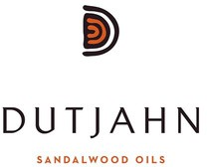
Dutjahn Sandalwood Oils Pty Ltd

Dutjahn Sandalwood Oils Pty Ltd is a Western Australian-based distillation company producing premium sandalwood oil from Santalum spicatum and Santalum album. Founded in 2017, the company is 50% Indigenous-owned through a partnership between Dutjahn Custodians, Kutkabbuba Aboriginal Corporation, and WA Sandalwood Plantations. Dutjahn fuses wild-harvested sandalwood from native title lands and sustainably managed plantation wood, creating ethically sourced oils for global luxury fragrance and cosmetics markets.
A two-time Australian Exporter Award winner and recipient of the UN Equator Prize, Dutjahn exports over 60% of its product and champions cultural respect, sustainability, and economic inclusion. The company’s mission is to empower Aboriginal communities through equitable participation in the sandalwood supply chain, while promoting regenerative agroforestry and environmental stewardship.
Operating from Kalgoorlie and Osborne Park, Dutjahn integrates traditional knowledge with modern practices to protect the integrity of Australian grown sandalwood. Its values—ethics, innovation, and cultural identity—are embedded in every aspect of its operations, making Dutjahn a global leader in responsible sourcing and Indigenous enterprise.

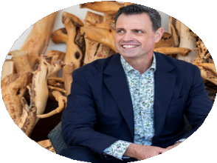
Guy Vincent
CEO

 gvincent@dutjahn.com +61 402328055
www.dutjahn.com

Scan here for more information

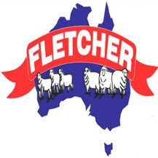
Fletcher International Exports

Fletcher International Exports (FIE) is one of Australia’s most integrated processors and exporters of lamb and sheep meat products. A private, family-owned company, with 50% of the company being under first nation ownership. Fletcher International operates two highly efficient, world-class processing facilities: one located in Dubbo, New South Wales; and the other near Albany in Western Australia. These two plants have a combined processing capacity of more than 90,000 sheep and lambs per week, which equates to over 4.5 million head per year.
The Fletcher meat processing philosophy has always been to utilise as much of each animal as possible. Consequently, in addition to lamb and sheep meat products, wool and sheep skins, the company markets a diverse range of high-quality co-products. The expansion of the company’s farming interests has strengthened the livestock supply chain, while providing a source of quality cross-bred lambs consistently throughout the year.
FIE currently exports to over 90 countries globally with a very strong presence in GCC region particularly the UAE. The relationships in the UAE began over 40 years ago, FIE now hold direct relationships in this region.


Thomas Jackson
Sales Executive

thomasj@fletchint.com.au +61 476990975
www.fletchint.com.au

Scan here for more information


Ilan Style

Ilan Style is a Torres Strait Islander, women-owned business offering a premium range of teas and curated gift solutions. Our teas are crafted in Australia with high-quality ingredients, delivering exceptional taste and a modern, culturally inspired experience.
Designed with both quality and aesthetic appeal in mind, our teas and packaging reflect contemporary style and cultural storytelling, making them suitable for retail, hospitality, and corporate settings.
In addition to our core tea range, Ilan Style creates bespoke gift sets and cultural products ideal for corporate gifting, events, and retail environments. We partner with trusted suppliers to ensure consistency and sustainability.
With a commitment to excellence, authenticity, and innovation, Ilan Style delivers teas and gifts that connect people through shared experiences of taste, wellness, and culture. We are dedicated to building strong partnerships and supplying products that resonate across diverse global markets.


Professor Kerry Arabena
Managing Director

info@ilanstyle.com.au +61 1800 939 276
www.Ilanstyle.com.au

Scan here for more information


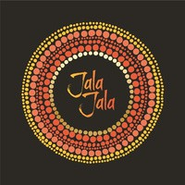
Jala Jala
and Only Mine

Jala Jala is a 100% female First Nations-owned business, with owner Sharon Brindley being the largest Female First Nations food manufacturer in Australia. Grounded in a strong connection to Country, culture, and family Jala Jala produces premium products using native Australian ingredients, proudly sharing and celebrating Indigenous heritage through food.
Founded with a clear vision to create a brand that respects tradition while embracing innovation, Jala Jala brings native flavours to modern Australian consumers through a growing product range that is culturally authentic and commercially successful.
Sharon Brindley also owns Only Mine, a premium chocolate company known for its handcrafted, artisan products. While both brands are independently operated, they reflect Sharon’s commitment to quality, innovation, and Australian-made excellence.
Jala Jala continues to expand its national presence as a leading voice in Indigenous-owned food manufacturing. With deep cultural roots and a strong entrepreneurial foundation, the company is setting new standards in the industry — blending respect for Country with bold, contemporary business practice.

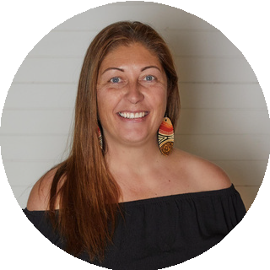
Sharon Brindley
Founder Director

sharon@jalajalatreats.com.au +61 415458420
www.jalajalatreats.com.au www.onlymine.com.au
Jala Jala Only Mine

Scan here for more information

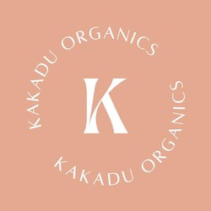
Kakadu Organics

Kakadu Organics is an Indigenous-owned, female-led enterprise. Founded by Kylie‑Lee Bradford, a Murrumburr woman who grew up in a small Aboriginal community in Kakadu National Park, the business is built on ancestral knowledge, cultural heritage, and meaningful social impact.
Kakadu Organics has a range of products including teas, skincare & wellness, homewares and treats, all infused with the wisdom of the land.

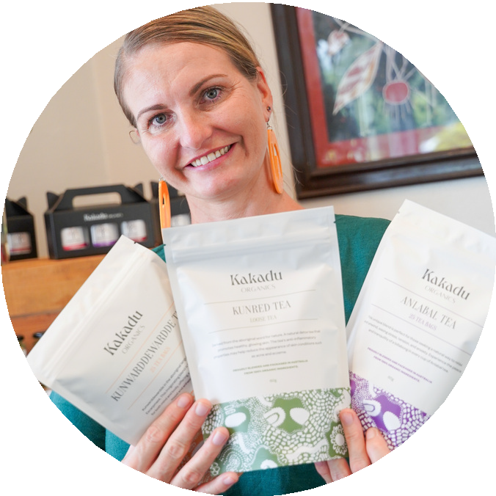
Kylie Bradford
General Manager

sales@kakaduorganics.com.au +61 479013212
www.kakaduorganics.com.au

Scan here for more information

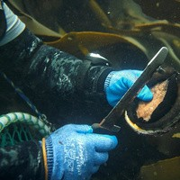
Land And Sea Aboriginal Corporation Tasmania

Tasmanian Aboriginal people have a special relationship with Sea Country, which has been sustaining our livelihoods, and culture for 40,000 years. This relationship has developed a deep knowledge and understanding how to care for and manager ocean resources for future generations.
Over the past eight years the Land and Sea Aboriginal Corporation Tasmania (LSACT) a social enterprise comprised of multiple Tasmanian Aboriginal organisations have led work to create a commercial market for cultural fisheries. By-mid 2024 LSACT had launched our business brand and operating company Tasmanian Aboriginal Seafoods and developed marketing and fishing infrastructure to support our cultural and ethical brand of social enterprise.
With innovation in packaging and product diversity we are able to export our ancient Sea Country foods to a global market.


Tim Russell-Jarvie
General Manager

tim@tasmanianaboriginalseafoods.com.au +61 475459151
www.tasmanianaborigionalseafoods.com.au

Scan here for more information


Red Centre Enterprises Pty Ltd

Red Centre Enterprises stands as a leading Australia’ First People owned parent company, dedicated to ethically reconnecting communities with Australia’s First Nations botanical knowledge. Its core mission involves researching, cultivating, and commercialising culturally significant native plants and their bioactive compounds, integrating ancient wisdom with cutting-edge science to foster sustainable, First Nation-led economic growth. This commitment extends to preserving ecological balance and cultural integrity, generating high-value natural products for health, wellness, and land restoration, from educational workshops to proprietary extracts for global cosmeceutical and nutraceutical markets.
The company’s expansive portfolio spans high-value sectors like cosmetics and pharmaceuticals, primary industries such as native agriculture, horticulture, and aquaculture, alongside dry and fresh retail products. Complementing these are essential services in agribusiness, research and development, cultural consultation, native nursery operations, cultural tourism, technology, disability provision, and land management, including contract growing, value-adding, retail, and wholesale activities.
Red Centre Enterprises meticulously upholds its brand as an entity that not only responsibly utilises invaluable Australia’s First People’s knowledge and resources through genuine partnership but also strategically incorporates First Nations Native Title reclaimed land, ensuring profound economic benefit and cultural preservation for Australia’s First Nation Peoples communities, alongside vital not-for-profit initiatives in education, training, and sport.


Traditional Elder Yuandamarra Keily
Founding Member


y uandamarra@red-centre.com.au  +61 402938781
www.red-centre.com.au

Scan here for more information


Yaala Sparkling

Yaala Sparkling is an Indigenous owned business devoted to making vibrant beverages that honour the true flavours our Ancestors have enjoyed for generations. We believe in sustainable growth, from the plants we use, to our business practice.
We work with Indigenous wild harvesters and local suppliers to create healthy beverages with benefits. They're sugar free, low calorie and have no artificial colours or preservatives, making it a healthy choice for any occasion.


Tara Croker
Founder

admin@y aalasparkling.com  +61 413117071
y aalasparkling.com

Scan here for more information

Beauty and Wellness

22


Baagi Milaygiin

Yaama my name is Deb Munson a proud Gomeroi / Dharug women and proud owner of Baagi Milaygiin (Grandmothers Spirit).
We grow harvest and create Aboriginal Bush Beauty and Wellness products is a modern way with Traditional knowledge and wisdom Our wellness products are instant as the Bush aroma is present on opening, making this great travel friendly for nausea calming soothing cramping very handy to have in your travel bag for all seasons and countries

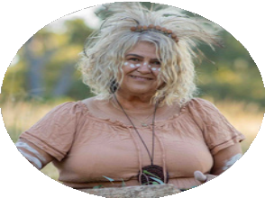
Deborah Munson
Sole Trader

deborah.munson@me.com +61 417224267
www.baagimilaygiin.com.au

Scan here for more information


Bush Clinicians Group Pty Ltd

Bush Clinicians Group (BCG) is an Indigenous-led enterprise uniting cultural knowledge, science, and innovation to create premium brands and social impact initiatives with global reach. Founded on Country in Queensland, BCG’s mission is simple yet powerful: solving disconnection
— reconnecting people to culture, land, and community. Our portfolio includes:
Ochre Sun – a luxury Indigenous skincare line rooted in bush medicine and CSIRO-aligned science.
No Brainer – a commonsense sunscreen brand designed for everyday protection.
Apuṟte Foundation – our future not-for-profit arm, investing in Indigenous entrepreneurship and cultural ecotourism initiatives.
BCG operates at the intersection of the agrifood, green economy, critical enabling technologies, and services sectors. Our work integrates native botanicals, renewable energy, data-driven sustainability, and cultural tourism to deliver measurable outcomes for communities and investors alike.
Aligned with the Australia–UAE Comprehensive Economic Partnership Agreement (CEPA) First Nations Action Plan, BCG offers UAE and GCC partners trusted collaboration opportunities in skincare, health, agritech, renewable energy, and cultural exchange.
With strong governance, cultural integrity, and a vision of “cultural luxury with impact,” BCG is building bridges between First Nations enterprises and international markets — delivering resilience, beauty, and legacy from Australia to the world.


Alana Kennedy
Founder and CEO

alana@bushclinicians.group +61 467156014
https://bushclinicians.group

Scan here for more information

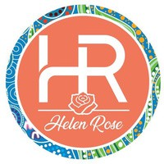
Helen Rose Pty Ltd

Helen Rose Pty Ltd is a proudly First Nations, female-led skincare and wellness company built on the foundation of culture, family, and the natural power of Australian native botanicals.
Our journey began in 2023, inspired by my father’s treatment journey and turning back to traditional bush medicine used by our people for generations. When we couldn’t find a product gentle enough to nourish his skin during recovery, we created our own. What began as a simple act of care has evolved into a powerful mission to share the wisdom of Country through natural wellness products.
In April 2025, we officially launched Helen Rose Pty Ltd to support others on their journey through life. This business is my way of echoing my father’s story, honouring cultural representation, and showcasing the beauty of Australia’s ancient plant knowledge.
Our signature range includes the Gumby Gumby Moisturiser, Sports Rub, Eucalyptus Chest Rub, and Calm Capsules, made with powerful native ingredients like Kakadu Plum, Davidson Plum, and Native Lemon Myrtle. Each product is created to nourish, restore, and support well-being—guided by Traditional Knowledge and made with love.
Our vision - To create a future where Traditional Bush Medicine sits proudly on every shelf—respected, celebrated, and accessible to all.
Our mission - To redefine wellness through culture, innovation, and inclusivity.
Our purpose - We exist to honour and share the power of First Nations plant knowledge, creating nourishing products that connect people to Country and culture.


Helen Bool
CEO and Managing Director

info@helenrose.com.au +61 428135193
helenrose.com.au

Scan here for more information

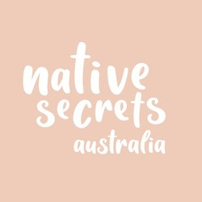
Native Secrets Australia

Native Secrets Australia is an Indigenous-owned business uniting culture, sustainability, and innovation to deliver ethical products and services to global markets. Our enterprise brings together two arms: Native Secrets Skincare and Secret Harvest Wild Botanicals, operating across agrifood, creative industries, green economy, and services.
Native Secrets Skincare creates 100% natural beauty and wellbeing products using wild-harvested botanicals, including our hero ingredient, cypress leaf oil. Formulated to be fragrance-free, gentle, and effective, our products meet the growing demand for safe, ethical, and sustainable skincare.
Secret Harvest is the harvesting and supply chain division, working directly with Indigenous harvesters and landholders to wild-harvest botanicals in culturally respectful and environmentally sustainable ways. This ensures biodiversity is protected while providing traceable, high-quality raw materials for industries spanning food, agriculture, wellness, and renewable sectors.
Together, these arms create a vertically integrated model that strengthens Indigenous economies, protects Country, and provides authentic stories to global partners. With established partnerships in airlines, retail, and export markets, Native Secrets Australia is positioned as a trusted collaborator for UAE and GCC partners seeking sustainable, ethical, and innovative Indigenous business solutions.
By uniting traditional knowledge with modern enterprise, we deliver products, partnerships, and purpose.


Cherie Thompson
Founding CEO

cherie@nativesecrets.com.au +61 417457291
www.nativesecrets.com.au

Scan here for more information


Nood Australia

Nood Australia is an Indigenous-owned (majority Aboriginal-owned) Australian brand specialising in natural, sustainable personal-care and cleaning products formulated with native Australian botanicals like Kakadu plum, lemon myrtle, quandong, eucalyptus, and wattleseed.
Their offerings span Yarta personal-care items (hand & body wash, shampoo, conditioner, body lotion), Wardli home cleaners (glass, surface, floor cleaning), hand sanitizers, and starter/refill packs—all ethically sourced, environmentally friendly, and made in Australia.
They emphasise social sustainability, supporting Indigenous enterprises through wild harvesting, fair trade, and donating 10% of net profit to Indigenous charities

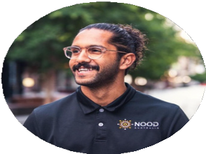
Anthony Wilson
Founder

anthony@wearenood.com.au +61 447667743
nood-australia.myshopify .com/

Scan here for more information

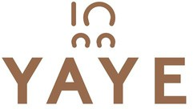
Yaye

Yaye (Arrernte for “Big Sister”) is a 100% Aboriginal-owned skincare and body care brand blending native Australian botanicals with modern formulations. Founded by Warumungu and Luritja woman, Melissa Cole, Yaye delivers sustainable, high-performance products that celebrate Indigenous knowledge and wellness traditions.
Certified by Supply Nation and NTIBN, Yaye is recognised for its ethical practices, quality assurance and capacity to scale for export markets. Our award-winning range, including the Red Ochre Face & Body Oil, is positioned for premium retail, luxury hotel amenities and corporate gifting. Yaye offers international partners a trusted, authentic and culturally distinctive brand aligned with green economy values.

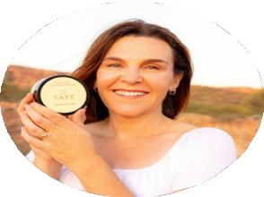
Melissa Cole
Owner

products@y aye.com.au +61 439873083
y aye.com.au

Scan here for more information

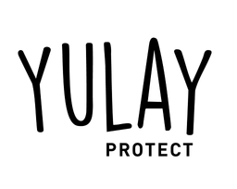
Yulay Protect

Yulay Protect is a 100% Indigenous-owned Australian sunscreen brand dedicated to safeguarding skin and celebrating culture. The name “Yulay” comes from the Gomeroi language meaning “skin”, reflecting a deep connection to country, community, and sun respect. With a high-performance SPF 50+ broad-spectrum and water-resistant formula, Yulay Protect meets rigorous Australian standards and is designed for use in extreme-sun environments.
Ideal for outdoor worksites, leisure and harsh desert climates. Yulay Protect is a brand that offers premium sun-protection and honours First Nations ownership, community impact, and quality innovation.


Garnet Brennan
Founder
garnet.brennan@y ulay .com.au +61 456215552
www.yulay .com.au

Scan here for more information

Creative Industries

30


Aboriginal Steel Art

Established in 2008, Aboriginal Steel art was the result of owner, Wayne McGinness, combining the love of his parent’s paintings and styles with his skills as a steel fabricator. Aboriginal Steel Art creates stainless steel sculptures for corporate gifts, trophies, fine art and architectural pieces.
ASA owns it's own laser cutters and relevant machinery, making sure all my pieces are fully Indigenous made.


Wayne McGinness
Owner Operator

contact@aboriginalsteelart.com  +61 415681949
aboriginalsteelart.com

Scan here for more information

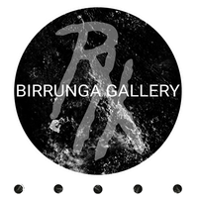
Birrunga Gallery Cultural Hub

Birrunga Gallery is a First Nations owned Cultural enterprise founded and led by Wiradyuri man, Birrunga Wiradyuri. Based in Meanjin (Brisbane, Australia), the gallery showcases contemporary Indigenous art while mentoring emerging artists through its Cultural Creative Development Program.
Delivering exhibitions, workshops, storytelling, Cultural tours and commissioned works, Birrunga Gallery creates authentic engagement with First Nations Culture. The gallery also offers catering and events featuring modern Australian cuisine infused with Native ingredients.
Internationally, Birrunga Gallery provides unique opportunities for collaboration and Cultural exchange, positioning Indigenous art and knowledge as powerful vehicles for education, Reconciliation and sustainable partnerships.

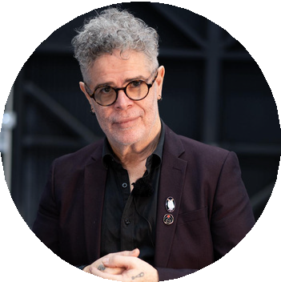
Birrunga Wiradyuri
Founder, Principal Artist

reception@birrunga.com.au +61 426411790
birrunga.com.au

Scan here for more information


Blackfisch

Blackfisch is a majority Indigenous-owned creative agency that has been telling stories through media since 2003. We deliver end-to-end creative and production services across Australia and the Asia-Pacific, with a strong focus on cultural awareness, authenticity and innovation.
Our expertise spans every stage of content creation, from concept development, copywriting and scriptwriting through to filming, editing, animation, photography, design and digital solutions. We are equally at home producing a national campaign, a government documentary, or a fast-turnaround project that needs to be delivered within hours.
Over two decades, we have partnered with leading corporations, community organisations and all levels of government. Our work includes public awareness campaigns, tourism promotions, documentaries, training materials, branded content, and broadcast television. Clients choose us for our ability to balance creativity with reliability, delivering high-quality outcomes on time and on budget.
Blackfisch is committed to supporting social progression through the power of media. We bring sensitivity to projects involving Indigenous languages, culture and country, ensuring voices are represented with respect. Backed by a talented team and state-of-the-art production facilities in Sydney, we continue to create content that informs, inspires and connects audiences everywhere.


Malinda Rutter
Creative Director


hello@blkfsch.com +61 412434855
www.blkfsch.com

Scan here for more information


Garuwa

GARUWA is a 100% First Nations-owned and led professional film and video production company that believes in the power of storytelling. Founded by Worimi siblings Genevieve Grieves and Kieran Satour, First Nations knowledges and culture are central to GARUWA’s ways of being. Grounded in collaborative and holistic approaches we work ethically, respectfully and innovatively to amplify community voices, support the next generation of storytellers and create a better future for generations to come.
As a proudly intercultural group of creatives, diversity is the core strength of our work. Our team includes incredible creatives, with First Nations peoples from language groups across the Country, and descendants with migrant backgrounds, who are united in their commitment to truth-telling, cultural integrity, and creating inclusive media that empowers communities.


Kieran Satour
Co-creator

kieran@garuwa.com  +61 406 900 116
garuwa.com

Scan here for more information

Konstantina Aboriginal Art

Konstantina (Kate Constantine) is a proud Gadigal woman of the Eora nation and a neo-contemporary Indigenous artist. She is re-imagining the traditions of her peoples’ dot painters and providing a modern narrative for all people to better understand a First Nations perspective as part of the fabric of Australia.
As a descendant of the Gadigal, she is passionate about her language, Culture and histories, much of which have been lost, misplaced or manipulated since the dawn of Colonisation. As such, her practice is heavily interconnected with her Mob and their oral histories and married with her esteemed academic research.
Her artworks are a physical manifestation of these stories and histories, a document in time to reconnect her people to their Country.
Konstantina is a highly sought after contemporary artist who is represented by galleries in Paris, London, Sydney, Melbourne and Brisbane, where her solo shows have sold out consistently for almost a decade. Her works have been awarded finalist places in over twenty Art Prizes and Awards, and been profiled at international art shows, on TV and for high profile restaurant and corporate works. Her public artworks are have seen her take over shopping centres, parklands and office buildings with her trademark contemporary edge.


Kate Constantine
Artist

shae@konstantinaaboriginalart.com +61 466288660
www.konstantinaaboriginalart.com

Scan here for more information


Magabala Books

Magabala Books is Australia’s leading Indigenous publishing house. Aboriginal owned and led, we celebrate and nurture the talent and diversity of Aboriginal and Torres Strait Islander voices.
Based in Broome, Western Australia, we publish Aboriginal and Torres Strait Islander authors, artists and illustrators from all over Australia. An independent, not-for-profit Indigenous Corporation, Magabala is governed by a dedicated Board of Kimberley Aboriginal educators, business professionals and creative practitioners.
Magabala publishes up to 18 new titles annually across a range of genres: children’s picture books, memoir, fiction (junior, YA and adult), non-fiction, graphic novels, social history and poetry. Our award-winning titles are recognised for their literary merit, cultural significance and contribution to the canon of Australian literature. We are always looking for new ways to share the creators’ stories and artwork we publish as widely as possible, whether through rights sales, export or international collaborations.
Magabala Books is an advocate and guardian, protecting the cultural and intellectual property rights of all our creators. We play a significant advisory role within the publishing industry, modelling best practice for the publishing of Indigenous stories. Magabala also delivers a range of innovative social and cultural initiatives.

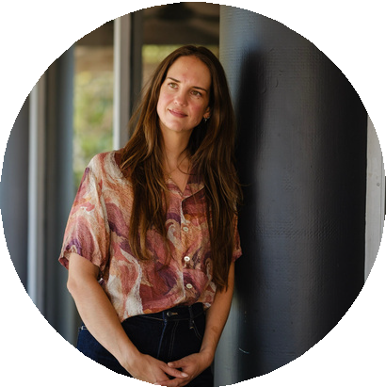
Dr Lilly Brown
CEO

lilly .brown@magabala.com +61 449629449
magabala.com

Scan here for more information


Ngali Pty Ltd

Ngali is a multi-award-winning Australian First Nations fashion brand founded in 2018 by Wiradjuri designer Denni Francisco. Based in Melbourne, Ngali translates licensed Aboriginal and Torres Strait Islander artworks into premium garments and accessories, honouring culture through contemporary design.
Each Ngali piece is created in respectful collaboration with artists, who receive ongoing royalties for their work, based on sales. By bringing First Nations creativity to a broader audience, Ngali expands opportunities for Indigenous artists, amplifying their voices and ensuring their stories are seen and celebrated on a global stage.
Ngali made history as the first First Nations brand to present a solo runway at Australian Fashion Week (2023) and again at Australian Fashion Week (2025). Its collections of refined garments and versatile silk scarves resonate strongly with international markets, where the appetite for meaningful, ethically produced fashion continues to grow. These pieces are not only luxurious but also timeless and adaptable, making them highly relevant to global consumers seeking both style and story.
With stockists including David Jones Department Store, high-end resorts and upcoming collaborations with leading retailers, Ngali is poised for expansion across the USA, UK, Scandinavia, and UAE — carrying First Nations design to the world.


Denni Francisco
Ceo and Creative Director

denni@ngali.com.au +61 418140635
www.ngali.com.au

Scan here for more information



Energy, Infrastructure and Sustainability

38


Aldridge Railway Signals

In 1987 Aldridge Road Traffic Signals bought a foundry that manufactured road signal casings, complementing our lens and injection moulding capabilities. This foundry also had tooling for railway signals and had been bidding for the contract with Sydney Trains to re-signal the metropolitan rail system. Aldridge won that contract in 1988 called the Sydney Metropolitan Re-signalling Program (SRMP) and spawned the creation of Aldridge Railway Signals.
World leading technology is developed by Aldridge here in Australia specialising in designing bespoke equipment for clients such as a signal that provides unique reporting such as condition monitoring. Unlike our competitors who build a standard LED module for their signalling, Aldridge has over 100 different types of LED modules with internal enhancements that do different things for different clients in different countries.
Aldridge has exported signals to Thailand, Taiwan, Malaysia, Singapore, Hong Kong, Sri Lanka, Indonesia, Philippines, Ireland and New Zealand.
Aldridge was awarded the 2023 Indigenous Exporter of the Year award in the Supply Nation, Supplier Diversity Awards and in 2024 and 2025 Aldridge won the NSW Premier’s Award for Indigenous exporter.


David Aldridge
Managing Director


david.aldridge@railsignal.com +61 419 993 119
railsignal.com

Scan here for more information

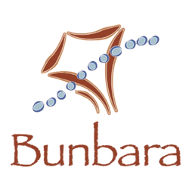
Bunbara

Bunbara is an Indigenous female owned Australian company delivering procurement, supply, and strategic services across the Oil, Gas, Energy, and Defence sectors. We combine technical capability with a strong commitment to Indigenous participation and local content.
We specialise in the supply of critical piping components, valves, fittings, flanges, instrumentation, bolts, gaskets, in high-end material grades, as well as procurement support services that ensure projects are delivered on time, and to specification. Our partnerships with leading manufacturers and distributors allow us to provide high-quality, cost effective solutions, ensuring value for our clients.
Beyond supply, Bunbara supports international companies seeking to meet Australian Indigenous Procurement and Local Participation requirements. By bridging global capability with local industry expectations, we help partners navigate compliance while creating genuine opportunities for Indigenous businesses and communities.
With a reputation for collaboration, reliability, and cultural integrity, Bunbara is positioned to support major projects both in Australia and internationally. We are proud to represent the strength and innovation of First Nations business on the global stage.


Nikky Irvine
Director

nikky@bunbara.com.au +61 423027933
www.bunbara.com.au

Scan here for more information


DICE Australia

DICE Australia – “Powering Communities, Empowering People”.
How we do it: A proudly Indigenous-owned company designing and delivering renewable energy solutions across Australia, including solar, battery storage, and smart energy systems for remote and urban communities, providing reliable, lower-emissions power where it's needed most - in the harshest environments on earth.
Anchored by in-house construction and infrastructure capability, we execute renewable projects at scale with quality, safety, and resilience for long-term performance.
Partnering with government, industry, and Traditional Owners, creating commercial and social value through sustainable projects and Indigenous employment. We are open to international partnerships across the Gulf region.


Shayne Newby
Business Development Manager


shayne@diceaust.com.au
+61 420262112
www.diceaust.com.au

Scan here for more information

Pictured: Raymond Pratt, Director.
For enquiries, please contact Shayne Newby


Electric Power Conversions Australia

Electric Power Conversions Australia (EPCA) is a Western Australian-based company electrifying heavy diesel mining equipment with its proprietary battery-electric technology. By reusing up to 80% of the existing vehicle, it delivers a cost-effective, lower-waste pathway to decarbonisation without the need to replace fleets. The E-Powertrain kit can be shipped directly to mining operations to carry out the retrofit locally on-site.
EPCA’s retrofitted trucks achieve the longest runtime with a rapid 50-minute recharge time, while cutting fuel and maintenance costs significantly. With its modular, export-ready solution, EPCA brings a solution to international mining operators to adopt cleaner, more efficient fleets while strengthening sustainability goals and operational competitiveness.

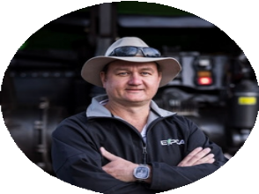
Clayton Franklin
Founder and Chief Engineer

 clayton.franklin@epca.net.au +61 427086301
epca.net.au

Scan here for more information


Forces
Group Australia

Forces Group Australia is a proudly 100% Indigenous-owned, Australian Made Certified company delivering deployable fitness, recovery, renewable energy, and containerised infrastructure solutions. Based in Queensland, we design and manufacture modular systems that are portable, robust, and engineered for Defence, government, mining, emergency services, and commercial clients.
Our proven product suite includes Deployable Gym Lockers, Outdoor Gym Conversions, Heat Stress & Recovery Units, Off-Grid Power Systems, and Accommodation Modules. These units are trusted by the Australian Defence Force and Australian Federal Police, with successful deployments across Australia and the Pacific.
Looking ahead, Forces Group is driving a new wave of innovation. We are developing deployable off-grid drinking water units that harness cutting-edge humidity-to-water technology to produce safe drinking water in any climate. We are advancing containerised farm systems to boost food security, enable self-sufficiency, and support rapid response in disaster relief. In addition, we are progressing a partnership to containerise a breakthrough machine that converts used cooking oil into diesel fuel, creating deployable renewable energy units.
Through Indigenous innovation, sustainable engineering, and global collaboration, Forces Group is shaping the future of deployable solutions — supporting communities, Defence, and industries worldwide.


Harrison Lee-Schell
Managing Director

team@forcesgroup.com.au +61 449773934
www.forcesgroup.com.au

Scan here for more information


Red Rock Services

Red Rock Services is a majority Aboriginal-owned company, proudly Supply Nation Certified and registered on the Aboriginal Business Directory WA. Founded in 2019, the business operates across the Pilbara, Gascoyne, and Kimberley, with a mission to deliver innovative, sustainable solutions that reduce environmental impact and create opportunities for Aboriginal participation.
Proudly manufacturing innovative Solar powered solutions, that support companies in meeting their net zero targets, by eliminating diesel dependency and reducing carbon emissions. Red Rock operates a multifaceted business, providing site-based trade support, workshop engineering and fabrication, facilities maintenance, piping, mechanical and flange management works, and most recently providing abrasive blast and paint solutions.

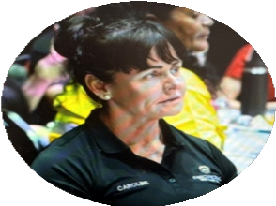
Caroline Quinn
Business Development Manager

caroline.quinn@redrockserv.com.au +61 483180030
www.redrockserviceswa.com.au

Scan here for more information


WRL Shipping Pty Ltd

WRL Shipping is a majority Indigenous, female-owned logistics company based in Brisbane, Australia, with offices in Atlanta and Idaho, USA, and representation across the UAE, Europe, UK, Singapore, and India. Established in 2008 as a second-generation family business, WRL has grown into a trusted partner delivering tailored freight forwarding and logistics solutions for clients in energy, mining, and resource sectors.
Our expertise spans domestic and international transport, heavy and project cargo, and complex supply chain requirements. We pride ourselves on agility, reliability, and a client-first approach—designing solutions that optimise cost, time, and risk while ensuring cargo is delivered safely and efficiently.
As an Indigenous-owned business, WRL is committed to creating meaningful opportunities and sustainable career pathways for the next generation. We bring diversity, integrity, and cultural depth to the logistics industry, demonstrating how Indigenous enterprise can thrive on a global stage.
With a dedicated team and an extensive partner network, WRL Shipping provides not just transport services but a collaborative, values-driven approach that strengthens client outcomes and contributes to a more inclusive business landscape.


Kira Seeley
Managing Director

kira@wrlshippingau.com +61 434057132
www.wrlshipping.com.au

Scan here for more information

Professional Services

46


Elephant in the Room Consulting

Elephant in the Room Consulting is a 100% Indigenous-owned, female-led consultancy specialising in cultural capability, strategic facilitation, and inclusive leadership development. Founded by Bundjalung woman Jenni Walke, EITRC is built on the belief that Indigenous wisdom belongs at the centre of business, not the margins. With over 25 years’ experience in leadership, strategy, and capability development, Jenni has worked across sectors, from grassroots enterprises and not-for-profits to ASX-listed corporations and government agencies, helping organisations embed cultural intelligence and purpose-led strategy into their operations.
EITRC’s approach is grounded in authenticity, systems thinking, and values-driven innovation. We deliver tailored programs that foster cultural safety, build internal capability, and drive meaningful transformation. Our services include strategic facilitation, Reconciliation Action Plan development, supplier diversity frameworks, and immersive cultural learning experiences that invite reflection, storytelling, and connection.
Through international partnerships with Indigenous organisations in the US and Canada, EITRC is co-designing culturally intelligent business practices and unlocking global opportunities for inclusive leadership. We are proud to contribute to the growth of the First Nations business sector and support Australia’s engagement with the UAE and GCC regions.
EITRC is more than a consultancy, it’s a movement committed to legacy, impact, and creating a future where inclusion is a strategic advantage.


Jenni Walke
Founder/ Managing Director

jenni@eitrconsulting.com +61 447396980
elephantintheroomau.com

Scan here for more information


Gilimbaa

Gilimbaa is a full-service communications and creative agency that has been operating since 2008, specialising in the development of culturally relevant and engaging design and content for and with Aboriginal and Torres Strait Islander communities and connecting resources to communities in an effective and empowering manner. We have an excellent track record in delivering design and communications projects for government agencies, corporate clients, universities, and not-for-profits, with a strong record of financial stability combined with excellence in project management and client service.
Gilimbaa means ‘today’ in the language of the Wakka Wakka people, and our work reflects the blending of the power and process of storytelling (and the role this plays in the education and celebration of culture and community) with innovative and effective communications processes and products. Our core focus is on the design and development of communications content and resources that are appropriate to the needs of, engaging and empowering for, and actively connected to Aboriginal and Torres Strait Islander communities around Australia.


David William
Owner/ Executive Director

office@gilimbaa.com.au +61 733678895
www.gilimbaa.com.au

Scan here for more information


Indigenous Emerging Business Forum Aboriginal Corporation

The Indigenous Emerging Business Forum Aboriginal Corporation (IEBFAC) is an Aboriginal-owned organization dedicated to empowering First Nations entrepreneurs and businesses throughout Western Australia. Our mission is to foster sustainable economic development by providing opportunities for Indigenous people to grow, connect, and thrive in the business world.
In partnership with the Chamber of Commerce and Industry of Western Australia (CCIWA), we co-manage the Aboriginal Business Directory of WA, which currently lists over 1,000 certified Aboriginal businesses. This directory is a vital resource, supporting the visibility and growth of Indigenous enterprises and connecting them to key procurement opportunities.
IEBFAC hosts the Indigenous Emerging Business Forum, the largest Indigenous business forum in Australia, which has attracted over 5,000 attendees to date. The event serves as a dynamic platform for networking, knowledge sharing, and showcasing Indigenous business innovation. It brings together Aboriginal entrepreneurs, corporate partners, government agencies, and industry leaders to drive impactful change and create lasting business connections.
Through strategic partnerships, mentorship, and culturally relevant support services, IEBFAC is committed to promoting Indigenous economic empowerment, fostering self-determination, and contributing to the growth of Australia’s diverse business landscape.


John O’driscoll
CEO

ceo@iebf.org.au +61 488999851
www.iebf.org.au

Scan here for more information


Sustainative

Sustainative means “sustain” with ‘native’ wisdom, is a local First Nations–led, multidisciplinary professional services firm.
We enhance Corporate ESG through our distinctive Indigenous Regenerative Sustainability model (triangle)—a holistic framework that combines Indigenous wisdom, evidence-based science, and technology to enhance climate resilience, public health, and reconciliation.


Abe Sharman
Director

abe.sharman@sustainative.com.au +61 420989193
sustainative.com.au

Scan here for more information

Technology

51


Australian Indigenous Ai Solutions

Indigenous-founded Australian technology and Business Solutions, that harnesses advanced AI, rooted with traditional business frameworks, cloud, and data-engineering to tackle the everyday and frontier challenges facing businesses nationwide—boosting efficiency, cutting costs, and unlocking new growth.
Grounded in a strong values-first culture and proven consulting expertise, we deliver practical solutions—from smart-workflow automation and predictive analytics to ethical AI governance frameworks, Six Sigma, that help organisations of every size move faster, innovate responsibly, and stay competitive in a rapidly changing market.


Trish Botha
Managing Director

trish.b@ausindigenousai.com.au +61 406856459
ausindigenousai.com.au

Scan here for more information


Centre for Appropriate Technology Satellite Enterprises (CFATSE)

Indigenous-founded Australian technology and Business Solutions, that harnesses advanced AI, rooted with traditional business frameworks, cloud, and data-engineering to tackle the everyday and frontier challenges facing businesses nationwide—boosting efficiency, cutting costs, and unlocking new growth.
Grounded in a strong values-first culture and proven consulting expertise, we deliver practical solutions—from smart-workflow automation and predictive analytics to ethical AI governance frameworks, Six Sigma, that help organisations of every size move faster, innovate responsibly, and stay competitive in a rapidly changing market.


Aaron Kabasobokwe
General Manager

kabasobokwe@gmail.com +61 479124614
www.cfat.org.au/cfat-se

Scan here for more information

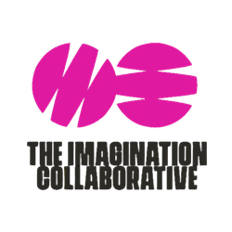
The Imagination Collaborative

The Imagination Collaborative is a First Nations owned event technology company redefining how large scale events are planned, designed, and delivered. Combining advanced CAD drafting, drone surveying, photogrammetry, and immersive 3D visualisation, we create digital twins that bring venues and experiences to life before they happen.
Our global team partners with governments, venues, and major event organisers to streamline planning, reduce costs, and unlock creativity. With a strong presence across Australia, the US, and the Middle East, we deliver innovative, sustainable solutions that support infrastructure, cultural exchange, and economic growth through technology driven collaboration.

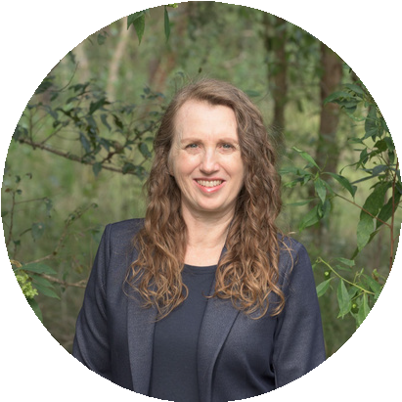
Tristan Morrison
Co-founder

tris@theimaginationcollaborative.com +61 412903015
theimaginationcollaborative.com

Scan here for more information



WV Technologies

WV Technologies specialises in the IT Lifecycle Services Industry, particularly around secure data destruction and E-waste recycling.
WV Technologies exports significant quantities of products across the world including to the UAE. WV Tech provides secure IT end-of-life management services locally, and export of used IT equipment globally.


Kurt Gruber
Director

kurt.gruber@wvtech.com.au +61 413734811
wvtech.com.au

Scan here for more information

Contact us
Austrade connects Australian businesses with the global opportunities that will help to drive the growth of the international trade.
Contact Austrade to schedule 1-on-1 meeting with the Australian companies featured in the catalogue.

Dubai@austrade.gov.au

Interested in learning more about Austrade’s work with First Nations exporters?

Trade advisers | Austrade International

Connect with us on social






Australian Trade and Investment Commission (Austrade)
@Austrade



