

Why Australia

Benchmark Report 2024

July 2024

Contents

Contents 1

CEO’s foreword 5

Chapter 1 – Fundamentals 6

The world’s 13th-largest economy 7

Our outperforming economy 8

Australia is a low-tax country 9

Good governance, strong institutions and the rule of law 10

Australia: open and business-friendly 11

A strong and dynamic financial system 12

The world’s 5th-most-valuable pension system 13

Australia’s cashless society 14

Chapter 2 – Australia: A global resource for a net zero future 15

A partner of choice in a net zero world 15

A natural leader in clean energy 16

Abundant minerals for a net zero transformation 17

A top destination for renewables investment 18

Rapid growth in renewable energy 19

Solar power: Australia’s next gold rush 20

The southern hemisphere’s solar powerhouse 21

Efficient solar power generation 22

Investment in industrial-scale hydrogen 23

Chapter 3 – Our skills and innovation 24

Top performers: from academia to quantum and beyond 24

Australia’s smart tech sectors 25

#1 for new tech skills 26

A leader in digital government 27

A pioneer in renewables R&D 28

Advanced research in hydrogen 29

Academic excellence — from neuroscience to space 30

Skilled workforce and innovation indicators 31

Australia's highly educated workforce 32

A big investor in education 33

Australia at #4 globally for top-ranked universities 34

Australian research pursues UN goals 35

Chapter 4 – Global ties & open markets 36

Outward looking with a passion for free trade 36

Proximity to Asia’s powerhouse economies 37

A broad network of trade agreements 38

Pioneering the modernisation of global trade 40

A global hub with diverse connections 41

Foreign investment reaches A$4.7 trillion 42

Australia attracts investors from America, Europe and Asia 43

The trillion-dollar trading nation 44

An open trading economy for services 45

Abundant energy and resources 46

Agrifood exports grow in global and premium markets 47

A growth market for international travellers 48

Chapter 5 – High quality of life 49

An attractive place to live and work 49

Top marks for talent attraction 50

Australia's dynamic cities 51

A nation of high-income households 52

No worries, we’re happy! 53

Strong commitment to a superb healthcare system 54

Table of figures

Figure 1 - World’s largest economies in 2023 7

Figure 2 - Change in real GDP¹, selected economies 8

Figure 3 – Tax revenue as a percentage of GDP by economy 9

Figure 4 – Global rankings of Australia’s governance 10

Figure 5 – Business efficiency and environment, 2024 11

Figure 6 – Global significance of Australia’s financial markets 12

Figure 7 – Global pension fund assets, 2023 13

Figure 8 – Cashless payments by country 14

Figure 9 – Australia’s renewable energy credentials 16

Figure 10 – Australia’s minerals - Global ranking for production and reserves, 2022 17

Figure 11 – Renewable energy region attractiveness 18

Figure 12 – Australia’s renewable energy generation volumes and world rankings 19

Figure 13 – Solar power potential¹, top 20 regions 20

Figure 14 – Electricity generated by solar – selected regions 21

Figure 15 – Cost of solar power generation by region¹, 2022 22

Figure 16 – A sample of hydrogen projects in Australia 23

Figure 17 – Australia’s tech credentials 25

Figure 18 – Skills for using, adopting and adapting frontier technologies¹, 2021 26

Figure 19 – E-Government index by region, selected regions¹ 27

Figure 20 – Renewable energy patents by economy 28

Figure 21 – Public spending on R&D for hydrogen and fuel cells 29

Figure 22 – Relative impacts of Australian scientific publications by research field, 2018–22 30

Figure 23 – Skilled workforce and innovation indicators – Global rankings 31

Figure 24 – Percentage of employed persons with tertiary education by industry¹ ― 2023 32

Figure 25 – Expenditure on educational institutions across OECD countries¹ 33

Figure 26 – Academic ranking of world universities, 2023 34

Figure 27 – Top 100 Universities Times Higher Education Impact Rankings, 2023 35

Figure 28 – Asia’s economic growth 37

Figure 29 – Australia’s free trade agreements 38

Figure 30 – Trade digitalisation index¹ for selected economies, 2023 40

Figure 31 – Foreign-born population across OECD countries, 2000 and 2022¹ 41

Figure 32 – Total foreign investment stock in Australia, 2003 to 2023 42

Figure 33 – Australia's main sources of foreign direct investment stock, 2013–2023 43

Figure 34 – Australia’s exports and imports of goods and services 44

Figure 35 – Services trade restrictiveness index¹ by sector, Australia vs OECD average in 2022² 45

Figure 36 – Energy and resources exports by economy in 2023 46

Figure 37 – Australia’s major agricultural products, 2023–24E 47

Figure 38 – Tourism investment pipeline² in Australia by sector and financial year³ 48

Figure 39 – Talent attractiveness 50

Figure 40 – Cost of living: Global city rankings, 2023 51

Figure 41 – Number of households with disposable income of more than US$75,000 per annum (selected economies)¹ 52

Figure 42 – Happiness Index and GDP per capita, 2023 53

Figure 43 – Government healthcare expenditure per capita, 2023 54

CEO’s foreword

It is with great pleasure that I present the Why Australia Benchmark Report 2024. This report is intended to be a key resource for decision-makers involved in foreign investment. As investors evaluate their future investment and growth strategies, this report highlights Australia's competitive advantages and underscores why Australia is an ideal destination for investment.

Australia's economic resilience and dynamism are remarkable. Before the pandemic, Australia enjoyed almost 30 years of uninterrupted annual economic growth. Consistently outpacing other advanced economies, Australia is forecast to continue to outperform our peers over the next five years to 2029.

Australia is a global leader in renewable energy. Australia holds the title of the largest producer of solar energy per person and has significant potential for offshore wind generation. Australia is also at the forefront of critical minerals. We have the largest known reserves of nickel, the 2nd-largest reserves of lithium, cobalt and tantalum, and the world’s 6th-largest reserves of rare earth minerals. Australia is also well-regarded for its strong environmental, social, and governance (ESG) credentials, and our reliable legal system offers predictability and protection for investors.

The Australian Government will invest A$22.7 billion (US$15.2 billion) over the next decade to build a Future Made in Australia. This is a plan to encourage and facilitate private sector investment and will present significant opportunities for investors in renewable hydrogen, critical minerals processing, green metals, low carbon liquid fuels, and clean energy manufacturing.

Strong global ties make Australia a prosperous trading nation. Our healthy economic outlook partly reflects the prosperity of Asia, with Australia enjoying the trade benefits of being close to many of the fastest growing economies in the world.

According to the United Nations, Australia has the highest global ranking for skills related to using, adopting and adapting frontier technologies. No wonder Australians’ noteworthy inventions include the electronic pacemaker, polymer bank notes, the inflatable aircraft escape slide and the human papilloma virus vaccine.

This report details Australia’s compelling value proposition. Our political stability, transparent regulations, and strong international trade relations ensure a secure and thriving business environment.

Explore the Why Australia Benchmark Report and discover why Australia is an exceptional choice for your business ventures.

Sincerely,

Xavier Simonet

Chapter 1 – Fundamentals

A growing economy

Australia's economy is strong and resilient. On current forecasts, Australia’s economy will have grown by 11.1% from 2019 to 2024. This is much stronger than the average of 7.8% for advanced economies, cementing Australia’s place as the world's 13th-largest economy.

Consistent growth makes Australia a preferred destination for global investors and a reliable springboard for expansion into the Asia-Pacific region. Today, Australia’s economic foundations are solid: a trusted financial system, open trade, strong governance, and a highly-skilled population.

Our finance system is advanced, efficient and particularly large with Australia’s financial institutions managing US$8 trillion in assets. The Australian dollar is the 6th-most traded currency worldwide thanks partly to our role as a major exporter of energy and resources.

Australia’s prosperity is anchored in a trustworthy legal system. Australian law safeguards intellectual property rights, spurring creativity in our tech industries. Our taxation levels are 5 percentage points below the average for wealthy countries, which aids investment. And adaptive regulation creates a business-friendly environment that rewards innovation.

Australia’s policies and institutions are geared towards ongoing growth so Australia can outperform its peers. The Australian Government’s ambitions to build a Future Made in Australia over the decades ahead includes incentives to attract private sector investment. It also maximises the economic and industrial benefits of the global move to net zero. Reforms include improvements to investment settings, institutions, and regulatory processes to attract and enable the investment that Australia needs.

The world’s 13th-largest economy

Strong growth has solidified Australia’s position as the world’s 13th-largest economy with nominal gross domestic product (GDP) reaching A$2.6 trillion (US$1.7 trillion) in 2023. Australia was home to just 0.3% of the world’s population, but accounted for 1.7% of the global economy. The International Monetary Fund (IMF) predicts that Australia’s economic growth will continue to outperform advanced economies over the next five years.

Figure 1 - World’s largest economies in 2023

The image shows a global map depicting the world's largest economies in 2023. It displays the rank, the economy (country name) and its percentage of total world nominal gross domestic product (GDP) in US dollars. The economies are:
1. US 26.1%; 2. China 16.9%; 3. Germany 4.3%; 4. Japan 4.0%; 5. India 3.4%; 6. UK 3.2%; 7. France 2.9%; 8. Italy 2.2%; 9. Brazil 2.1%; 10. Canada 2.0%; 11. Russia 1.9%; 12. Mexico 1.7%; 13. Australia 1.7%; 14. Korea 1.6%; 15. Spain 1.5%; 16. Indonesia 1.3%; 17. Netherlands 1.1%; 18. Türkiye 1.1%; 19. Saudi Arabia 1.0%; 20. Switzerland 0.8%; and ASEAN 3.6% ( includes 16. Indonesia 1.3%). 


**Notes:** **1.** Across 196 economies. **2.** The GDP for the top 20 largest economies was US$84,579 billion or 81% of the world’s GDP in 2023. **3.** The GDP for the rest of the world was US$20,212 billion in 2023 or 19% of global GDP.

**Sources:** International Monetary Fund, 2024, World economic outlook, April 2024 database; Reserve Bank of Australia, 2024, Foreign exchange rates; Austrade.

Our outperforming economy

Australia consistently grows faster than other advanced economies. During the period 2019 to 2024, our economy is forecast to have grown by 11.1%, outpacing the average of 7.8% growth for advanced economies. Over this period, we will have matched growth in the US, almost tripled the expansion in the Euro Area, and recorded growth that is five times the rate of the UK. Australia is also forecast to continue to outperform our peers over the next five years to 2029. As a major regional exporter, our outlook partly reflects the prosperity of our major trading partners – including India, China and the Association of Southeast Asian Nations (ASEAN)² economies.

Figure 2 - Change in real GDP¹, selected economies

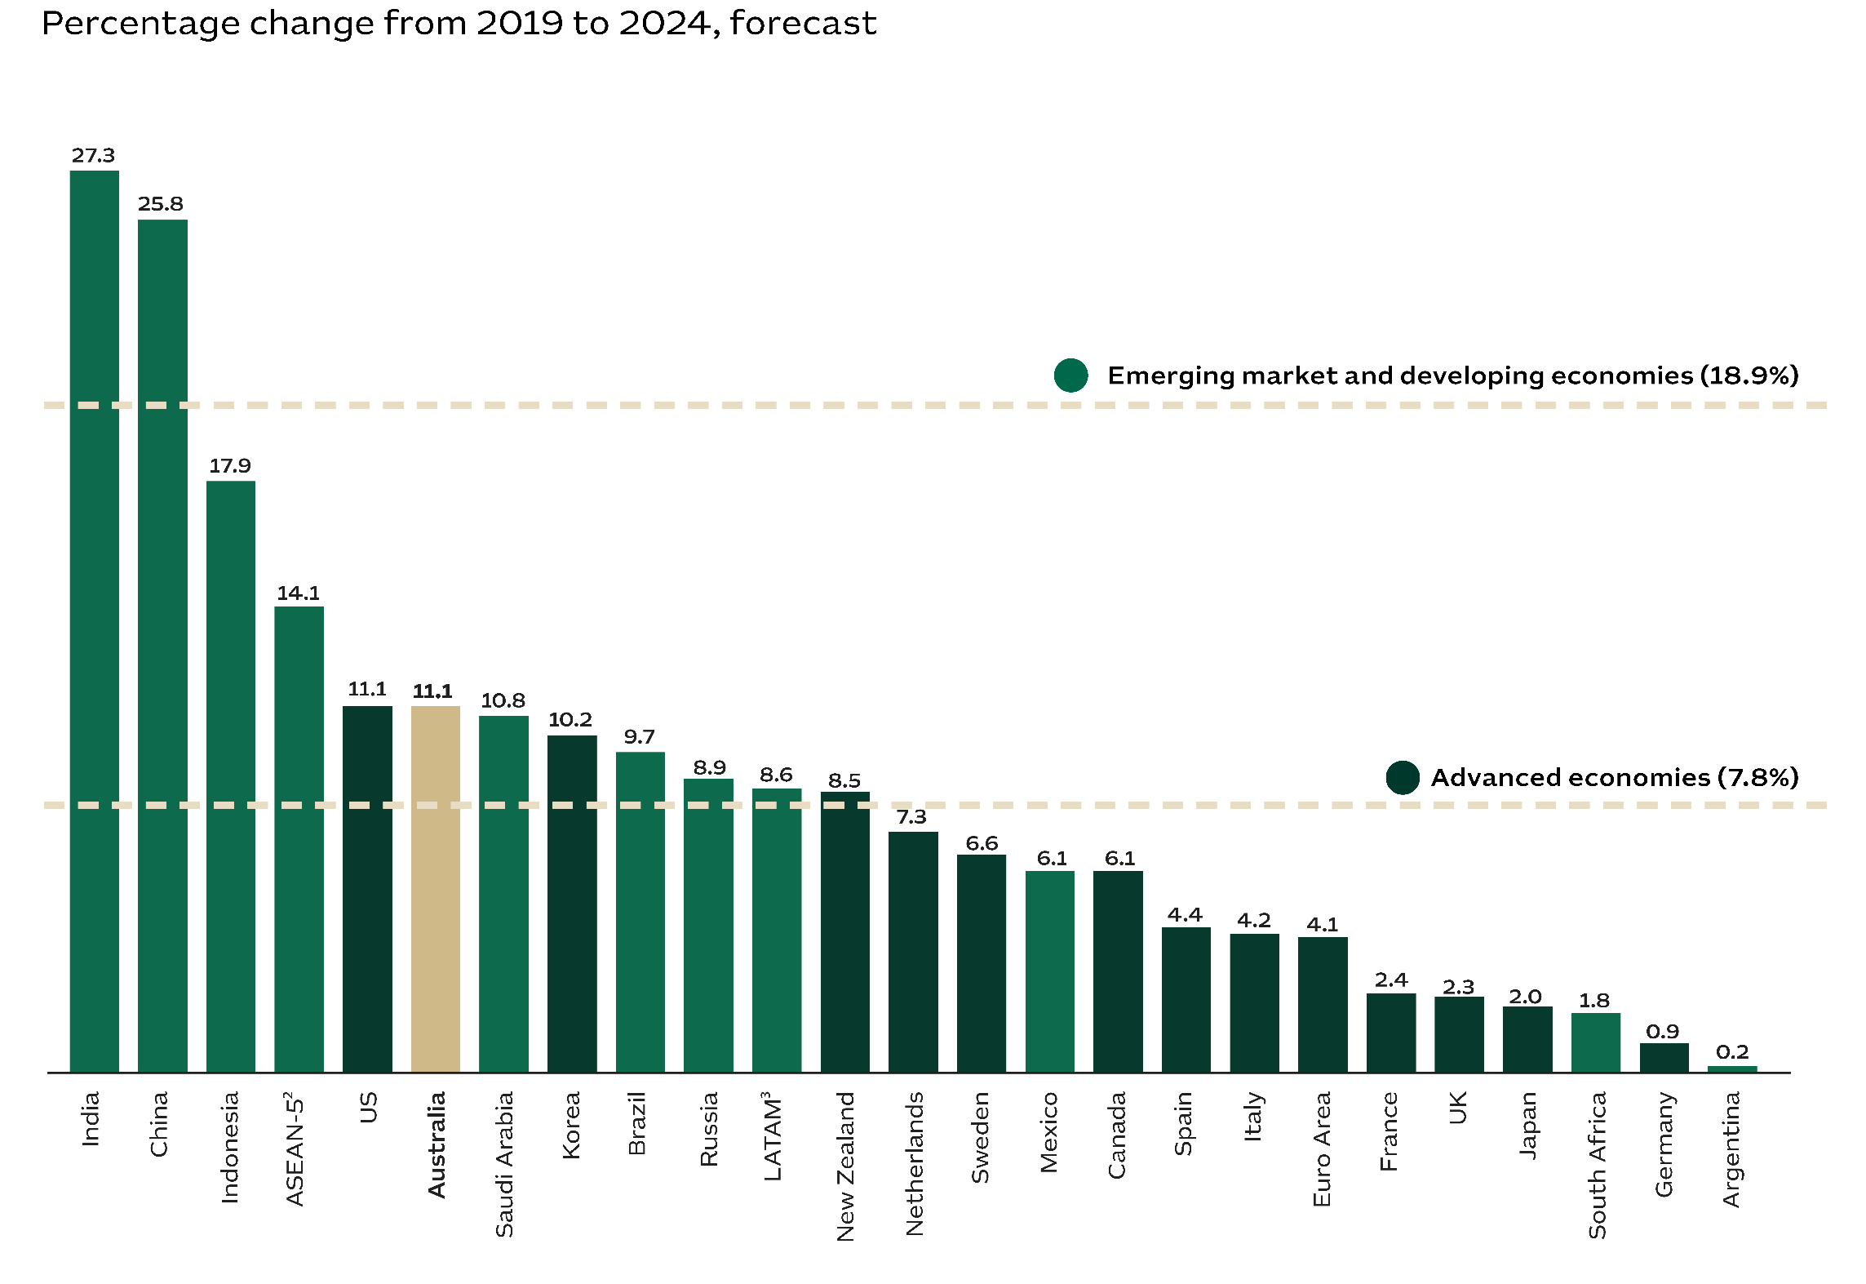

**Notes: 1.** Gross domestic product (GDP) is in national currency and constant prices. **2.** Association of Southeast Asian Nations. The forecast includes Indonesia, Malaysia, Philippines, Singapore and Thailand. Singapore is classified as an advanced economy. **3.** Latin America and the Caribbean.

**Sources:** International Monetary Fund, 2024, World Economic Outlook, April 2024 database; Austrade.

Australia is a low-tax country

Australia has one of the lowest overall tax rates of any high-income country. Our tax revenue is equal to just 29% of GDP, which is 5 percentage points lower than the 34% average for OECD countries.¹ Australian taxes on goods and services are equivalent to 7% of Australia’s GDP, compared to 11% across OECD countries. Australia’s corporate tax rate is typically lower due to various deductions, credits and incentives. For instance, R&D tax incentives significantly reduce rates for innovative companies (a small company that invests $100,000 in R&D may be eligible to receive a [cash refund of over $40,000](https://business.gov.au/grants-and-programs/research-and-development-tax-incentive)). Australia's corporate tax laws are stable and predictable, helping to reduce costs, like our [tax agreements with other countries](https://treasury.gov.au/tax-treaties/income-tax-treaties) that prevent tax duplication.

Figure 3 – Tax revenue as a percentage of GDP by economy

A bar chart shows the tax revenue as a percentage of gross domestic product (GDP) by country, using 2021 data or the latest available across the OECD dataset. The bar chart is stacked; the top part shows tax on personal income and corporate profits, and the lower part shows other taxes.  The figures behind the graph are: France (1) 13% for personal & corporate; 33% for other taxes; and 46 for total; Norway (2) 27% for personal & corporate; 18% for other taxes; and 44 for total; Austria (3) 13% for personal & corporate; 30% for other taxes; and 43 for total; Finland (4) 16% for personal & corporate; 27% for other taxes; and 43 for total; Italy (5) 14% for personal & corporate; 29% for other taxes; and 43 for total; Belgium (6) 16% for personal & corporate; 27% for other taxes; and 42 for total; Denmark (7) 27% for personal & corporate; 15% for other taxes; and 42 for total; Sweden (8) 15% for personal & corporate; 27% for other taxes; and 41 for total; Greece (9) 8% for personal & corporate; 32% for other taxes; and 39 for total; Germany (10) 13% for personal & corporate; 26% for other taxes; and 39 for total; Netherlands (12) 13% for personal & corporate; 25% for other taxes; and 38 for total; Spain (14) 12% for personal & corporate; 26% for other taxes; and 38 for total; UK (17) 13% for personal & corporate; 22% for other taxes; and 35 for total; Iceland (19) 16% for personal & corporate; 18% for other taxes; and 35 for total; OECD 12% for personal & corporate; 23% for other taxes; and 34 for total; Japan (21) 11% for personal & corporate; 23% for other taxes; and 34 for total; New Zealand (23) 19% for personal & corporate; 15% for other taxes; and 34 for total; Canada (25) 16% for personal & corporate; 17% for other taxes; and 33 for total; Israel (26) 12% for personal & corporate; 21% for other taxes; and 33 for total; Korea (28) 12% for personal & corporate; 20% for other taxes; and 32 for total; Australia (30) 18% for personal & corporate; 11% for other taxes; and 29 for total; US (31) 14% for personal & corporate; 13% for other taxes; and 28 for total; Switzerland (32) 12% for personal & corporate; 16% for other taxes; and 27 for total; Ireland (35) 11% for personal & corporate; 10% for other taxes; and 21 for total; Türkiye (36) 6% for personal & corporate; 15% for other taxes; and 21 for total; Mexico (38) 7% for personal & corporate; 10% for other taxes; and 17 for total.

**Notes: 1.** Measured as a percentage of GDP. Tax systems across countries vary significantly and this makes direct comparisons difficult on a like-for-like basis. A simple measure used by the OECD is to consider the total ‘tax take’ of an economy. The tax take (or tax burden) is the ratio of total tax revenues to GDP, at market prices. This ratio is a broad measure of a country’s taxation impost which cuts across the various bases, rates and thresholds. **2.** Social security contributions/taxes as “compulsory payments paid to general government that confer entitlement to receive a (contingent) future social benefit”. For example, unemployment insurance or family allowances. Social security contributions are often levied on employers and not only employees. **3.** The number in brackets indicates the country’s ranking across OECD members.

**Sources:** Organisation for Economic Co-operation and Development, 2024, Revenue Statistics - OECD countries: Comparative tables, accessed on 28 Feb 2024; Austrade.

Good governance, strong institutions and the rule of law

Australia has a global reputation for good government. We are recognised as one of the least corrupt nations, and Australia’s legal system is well grounded, professional and transparent. Australia is a global leader in protecting property rights, including intellectual property, and our sound governance sustains investor confidence. Today, Australia provides a stable base for multinationals who want to secure their supply chains, broaden their commercial horizons, or establish new operations in the Asia-Pacific region.

Figure 4 – Global rankings of Australia’s governance

The infographic shows the following information:
#1 Legal system
Australia has a transparent and fair legal system. (footnote #1)
#1 Lowest risk of social unrest
Globally, Australia has the lowest risk of social unrest. (footnote #1)
#2 Regulatory quality
Australia’s government has a strong ability to formulate and implement sound policies and regulations. (footnote #3)
#1 Quality of bureaucracy
Australian public servants have the highest level of specialisation and technical qualification. (footnote #1)
#2 External intervention
Australia’s government is free from the influence and impact of external actors. (footnote #2)
#7 Factionalised elites
Australia’s institutions are less likely to be fragmented by the brinkmanship and gridlock of ruling elites. (footnote #2)


**Sources**: **1.** Economic Intelligence Unit, 2024, Viewpoint database. **2.** Fund for Peace, 2023, Fragile states index. **3.** The World Bank, 2023, The worldwide governance indicators. **4.** Austrade.

Australia: open and business-friendly

Australia is a welcoming place for foreign investors and startup ventures, and we lead the world in credit ratings. We rank 6th for low tariff barriers, which reflects Australia’s commitment to open trade. Other high performing areas include Australia's macroeconomic environment and contract enforcement, which are global standouts. Global rankings also recognise our relative strength as a place to launch a new business and as an environment for private enterprise.

Figure 5 – Business efficiency and environment, 2024

The table shows the rankings of indicators by region, as follows:
IMD World Competitiveness Yearbook 2024 rankings shows the following indicators: Country credit rating¹: Australia 1; China 27; India 53; Japan 30; Korea 17; Norway 1; Singapore 1; UK 22 and US 12. Environmental agreements²: Australia 1; China 7; India 51; Japan 34; Korea 59; Norway 40; Singapore 38; UK 11 and US 55. Income distribution³: Australia 2; China 9; India 23; Japan na; Korea 29; Norway 38; Singapore na; UK 54 and US 55. Agricultural productivity: Australia 5; China 59; India 58; Japan 45; Korea 43; Norway 9; Singapore 63; UK 7 and US 14. Financial card transactions⁴: Australia 5; China 18; India 60; Japan 31; Korea 16; Norway 11; Singapore 6; UK 9 and US 2. Number of days to start a business: Australia 5; China 32; India 53; Japan 38; Korea 27; Norway 9; Singapore 2; UK 15 and US 9. Tariff barriers: Australia 6; China 46; India 62; Japan 43; Korea 60; Norway 52; Singapore 1; UK 5 and US 37. Enforcing contracts⁵: Australia 6; China 5; India 63; Japan 35; Korea 2; Norway 3; Singapore 1; UK 26 and US 16. 
EIU Business Environment 2024 rankings shows the following indicators: Private enterprise⁶: Australia 5; China 46; India 42; Japan 20; Korea 26; Norway 12; Singapore 8; UK 10 and US 1. Macroeconomic environment⁷: Australia 5; China 32; India 36; Japan 42; Korea 13; Norway 2; Singapore 9; UK 39 and US 43. 
Fund for Peace (2024) Fragile States Index 2023 rankings shows the following indicators: Human flight and brain drain⁸: Australia 1; China 33; India 72; Japan 26; Korea 36; Norway 3; Singapore 9; UK 21 and US 14. 


**Notes: 1.** This index is based on credit ratings from Fitch, Moody’s and S&P. **2.** Based on the number of international multilateral environmental agreements that have been met. **3.** The percentage of income held by the bottom 10% of income earners. A higher percentage indicates a more equitable distribution. **4.** Financial card transactions, US dollars per capita. **5.** Time and cost of a commercial dispute and the quality of judicial processes. **6.** Policy towards private enterprise measures protection of property rights and government attitudes to competition. **7.** The macroeconomic environment index is a measure designed to assess the macroeconomic stability of a country. This index takes into account various economic indicators that reflect the health and stability of an economy. **8.** The Human Flight and Brain Drain index evaluates the economic impact of the emigration of productive, skilled individuals due to economic deterioration or political persecution in their home country.

**Sources:** Institute for Management Development, 2024, World competitiveness yearbook 2024; Economist Intelligence Unit, 2024, EIU overall business environment rating; Fund for Peace, 2024, Fragile States Index 2023; Austrade.

A strong and dynamic financial system

Australia’s financial system combines innovation and rock-solid foundations. Our financial institutions currently manage around US$8 trillion in assets and the Australian dollar is the 6th-most traded currency in the world. Our impressive repayments culture boasts a 99.3% on-time loan repayment rate, which outperforms the average of 94.8% amongst major advanced economies.

Figure 6 – Global significance of Australia’s financial markets

The infographic shows the following information:
US$8.0 trillion1
Assets of Australian 
financial institutions*
Four times Australia’s nominal GDP
*December 2023
US$2.4 trillion2,3
Fund assets under management*
6th-largest in the world
2nd-largest in the Asia-Oceania region
*September 2023
94% cashless payments 4
Point of sale*
2nd-largest in the world
*2022
US$2.4 trillion5
Pension assets*
5th-largest in the world 
4th-largest in the world as a percentage of GDP
*2023
US$479 billion6
Daily foreign exchange trade using Australian dollar across 52 countries
6th-most traded currency in the world

99.3% performing loans⁷
Of all deposit-taking institutions*
9th-highest in the world
3rd-highest in the Asia-Oceania region
*First quarter, 2023


**Notes: 2.** For international comparison, the Investment Company Institute excludes funds of funds. **4.** All person-to-business transactions that occur at the physical point of sale. This includes traditional in-store transactions as well as all face-to-face transactions, regardless of where they take place.

**Sources: 1.** Reserve Bank of Australia (RBA), 2024, Assets of financial institutions; Australian Bureau of Statistics (ABS), 2024, Managed funds; Australian Prudential Regulation Authority, 2024, Quarterly general insurance performance statistics; ABS, 2024, Assets and Liabilities of Australian Securities; ABS, 2024, Australian National Accounts: national income, expenditure and product; RBA, 2024, Foreign exchange rates, accessed via Macrobond in March 2024. **3.**Investment Company Institute, 2024, Worldwide market data. **5.** Worldpay from FIS, 2024, The Global Payments Report 2023; accessed on 13 March 2024. **6.** Thinking Ahead Institute, 2022, Global pension assets study. **7.**International Monetary Fund, 2024, Financial Soundness Indicators, accessed 18 March 2024; Austrade.

The world’s 5th-most-valuable pension system

Australia’s system of compulsory superannuation has helped create the world’s 5th-largest pension market, worth A$3.7 trillion (US$2.4 trillion) in 2023. Australian pension funds have recorded strong growth of 9.2% per year over the last two decades with assets rising to the equivalent of 145% of GDP in 2023. This marks an increase from 78% in 2003. In addition to the vitality of Australia’s rapidly growing pension system, our superannuation is a major driver of the country’s fast-expanding managed funds industry.

Figure 7 – Global pension fund assets, 2023

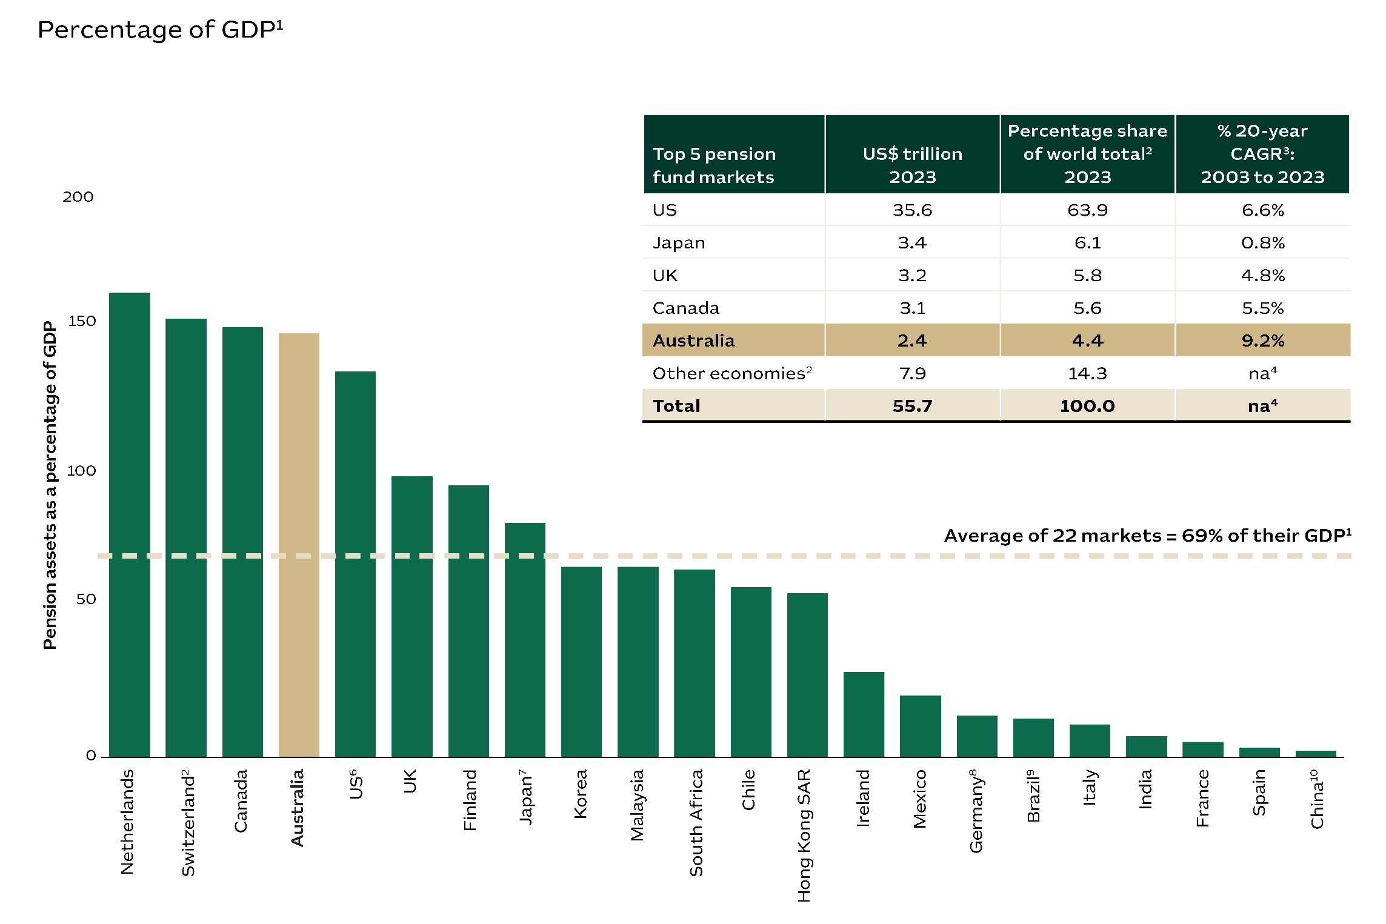

**Notes:**  **1.** The assets/GDP ratio for individual markets is calculated in local currency terms, and the total assets/GDP ratio is calculated in US dollars. **2.** Thinking Ahead Institute analysed 22 economies. **3.** CAGR = compound annual growth rate. **4.** na = not available for publication. **5.** Only includes autonomous pension funds. It does not consider insurance companies assets. **6.** Includes Individual Retirement Accounts (IRAs). **7.** Does not include the unfunded benefit obligation of corporate pension plans (account receivables). **8.** Only includes pension assets for company pension schemes. **9.** Only includes pension assets from closed entities. **10.** Only includes Enterprise Annuity assets.

**Sources:** Willis Towers Watson, 2024, Thinking Ahead Institute and secondary sources, Global Pension Funds Assets Study; Reserve Bank of Australia, 2024, Foreign exchange rates - accessed during March 2024; Austrade**.**

Australia’s cashless society

We are leaders in creating a cashless society, with 94% of transactions now taking place digitally. This puts Australia in 2nd place in digital-payment rankings, reflecting consumer trust in our financial security and system. Australia’s cashless society promotes easier, faster and safer transactions in a market economy that embraces traceability and transparency.

Figure 8 – Cashless payments by country

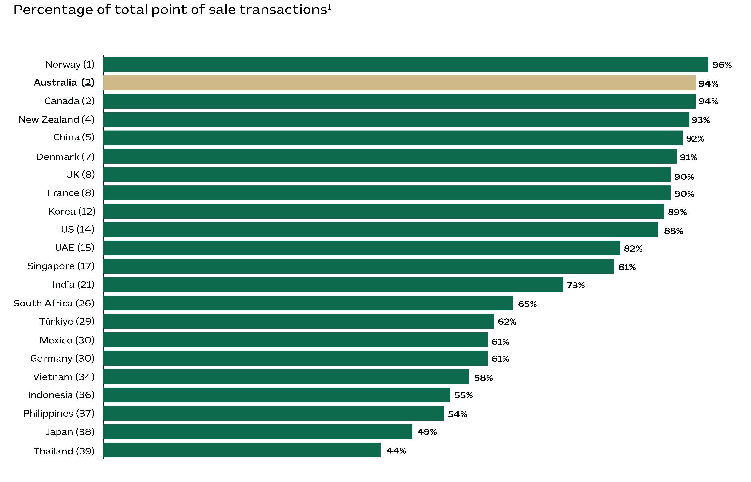

**Note: 1.** All person-to-business transactions that occur at the physical point of sale. This includes traditional in-store transactions as well as all face-to-face transactions, regardless of where they take place.

**Source:** Worldpay from FIS, 2024, The Global Payments Report 2023, accessed on 13 March 2024; Austrade.

Chapter 2 – Australia: A global resource for a net zero future

A partner of choice in a net zero world

Given our critical and abundant natural endowments, Australia is well positioned to strengthen priority supply chains and become an indispensable part of the net zero global economy.

Our natural resources will help drive the global net zero transformation. This is complemented by the reputation we have established as a safe and profitable destination for investment. As a result, Australia is the 5th-most attractive destination in the world for investment in renewable energy.

Australia offers significant economic opportunities to help reduce global emissions with our vast renewable energy potential and our plentiful mineral resources. These include renewable hydrogen, green metals and critical minerals processing, along with manufacturing for a net zero transition.

Minerals are a core asset. The Australian continent has vast reserves of minerals that are vital to the global transformation to net zero. We are already the world’s largest producer of lithium and iron ore, and have the largest known reserves of zinc, nickel and iron ore. Australia also has the 2nd-largest reserves of lithium, cobalt and tantalum, and the 6th-largest reserves of rare earth minerals.

Solar power is growing rapidly thanks to great geography, ideal weather and supportive market regulation. As a result, Australia is the largest producer of solar energy per person in the world. Australia also has the theoretical potential for 5,000 gigawatts of offshore wind generation, which is greater than the combined output of all the world’s coal-fired power stations.

Australia is set to become a major global producer of clean hydrogen. Currently, more than 100 major hydrogen projects are under development across the country. A significant number of these projects focus on green hydrogen, taking advantage of our abundant wind and solar power.

Finally, there is a supportive policy environment, including the Australian Government’s ambitions for a Future Made in Australia that aims to encourage and facilitate private sector investment.

A natural leader in clean energy

Australia has a comparative advantage in renewable energy thanks to world-leading, large-scale resources. Our continent receives the highest level of solar radiation per square metre globally, making it one of the best locations for solar energy. Additionally, Australia boasts some of the best wind resources, with vast onshore and offshore areas that have consistent, high-speed winds suitable for energy generation. These two factors make Australia an attractive place to invest in wind and solar power. Australia also has ambitious emissions-reduction targets: 43% below 2005 levels by 2030 and net zero by 2050, which helps provide investors with certainty on our energy transition.

Figure 9 – Australia’s renewable energy credentials

The infographic shows the following information:
A$300 billion in potential hydrogen investments1
Over 100 major hydrogen projects planned2
+37,000 km2 of future wind generation3
Larger than the surface area of Belgium or the Netherlands
The 2nd highest potential for solar power4
6th-largest producer of solar energy5
Sufficient to power 7 million homes6
1st in per capita terms⁵
Almost 40,000 renewable energy patents in two decades7
7th for renewable energy patents per head7
10,700 patents in solar technologies7
4,000 patents in wind technologies7
4,000 patents in bioenergy technologies7
Largest producer of lithium in the world
Largest reserves of nickel, zinc and
iron ore
2nd largest reserves of lithium, copper, cobalt and tantalum8
5th-most attractive country for renewable energy investment9
9.3 terawatt-hours more of solar and wind energy in one year10
Target of 82% of power from renewables by 203011


**Sources: 1.** Department of Climate Change, Energy, the Environment and Water, 2024, Australia’s National Hydrogen Strategy. **2.** Geoscience Australia, 2022, Australian Hydrogen projects dataset, September 2022. **3.** Department of Climate Change, Energy, the Environment and Water, 2024, Australia's offshore wind areas. **4.** The World Bank, 2023, Global photovoltaic power potential by country. **5.** The World Bank, 2024, The World Bank open data; U.S. Energy Information Administration, 2024, Electricity data; Worldometer, 2024, Population by country; all accessed on 19 April 2024, Austrade. **6.** Frontier Economics, 2020, Residential energy consumption benchmarks. **7.** IRENA, 2022, Patents evolution; Worldometer, 2022, Population by country. **8.** Geoscience Australia, 2024, Australia’s Identified Mineral Resources; US Department of the Interior, 2024, Mineral Commodity Summaries. **9.** EY, 2024, Renewable Energy Country Attractiveness Index 2023. **10.** Department of Industry, Science, Energy and Resources (2024) Australian Energy Statistics. **11.** Department of Climate Change, Energy, the Environment and Water, 2022, Government backs next-generation renewable technology; Austrade.

Abundant minerals for a net zero transformation

Australia is a secure and reliable source of minerals. And with abundant reserves and an advanced mining industry, Australia will remain a top exporter of minerals. Australia boasts the largest reserves of iron ore including magnetite and high-grade hematite, which are ideal for green steel production. We are also the world’s largest producer of lithium, which is in high global demand owing to the popularity of lithium batteries. Australia boasts the world's largest reserves of zinc and nickel, and is also becoming a key supplier of multiple rare earth minerals. And Australia is a promising destination for fresh investment. About 80% of our land is still largely unexplored, offering vast potential for discovering new mineral deposits.

Figure 10 – Australia’s minerals - Global ranking for production and reserves, 2022

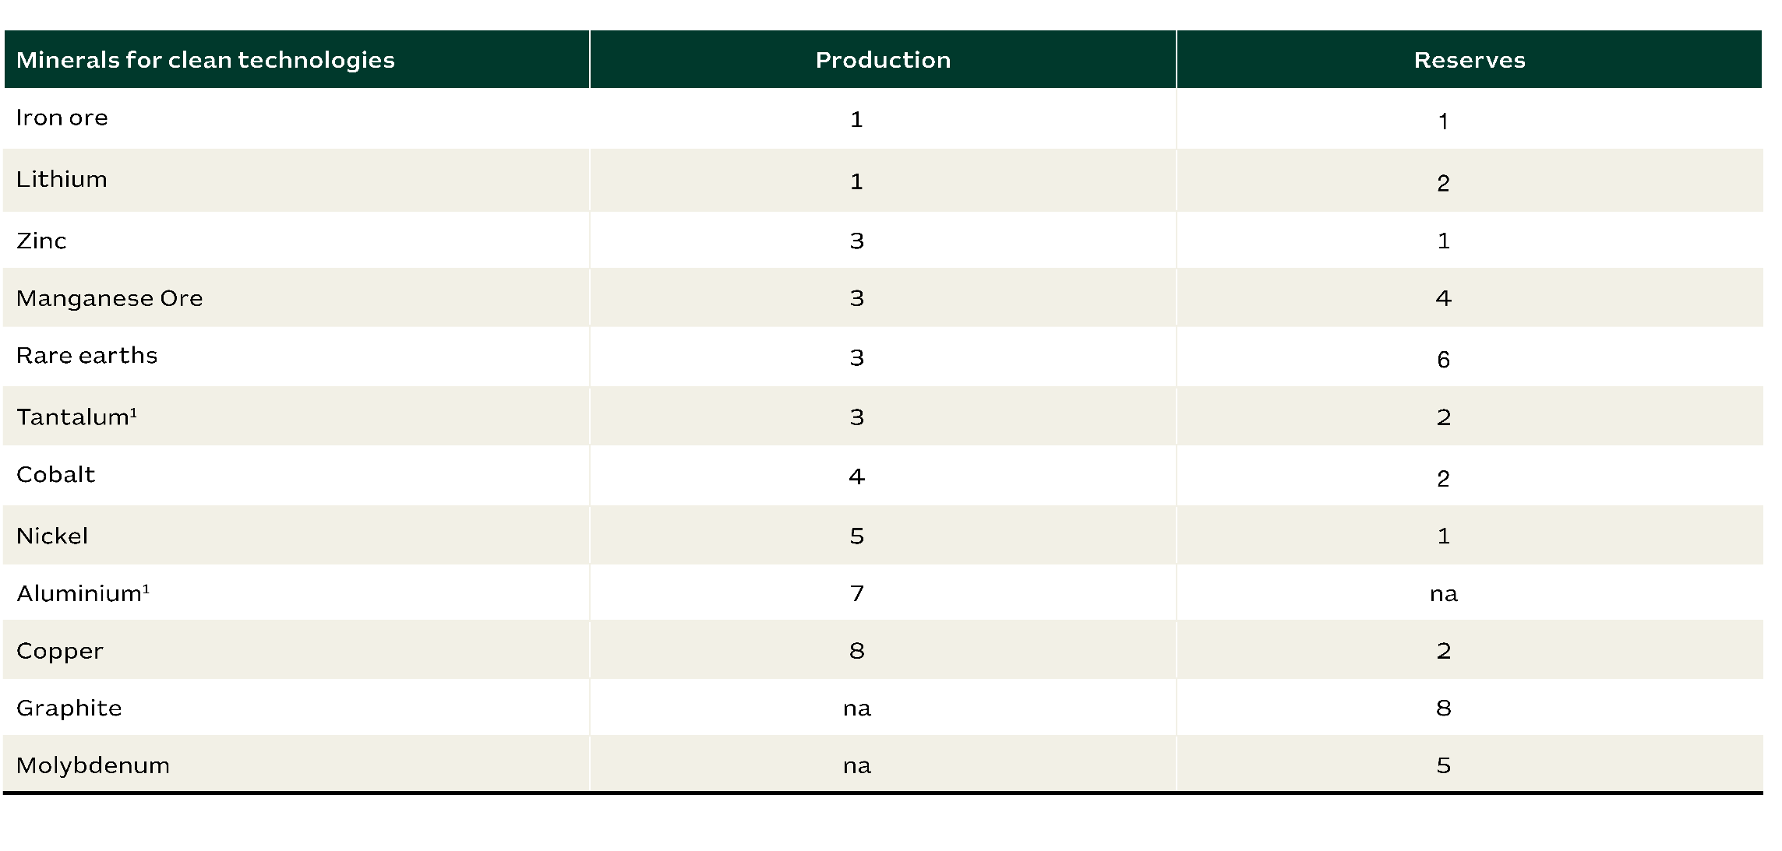

**Note: 1.** Information for 2023.

**Sources:** Geoscience Australia, 2024, Australia’s Identified Mineral Resources; US Department of the Interior, 2024, Mineral Commodity Summaries; Austrade.

A top destination for renewables investment

Australia is a top-tier location for investment in renewable energy. In fact, EY ranked Australia as the 5th-most attractive destination in the world for renewable energy investment in 2023. This measure takes into account factors such as energy demand, policy reliability, project stability and delivery, and the diversity of natural resources.

Figure 11 – Renewable energy region attractiveness

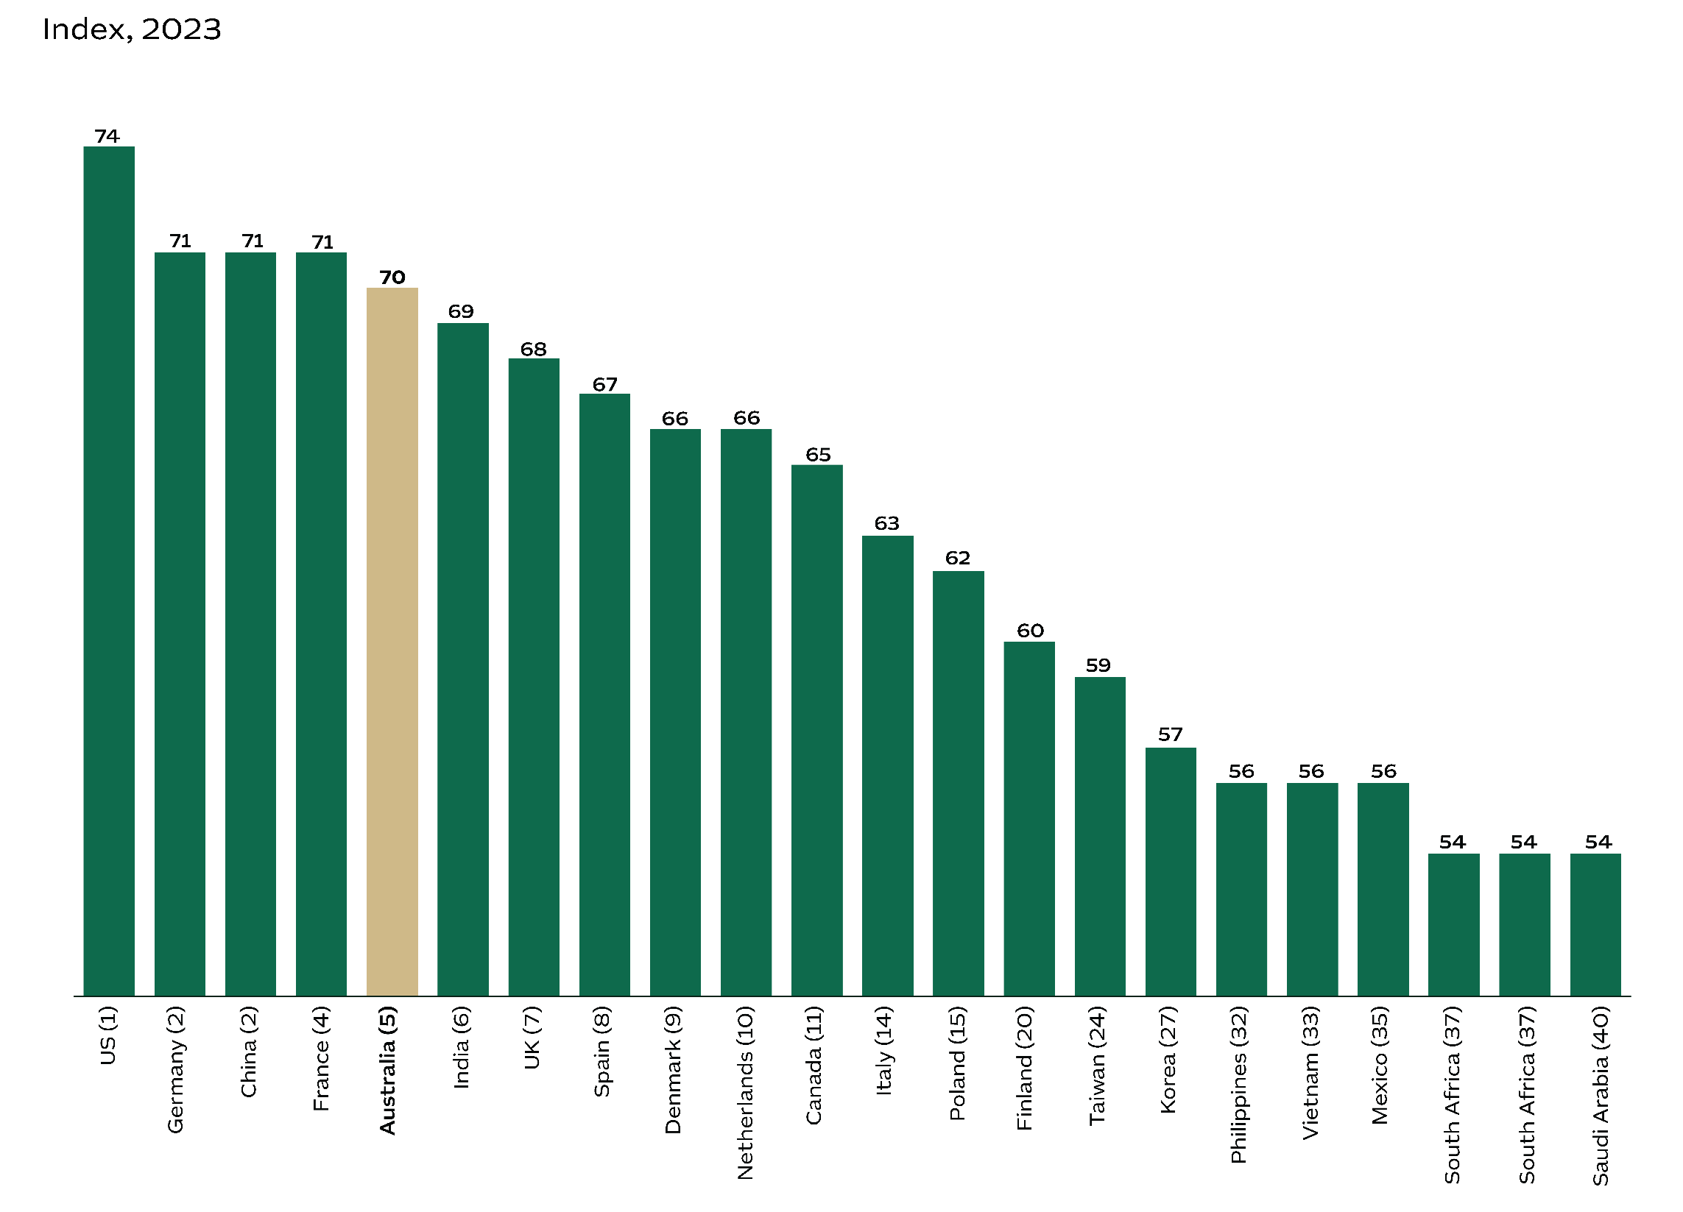

**Source:** EY, 2024, Renewable Energy Country Attractiveness Index 2023, accessed February 2024, Austrade.

Rapid growth in renewable energy

Renewables are delivering a fast-growing share of Australia’s energy production. Over the past eight years, Australia’s renewable electricity production has nearly tripled, thanks to solar and wind power. In 2023 alone, these two sources contributed an additional 9.3 terawatt-hours of renewable energy to Australia's grids. Looking forward, Australia is targeting 82% renewable energy in our electricity grids by 2030. To meet this target, the country's electricity grid will need significant upgrades, which will open up new opportunities for investment.

Figure 12 – Australia’s renewable energy generation volumes and world rankings

The graph plots Australia's renewable energy generation by year and type. 
The graph contains the following information: 
Hydropower 14.21 TWh in 2015, 17.93 TWh in 2016, 13.75 TWh in 2017, 17.53 TWh in 2018, 14.39 TWh in 2019, 14.81 TWh in 2020, 16.38 TWh in 2021, 17.37 TWh in 2022, 15.98 TWh in 2023.  Wind energy 11.83 TWh in 2015, 13.04 TWh in 2016, 13.21 TWh in 2017, 16.26 TWh in 2018, 19.47 TWh in 2019, 22.61 TWh in 2020, 26.8 TWh in 2021, 30.05 TWh in 2022, 31.87 TWh in 2023. Solar PV 6.2 TWh in 2015, 7.44 TWh in 2016, 8.92 TWh in 2017, 12.33 TWh in 2018, 18.3 TWh in 2019, 23.84 TWh in 2020, 31.19 TWh in 2021, 37.54 TWh in 2022, 44.99 TWh in 2023.  Bioenergy 3.68 TWh in 2015, 3.63 TWh in 2016, 3.56 TWh in 2017, 3.59 TWh in 2018, 3.47 TWh in 2019, 3.41 TWh in 2020, 3.34 TWh in 2021, 3.19 TWh in 2022, 3.13 TWh in 2023. TOTAL 253.98 TWh in 2015, 258.22 TWh in 2016, 258.97 TWh in 2017, 262.63 TWh in 2018, 265.9 TWh in 2019, 265.16 TWh in 2020, 267.45 TWh in 2021, 272.92 TWh in 2022, 273.11 TWh in 2023. Renewables % of total electricity generation (right-hand side) 3.7% in 2015; 3.6% in 2016; 3.6% in 2017; 3.6% in 2018; 3.5% in 2019; 3.4% in 2020; 3.3% in 2021; 3.2% in 2022; 3.1% in 2023. 


**Sources:** U.S. Energy Information Administration, 2023, International energy statistics; Department of Industry, Science, Energy and Resources (2024) Australian Energy Statistics; Department of Climate Change, Energy, the Environment and Water, 2023, Government backs next-generation renewable technology, December 2022; Snowy Hydro, 2024, About Snowy 2.0; Austrade.

Solar power: Australia’s next gold rush

Australia is one of the best locations for solar energy globally. The Australian continent receives the highest level of solar radiation per square metre in the world and our nation was ranked as having the 2nd-highest potential for solar power. Australians are also keen adopters of solar power for domestic use with over 3.7 million photovoltaic (PV) installations by late 2023. These installations collectively generate over 34 gigawatts of power. This strong consumer uptake is helping to drive investment in the solar industry in Australia, and demand for power-storage technologies.

Figure 13 – Solar power potential¹, top 20 regions

The graph plots the solar power potential for the top 20 regions, expressed in terawatts per day. The information, including each country's ranking in brackets, is as follows:
Russia (1) 51 trillion; Australia (2) 44 trillion; Brazil (3) 44 trillion; US (4) 41 trillion; China (5) 39 trillion; Canada (6) 30 trillion; India (7) 15 trillion; Algeria (8) 14 trillion; Argentina (9) 14 trillion; Saudi Arabia (10) 13 trillion; Congo (11) 12 trillion; Mexico (12) 11 trillion; Libya (13) 11 trillion; Kazakhstan (14) 10 trillion; Iran (15) 9 trillion; Indonesia (16) 8 trillion; Niger (17) 8 trillion; Chad (18) 8 trillion; Mali (19) 7 trillion; and Angola (20) 7 trillion.

**Note: 1.** Measured by theoretical potential solar photovoltaic power.

**Sources:** The World Bank, 2023, Global photovoltaic power potential by country; Geoscience Australia, 2023, Australia’s solar energy resources and production; US Office of Energy Efficiency and Renewable Energy, 2023, How much power is 1 gigawatt?; Australian Photovoltaic Institute, 2024, Market Analyses (apvi.org.au); Austrade.

The southern hemisphere’s solar powerhouse

Australia was ranked the world's 6th-largest producer of solar power in 2022, generating a total of 40 terawatt-hours. Australia now produces nearly double the solar power of Mexico and the UK combined. In per capita terms, Australia became the world's largest producer of solar electricity in 2022 at 1,500 kilowatt-hours (kWh) generated per person. This was higher than the Netherlands (997 kWh per person), Japan (745 kWh per person) and Germany (691 kWh per person). Mega projects include the 26 gigawatt Australian Renewable Energy Hub (AREH). Located in the Pilbara region of Western Australia, the 6,500 km2 wind and solar AREH project will export green hydrogen.

Figure 14 – Electricity generated by solar – selected regions

The graph plots the electricity generated by solar energy in 2022, expressed in terawatts-hour per capita. 
The information, including each country's ranking in brackets, is as follows: Russia (1) 51 trillion; Australia (2) 44 trillion; Brazil (3) 44 trillion; US (4) 41 trillion; China (5) 39 trillion; Canada (6) 30 trillion; India (7) 15 trillion; Algeria (8) 14 trillion; Argentina (9) 14 trillion; Saudi Arabia (10) 13 trillion; Congo (11) 12 trillion; Mexico (12) 11 trillion; Libya (13) 11 trillion; Kazakhstan (14) 10 trillion; Iran (15) 9 trillion; Indonesia (16) 8 trillion; Niger (17) 8 trillion; Chad (18) 8 trillion; Mali (19) 7 trillion; and Angola (20) 7 trillion.


**Note: 1.** The number in brackets indicates the economy’s ranking across 210 economies.

**Sources:** The World Bank, 2024, The world bank open data; U.S. Energy Information Administration, 2024, Electricity data; Worldometer, 2024, Population by country; all accessed on 19 April 2024, Austrade.

Efficient solar power generation

Australia’s competitiveness in solar power is due to its weather, ideal geography, supportive regulation and an efficient market. Our costs for solar power production fell by 91% from 2010 to 2024 and IRENA now ranks Australia as the 5th-most affordable nation for large-scale solar power production in the world. These low generating costs are set to attract further investment in solar power and associated grid infrastructure.

Figure 15 – Cost of solar power generation by region¹, 2022

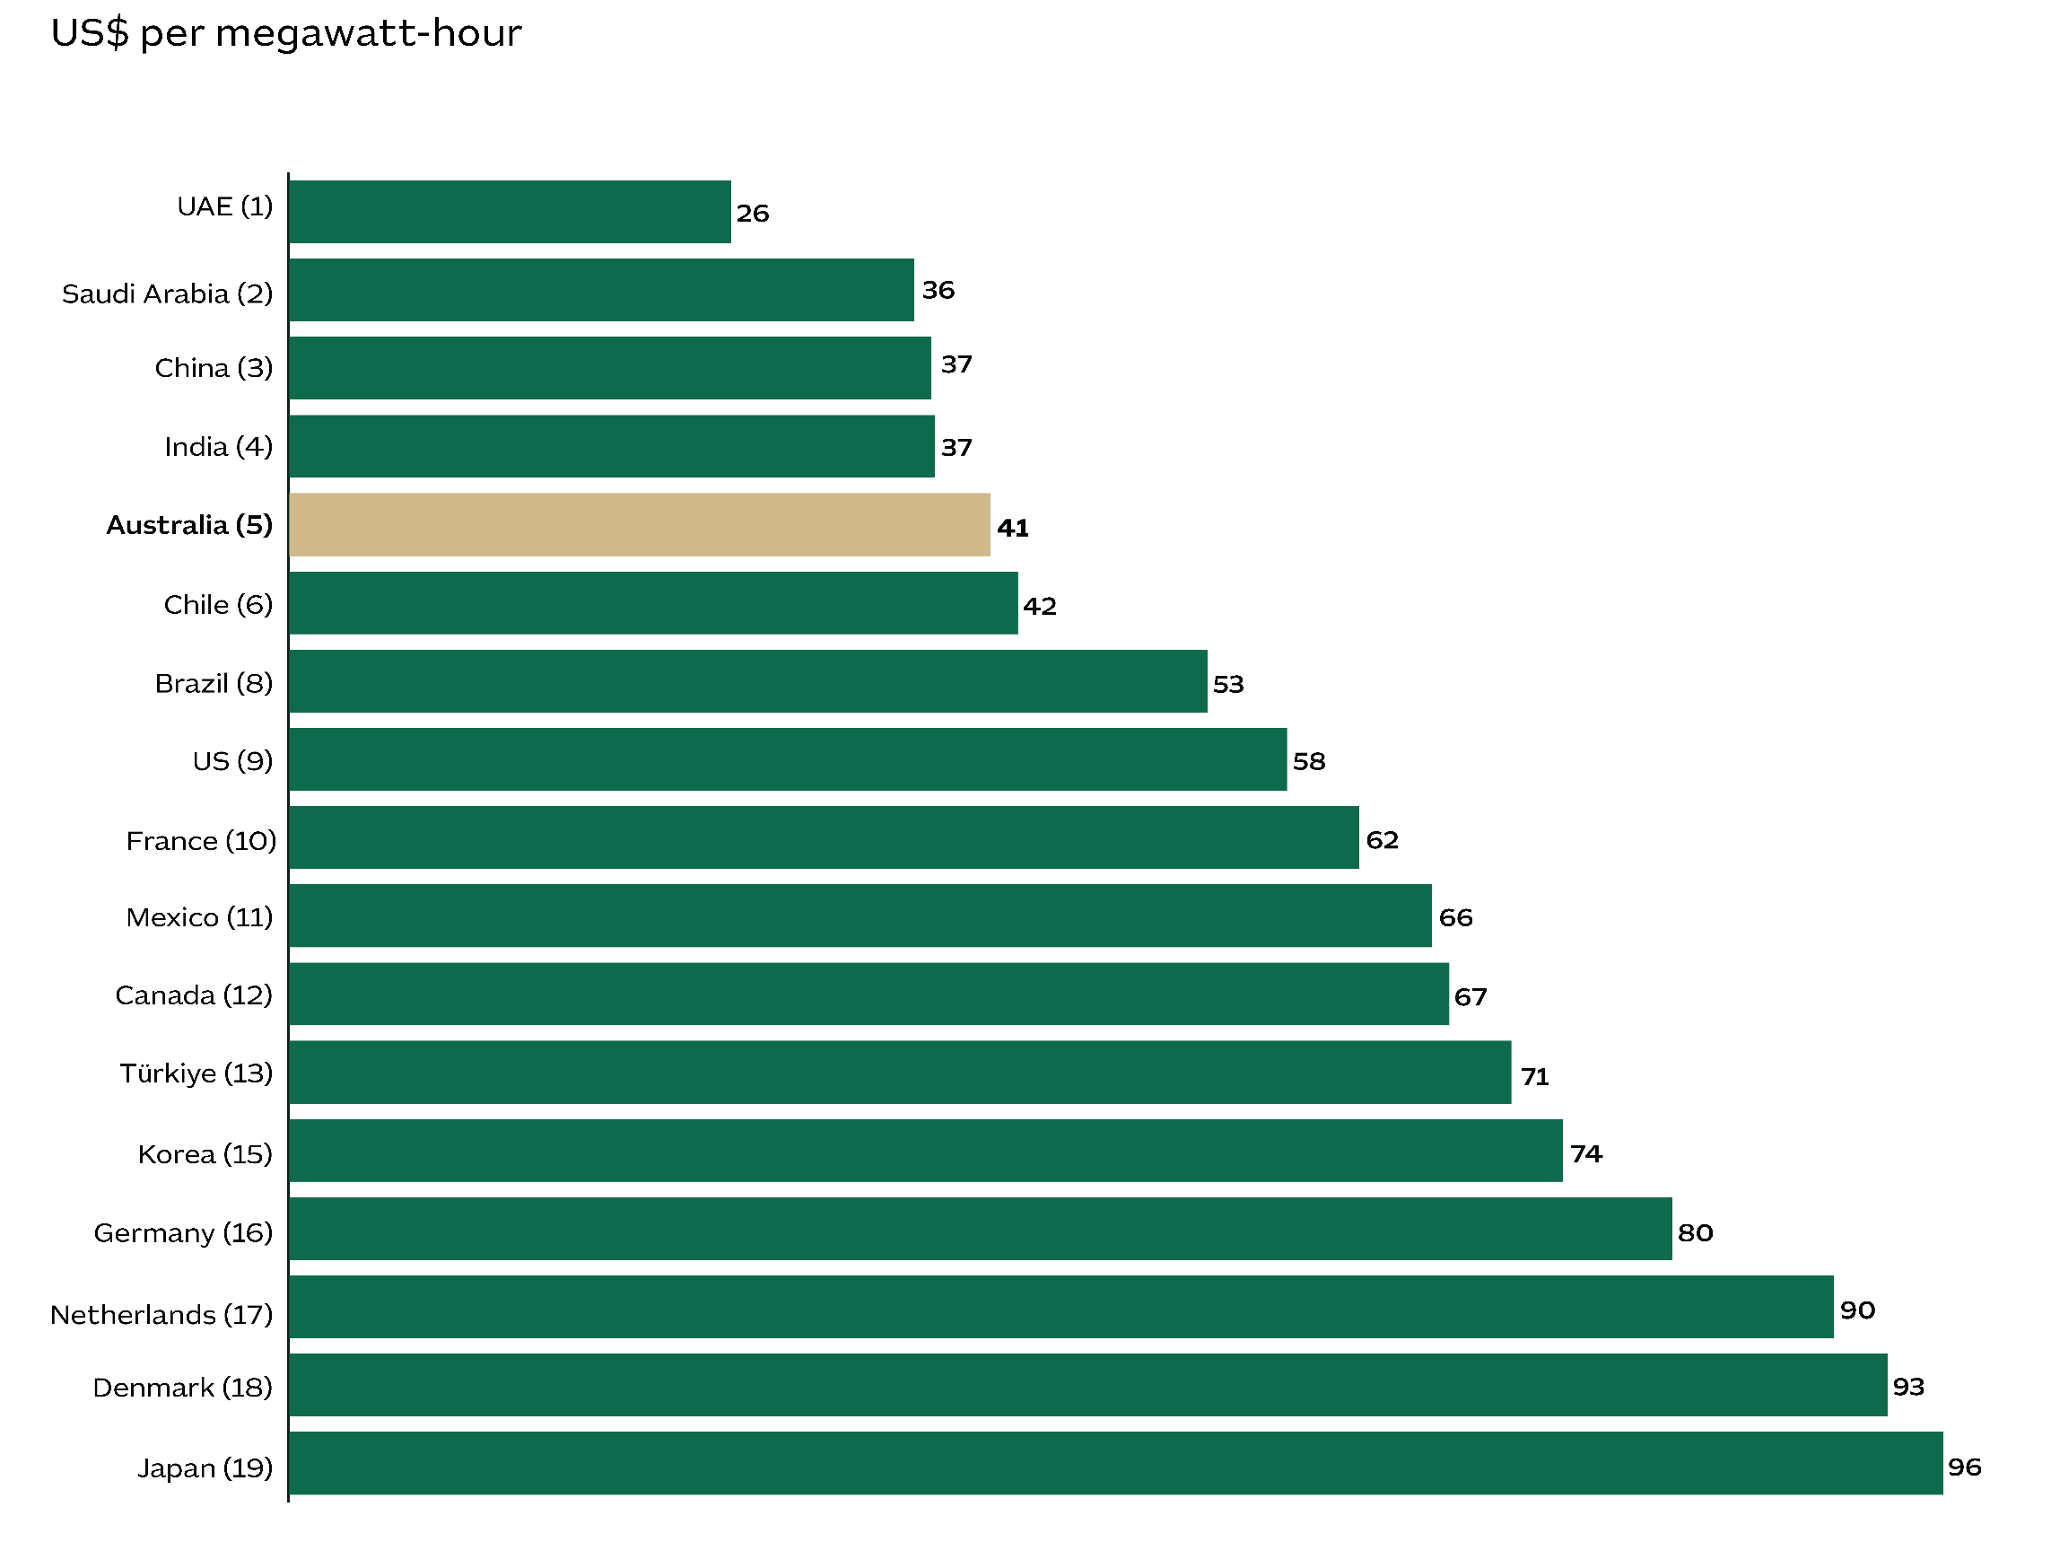

**Note: 1.** The ranking is based on the average levelised cost of energy (LCOE) from a solar photovoltaic (PV) utility-scale plant across the top 20 producers. The LCOE measures the cost of producing a unit of energy, taking into account the cost of the PV technology, capital expenditure, operation costs, and the discount rate over the typical PV plant lifetime.

**Source:** IRENA, 2023, Renewable Power Generation Costs in 2022, International Renewable Energy Agency, Abu Dhabi; Austrade.

Investment in industrial-scale hydrogen

Australia is on track to be a global leader in hydrogen. Over 100 hydrogen projects are in active development with up to A$300 billion in potential hydrogen investments. Abundant wind and solar power are supporting a rapid scaling of green hydrogen projects with Australia set to become an exporter of green hydrogen to high-demand hubs in Asia like Japan, Singapore and Korea. In fact, the International Energy Agency (IEA) recognises Australia – along with Europe – as a leader in the development of the global hydrogen industry.

Figure 16 – A sample of hydrogen projects in Australia

The map shows key hydrogen projects in Australia. When available, the expected production weight is shown in megawatts.
The project names by state/territory are:
Queensland: Edify Green Hydrogen Project (1,000); HyNQ (>1,000); Central Queensland Hub (>5,000); and Gibson Island Green Ammonia Feasibility (550).
Western Australia: Australian Renewable Energy Hub (26,000); Western Green Energy Hub (50,000); HyEnergy Project; Murchison Hydrogen Renewables (3,000) ; H2Kwinana (418); and H2Perth (250).
South Australia: Cape Hardy Hub (>10,000); and Hydrogen Jobs Plan Whyalla (200).
Tasmania: Bell Bay Powerfuels (240); H2TAS (300); and HIF Tasmania eFuels (250).
Northern Territory: Green Springs Project (10,000); Darwin Hub (>1,000); and Tiwi H2 (1,400).
New South Wales: Hunter Hub (>2,000); and Illawarra Hub (>1000).
Victoria: Liquefied Hydrogen Supply Chain Commercial Demonstration Project; ad Hydrogen Portland (220). 


**Notes: 1.** The numbers in brackets indicate projects’ potential capacity in megawatts. **2.** Not all key hydrogen projects were included in the figure. Please refer to <https://www.csiro.au/en/maps/hydrogen-projects/> for a more comprehensive list.

**Sources:** Reuters, 2022, World’s first hydrogen tanker to ship test cargo to Japan from Australia; International Energy Agency, 2022, Global hydrogen review 2022; CSIRO, 2023, Hydrogen map; Geoscience Australia, 2022, Australian Hydrogen Projects dataset, September 2022; Government of South Australia, 2023, Port Bonython Hydrogen Hub; Goyder Renewables Zone, 2023, Renewable energy for South Australia; Department of Climate Change, Energy, the Environment and Water, 2024, Australia’s National Hydrogen Strategy; Austrade.

Chapter 3 – Our skills and innovation

Top performers: from academia to quantum and beyond

Australia is a highly-skilled nation. Our technical colleges develop the skills needed by local industry, including agriculture and mining. Meanwhile, our universities create a highly capable professional workforce and entrepreneurs that power innovation in everything from medical technology to renewable energy.

Australia is the 7th-largest spender on education in the world. This investment helps to generate the skills we need for our dynamic and advanced economy. Expenditure on formal education in Australia is equivalent to 6.2% of our GDP. As a result, Australia’s workforce is highly qualified as almost half of our workers hold a tertiary qualification. Our workforce is also adaptive to change with Australia ranked 1st in the world for our skills in using, adapting and adopting emerging technologies.

We are also a top performer in the provision of higher education. Australia has more universities in the world’s top 100 than any other country outside of the US, China and the UK. Our scientific publications are highly ranked globally in terms of their impact in 19 separate academic fields, which include space science, clinical medicine, engineering and microbiology. A tradition of collaboration helps transform innovative research into functional solutions and new products.

Australians have established a global reputation for creating new technologies in niche industries where we have a competitive advantage. These include mining and resources, renewable energy, agriculture, finance, health and education. Our organisations outperform our peers in the adoption of quantum computing, artificial intelligence (AI) and robotics.

Australia has long supported businesses with favourable tax incentives, like [R&D tax incentives](https://business.gov.au/grants-and-programs/research-and-development-tax-incentive) and [Venture Capital Limited Partnerships](https://business.gov.au/grants-and-programs/venture-capital-limited-partnerships). These efforts have helped drive innovation and commercialisation across various sectors. Our ongoing industry and technology strategies also demonstrate a strong commitment to groundbreaking technologies like quantum computing, AI, and robotics. Investing in people is a key part of Australia's approach to developing skills and fostering innovation. This includes consistent efforts to promote diversity in science, technology, engineering, and mathematics (STEM).

Australia’s smart tech sectors

Australia is a magnet for tech developers, spurred on by an environment where scholars and entrepreneurs work together. Our innovators have used blockchain to revolutionise parts of the financial services industry, championed immersive simulation in education, transformed medical procedures using robotics, and modernised agriculture using Internet of Things (IoT) designs. Today, Australia has a reputation for being a pioneer in silicon-based quantum computing research. Our ability to problem-solve using new technologies draws investors and entrepreneurs from around the world.

Figure 17 – Australia’s tech credentials

The infographic shows the following information:
A$45 billion fintech industry¹
Ranked 6th in the world2 
Over 800 fintech companies in 2023¹
46% of fintechs raised over A$10 million each in 20233
+$200 billion per year boost from AI utilisation8
150,000 additional jobs from AI⁸
Over 650 AI companies in 2024⁹
#5 for healthcare innovation4
Around 700 biotech and medtech companies5
US$6.6 billion medical device market in 20236
US$192 billion spent on health in 2023. This places Australia as the 5th-highest in the world for health expenditure per capita.7
A$6 billion quantum industry by 2045¹⁰
28 quantum-focussed companies in Australia ¹¹
#13 in number of quantum startup companies¹²
A$1 billion investment in one quantum computer ¹³


**Sources: 1.** Fintech Australia, 2024, What is fintech? **2.** Findexable, 2021, Global Fintech Rankings Report, accessed April 2024. **3.** EY, 2024, FinTech Australia Census 2023, accessed April 2024. **4.** Foundation for Research on Equal Opportunity, 2024, Australia: #5 in the 2022 World Index of Healthcare Innovation. **5.** AusBiotech, 2024, Biotech Sector Fast Facts **6.** Fitch Solutions, 2024, Australia Medical Devices Report Q2 2024. **7.** Fitch Solutions, 2024, Worldwide Medical Devices Market Factbook. **8.** Mangan, J., 2024, Australia’s AI Imperative: The economic impact of artificial intelligence and what’s needed to further its growth. **9.** Crunchbase, 2024, Build Query: Hubs. **10.** CSIRO, 2022, Growing Australia's Quantum Technology Industry **11.** Australia’s Chief Scientist, 2023, Australia's expertise and offering in quantum **12.** Office of the NSW Chief Scientist & Engineer, 2024, Quantum Algorithms and Applications. **13.** Department of Industry, Science and Resources, 2024, Leading quantum company chooses Australia as site for its groundbreaking utility scale quantum computer; Austrade.

#1 for new tech skills

Australia scores a top ranking for skills in using, adapting and adopting emerging technologies. This makes us a standout for international investors. Oxford Insights ranks Australia as one of the top eight governments in the world in terms of capacity to benefit from AI. They also rank us 3rd for data infrastructure and support. Great Australian inventions include the electronic pacemaker, polymer bank notes, the inflatable aircraft escape slide, the human papilloma virus vaccine, Google Maps, Wi-Fi and the cochlear implant.

Figure 18 – Skills for using, adopting and adapting frontier technologies¹, 2021

The bar chart shows an index measuring an economy (country)’s skills for using, adopting and adapting frontier technologies in 2021.The content behind the graph is:
Australia (ranked #1) index value 100; Sweden (ranked #2) index value 95; Finland (ranked #5) index value 90; Norway (ranked #6) index value 89; Singapore (ranked #8) index value 88; Netherlands (ranked #9) index value 86; New Zealand (ranked #10) index value 86; UK (ranked #12) index value 83; Germany (ranked #17) index value 78; US (ranked #18) index value 77; Canada (ranked #21) index value 74; Hong Kong SAR (ranked #22) index value 73; France (ranked #24) index value 73; Korea (ranked #26) index value 72; Saudi Arabia (ranked #44) index value 60; Japan (ranked #51) index value 56; China (ranked #92) index value 43; Indonesia (ranked #107) index value 36; India (ranked #109) index value 36; and Vietnam (ranked #116) index value 33.


**Note: 1.** The number in brackets indicates the economy’s ranking across 158 economies. 2021 is the latest year available as of April 2024.

**Sources:** United Nations Conference on Trade and Development, 2024, Frontier technology readiness index, accessed during April 2024; Oxford Insights, 2024, AI readiness index 2023; Austrade.

A leader in digital government

The Australian Government is an early adopter. In 2022, we ranked 7th among 193 governments in the United Nations E-Government Development Index (EGDI).² The transition to online services enhances the efficiency of official communications, with Australia’s *myGov* being a prime example. This is Australia’s centralised portal for health, tax and welfare services. Advanced digital services also make it relatively straightforward to set up a business in Australia. Firstly, an Australian Business Number is needed to operate a business, which can be registered online. Depending on the business type, registration for various taxes may also be needed like the Goods and Services Tax (GST) and Pay As You Go (PAYG). For more details, visit Australia’s [Business Registration Service](https://register.business.gov.au/).

Figure 19 – E-Government index by region, selected regions¹

The graph shows the E-Government index by region in 2022. The information presented is as follows:
Denmark ( ranked #1): Online Service  0.33 Telecommunications-Infrastructure 0.33  Human Capital 0.32 Total 0.97 - Finland ( ranked #2): Online Service  0.33 Telecommunications-Infrastructure 0.33  Human Capital 0.32 Total 0.95 - Korea ( ranked #3): Online Service  0.33 Telecommunications-Infrastructure 0.33  Human Capital 0.30 Total 0.95 - New Zealand ( ranked #4): Online Service  0.32 Telecommunications-Infrastructure 0.32  Human Capital 0.33 Total 0.94 - Sweden ( ranked #5): Online Service  0.30 Telecommunications-Infrastructure 0.30  Human Capital 0.32 Total 0.94 - Iceland  ( ranked #5): Online Service  0.30 Telecommunications-Infrastructure 0.30  Human Capital 0.32 Total 0.94 - Australia ( ranked #7): Online Service  0.31 Telecommunications-Infrastructure 0.31  Human Capital 0.33 Total 0.94 - Netherlands  ( ranked #9): Online Service  0.30 Telecommunications-Infrastructure 0.30  Human Capital 0.32 Total 0.94 - USA ( ranked #10): Online Service  0.31 Telecommunications-Infrastructure 0.31  Human Capital 0.31 Total 0.92 - UK ( ranked #11): Online Service  0.30 Telecommunications-Infrastructure 0.30  Human Capital 0.31 Total 0.91 - Singapore ( ranked #12): Online Service  0.32 Telecommunications-Infrastructure 0.32  Human Capital 0.30 Total 0.91 - Japan ( ranked #14): Online Service  0.30 Telecommunications-Infrastructure 0.30  Human Capital 0.29 Total 0.90 - Norway  ( ranked #17): Online Service  0.27 Telecommunications-Infrastructure 0.27  Human Capital 0.32 Total 0.89 - Canada ( ranked #32): Online Service  0.28 Telecommunications-Infrastructure 0.28  Human Capital 0.31 Total 0.85 - Europe ( ranked #na): Online Service  0.26 Telecommunications-Infrastructure 0.26  Human Capital 0.29 Total 0.83 - China ( ranked #43): Online Service  0.30 Telecommunications-Infrastructure 0.30  Human Capital 0.25 Total 0.81 - Mexico ( ranked #62): Online Service  0.27 Telecommunications-Infrastructure 0.27  Human Capital 0.26 Total 0.75 - Indonesia ( ranked #77): Online Service  0.25 Telecommunications-Infrastructure 0.25  Human Capital 0.25 Total 0.72 - Vietnam ( ranked #86): Online Service  0.22 Telecommunications-Infrastructure 0.22  Human Capital 0.23 Total 0.68 - Asia ( ranked #na): Online Service  0.20 Telecommunications-Infrastructure 0.20  Human Capital 0.24 Total 0.65 - World ( ranked #na): Online Service  0.19 Telecommunications-Infrastructure 0.19  Human Capital 0.23 Total 0.61 - India ( ranked #105): Online Service  0.26 Telecommunications-Infrastructure 0.26  Human Capital 0.19 Total 0.59 - Africa ( ranked #na): Online Service  0.12 Telecommunications-Infrastructure 0.12  Human Capital 0.16 Total 0.41.


**Notes: 1.** The number in brackets indicates the country’s ranking across 193 countries. **2.** The E-Government Development Index (EGDI) measures the degree of digitalisation by the public service. The EDGI is based on the weighted average of three indices: the telecommunications infrastructure index, the online service index and the human capital index.

**Sources:** United Nations Department of Economic and Social Affairs, 2024, E-Government Survey 2022; Austrade.

A pioneer in renewables R&D

Australia is a significant contributor to R&D in renewable energy. Patent registration in Australia is exceptionally high with Australians registering 10,700 patents in solar technologies and 4,000 patents in wind energy between 2000 and 2022. In terms of total renewable energy patents per person, Australia ranks 7th in the world, which is just behind Germany and ahead of the US. High patent registrations demonstrate that Australia’s business and research sectors are developing innovative and practical ways to address the challenges related to renewable energy.

Figure 20 – Renewable energy patents by economy

The graph plots the number of renewable energy patents per million persons in different economies from 2000 to 2022.
The information, including each region's ranking in brackets, is as follows: Korea (1) 5110; Japan (2) 3689; Denmark (3) 2368; San Marino (4) 2228; Taiwan (5) 2151; Germany (6) 1910; Australia (7) 1723; US (8) 1517; Canada (9) 1454; Austria (10) 1314; Singapore (11) 1139; China (12) 1090; New Zealand (14) 740; Hong Kong SAR (16) 632; Norway (17) 629; France (22) 432; UK (24) 359; Sweden (29) 238; Netherlands (33) 183; and Italy (40) 115. 

**Notes: 1.** This includes diverse sources of energy such as biofuels, waste-derived fuel, geothermal energy, heat pumps, hydropower, marine energy, PV-thermal hybrid, solar photovoltaic, solar thermal and wind energy. It also covers 'enable technologies,' as defined by IRENA. **2.** There is a delay between the submission of data and its official publication as patents. For this reason, data from recent year is not presented in the charts.

**Sources:** The World Bank, 2024, Population; IRENA, 2024, INSPIRE, Data provided by the Innovation for the Energy Transition Division of IRENA; Austrade.

Advanced research in hydrogen

Australian researchers are pioneering new technologies in solar power, renewable hydrogen and battery storage. For example, Australia’s lead science agency, the CSIRO is leading efforts to create a commercially sustainable hydrogen industry in Australia. The International Energy Agency (IEA) ranks Australia among the top three countries in the world for per-capita public spending on R&D in hydrogen and fuel cell technologies.

Figure 21 – Public spending on R&D for hydrogen and fuel cells

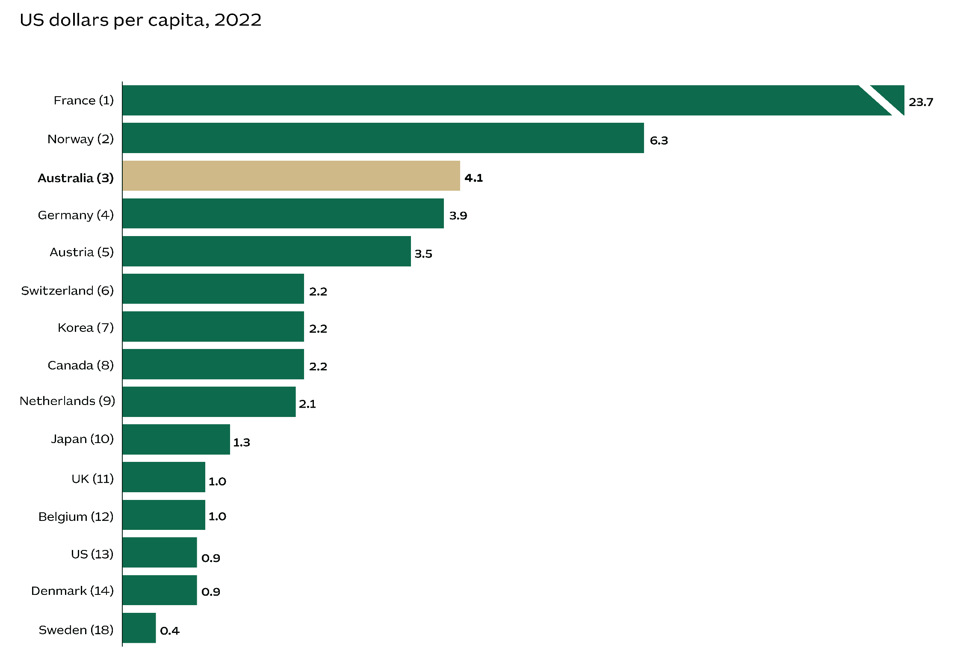

**Note: 1.** The number in brackets indicates the economy’s ranking across 33 IEA members and associate countries.

**Sources:** The World Bank, 2024, Population; Worldometer, 2022 Population by country; IRENA, 2022, Patents evolution; accessed December 2022; International Energy Agency, 2024, Energy Technology R&D Budgets; Austrade.

Academic excellence — from neuroscience to space

Australian scientific publications are highly ranked globally in terms of their impact in 19 academic fields. Our expertise is broad based, ranking ‘very high’ in computer science, space science, clinical medicine, molecular biology and genetics, physics, materials science, and engineering. We also ranked ‘high’ in fields like chemistry, geosciences, microbiology, neuroscience and behaviour, and immunology. Many Australian scientific research publications consistently perform at least 20% better than the worldwide average in terms of impact.

Figure 22 – Relative impacts of Australian scientific publications by research field, 2018–22

The bar chart shows the index of relative impacts of Australian scientific publications by research field from 2018 to 2022.
The very highly ranked Australian fields are: Engineering (1.52); Multidisciplinary (1.54); Materials science (1.56); Physics (1.61); Molecular biology & genetics (1.61); Clinical medicine (1.63); Space science (1.69); and Computer science (1.74).
The highly ranked Australian fields are: Psychiatry/psychology (1.25); Social sciences, general (1.27); Immunology (1.29); Plant & animal science (1.3); Environment/ecology (1.34); Neuroscience & behaviour (1.36); Biology & biochemistry (1.37); Microbiology (1.37); Geosciences (1.37); and Chemistry (1.43).
Other not highly ranked Australian fields are: Agricultural sciences (1.15); Economics & business (1.18); Pharmacology & toxicology (1.18); and Mathematics (1.21).
The global average is 1.0.

**Sources:**  InCites™, Clarivate Analytics, 2022, InCities dataset, accessed 26 March 2024; Austrade.

Skilled workforce and innovation indicators

Australia’s strength in skills and innovation rests on multiple foundations that include excellent schooling, openness to migration, mobility and a diverse workforce. We benefit from a combination of regulatory standards that ensure qualifications are world-class and a culture of continuous learning. This is supported by a network of tertiary education institutions that work closely with local industry to produce meaningful research, innovations, and skills that are in high demand.

Figure 23 – Skilled workforce and innovation indicators – Global rankings

The table shows global rankings for different skilled workforce and innovation indicators. 
The content in the table is:
The Global Innovation Index 2023 Ranking in:  School life expectancy, years -Australia rank 1; US rank 31; UK rank 16; France rank 41; Germany rank 20; Japan rank 48; Korea rank 26;  and Switzerland rank 23.  E-participation¹ -Australia rank 2; US rank 10; UK rank 6; France rank 37; Germany rank 32; Japan rank 1; Korea rank 9; Switzerland rank 41.  Regulatory quality -Australia rank 4; US rank 18; UK rank 17; France rank 24; Germany rank 11; Japan rank 19; Korea rank 28; Switzerland rank 9.  Females employed with advanced degrees -Australia rank 6; US rank 9; UK rank 22; France rank 19; Germany rank 48; Japan rank 25; Korea rank 28; Switzerland rank 31.  
IMD World Competitiveness Yearbook 2023 Ranking in:  Student mobility² -Australia rank 2; US rank 30; UK rank 8; France rank 27; Germany rank 20; Japan rank 43; Korea rank 40; Switzerland rank 10.  Adaptive attitudes³ -Australia rank 4; US rank 2; UK rank 7; France rank 43; Germany rank 28; Japan rank 22; Korea rank 1; Switzerland rank 16.  Nobel prizes -Australia rank 10; US rank 1; UK rank 2; France rank 4; Germany rank 3; Japan rank 5; Korea rank 29; Switzerland rank 6.  
The Global Talent Competitiveness Index 2023 Ranking in:  High-level skills, global knowledge -Australia rank 2; US rank 3; UK rank 8; France rank 25; Germany rank 32; Japan rank 38; Korea rank 16; Switzerland rank 1.  Tertiary enrolment⁴ -Australia rank 3; US rank 13; UK rank 37; France rank 40; Germany rank 28; Japan rank 47; Korea rank 4; Switzerland rank 46.  Scientific journal articles -Australia rank 4; US rank 24; UK rank 15; France rank 32; Germany rank 25; Japan rank 36; Korea rank 22; Switzerland rank 1.  University ranking⁵ -Australia rank 5; US rank 1; UK rank 2; France rank 8; Germany rank 10; Japan rank 7; Korea rank 9; Switzerland rank 4.  Tolerance of immigrants -Australia rank 6; US rank 11; UK rank 24; France rank 60; Germany rank 34; Japan rank 72; Korea rank 66; Switzerland rank 29.  Startups⁶ -Australia rank 6; US rank na; UK rank 1; France rank 28; Germany rank 75; Japan rank 101; Korea rank na; Switzerland rank 31.  
United Nations Human Development Report 2023-24 Ranking in:  Human Development Index⁷ -Australia rank 10; US rank 20; UK rank 15; France rank 28; Germany rank 7; Japan rank 24; Korea rank 19; Switzerland rank 1.


**Notes: 1.** A measure of citizen engagement in public policymaking. **2.** Foreign tertiary–level students per thousand inhabitants. **3.** This index illustrates how the public perceives globalisation, as well as their use of online services that facilitate public interaction with government. It also evaluates how accessible technology is to the general public. **4.** Index composed of the ratio of total tertiary enrolment to the corresponded population. **5.** Based upon QS World University rankings. **6.** The number of newly registered firms per working-age persons. **7.** Index combines economic, social and educational indicators.

**Sources:** World Intellectual Property Organization, 2023, Global Innovation Index 2023; International Institute for Management Development, 2023, IMD World Competitiveness Yearbook 2023; INSEAD, 2023, The Global Talent Competitiveness Index 2023; United Nations, 2024, Human Development Report 2023-24; Austrade.

Australia's highly educated workforce

Australian colleges and universities produce high-calibre workers. Almost half of the employed population in 2023 – around 48% – had a tertiary education. This is much higher than the 39% who had a tertiary education a decade ago. Sectors with around 70% or more of their workers holding a tertiary qualification are professional and scientific services, financial and insurance services, and education and training.

Figure 24 – Percentage of employed persons with tertiary education by industry¹ ― 2023

The graph shows the percentage of employed persons with tertiary education by industry for the year 2022. 
The content in the graph is:
The all-industry average was 39% in 2013 and 48% in 2023.
By industry is: Construction 21%; Accommodation & food services 26%; Agriculture, forestry & fishing 29%; Retail trade 29%; Other services 29%; Manufacturing 32%; Transport, postal & warehousing 33%; Mining 33%; Wholesale trade 36%; Administrative & support services 37%; Arts & recreation services 41%; Rental, hiring & real estate services 46%; Electricity, gas, water & waste services 48%; Public administration & safety 61%; Information media & telecommunications 64%; Healthcare & social assistance 65%; Financial & insurance services 70%; Education & training 74%; and Professional, scientific & tech. services 76%.


**Note: 1.** Tertiary education refers to Advanced Diploma/Diploma or higher.

**Sources:** Australian Bureau of Statistics, 2023, Education and Work, accessed 05 January 2024; Austrade.

A big investor in education

Australia invests heavily in skills development. We are the 7th-largest spender on education among the 38 members of the Organisation for Economic Co-operation and Development (OECD), committing the equivalent of 6.2% of our GDP to educational institutions. This surpasses the OECD average of 5.1% and outperforms countries such as the US, Canada, and New Zealand.

Figure 25 – Expenditure on educational institutions across OECD countries¹

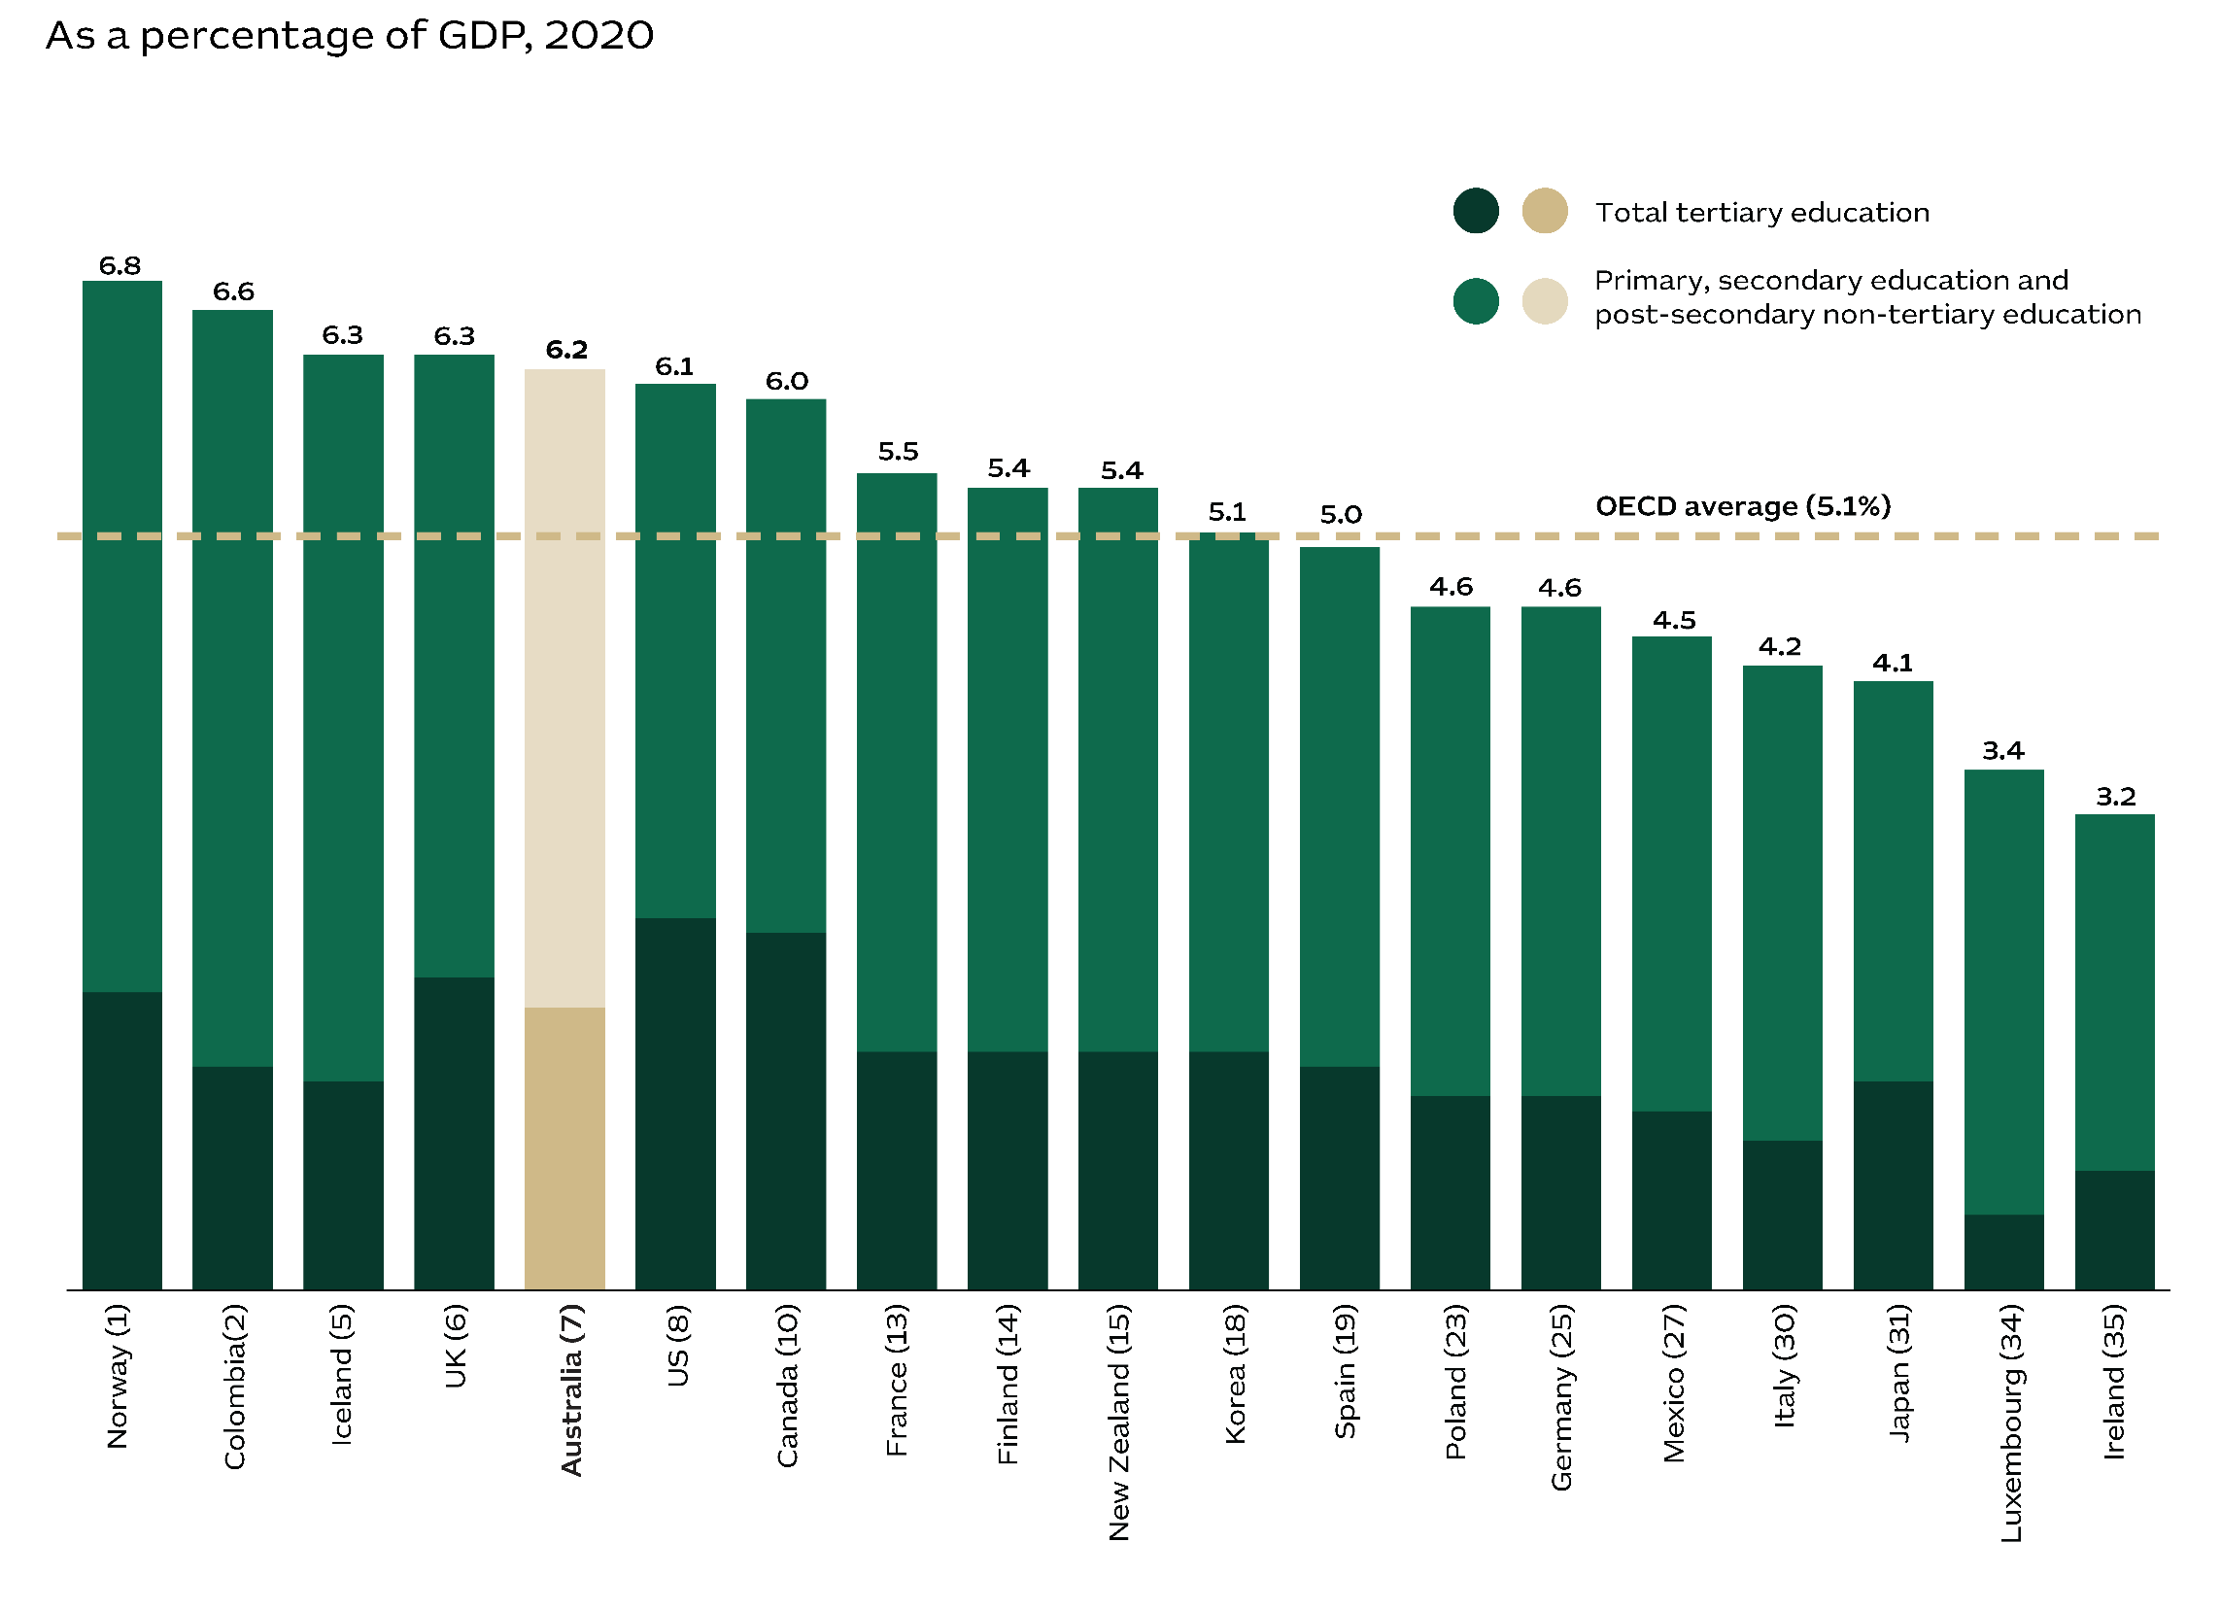

**Notes: 1.** Expenditure on all public and private institutions. Values of expenditure are expressed in USD-equivalent, after converting local currencies using purchasing-power parity (PPP) conversion factors. **2.** The latest data available from the OECD database does not include data from Greece. **3.** The numbers in brackets indicate the economy’s ranking across OECD economies.

**Sources:** Organisation for Economic Co-operation and Development, 2024, OECD Statistics; Austrade.

Australia at #4 globally for top-ranked universities

Australia punches above its weight globally when it comes to quality tertiary education. According to the Academic Ranking of World Universities, there are six Australian universities among the world’s top 100. Only much larger economies (the US, China and the UK) had more universities on the list.1 And Australian academia is on the rise. While 14 of our universities made it into the top 500 in 2004, 24 institutions were among the Index’s top 500 by 2023. Our top-performing institutions are the University of Melbourne (35th), the University of Queensland (51st), the University of New South Wales (72nd), the University of Sydney (73rd), Monash University (77th), and the Australian National University (84th).

Figure 26 – Academic ranking of world universities, 2023

The table contains the academic ranking of world universities. The information is: US, ranked 1, has 38 universities in the top 100, 61 in the top 200, 82 in the top 300, 99 in the top 400, 117 in the top 500, 70 between top 501 and 1000 - a total of 187 universities in the top 1000.  China, ranked 2, has 10 universities in the top 100, 32 in the top 200, 50 in the top 300, 68 in the top 400, 88 in the top 500, 103 between top 501 and 1000 - a total of 191 universities in the top 1000.  UK, ranked 3, has 8 universities in the top 100, 20 in the top 200, 25 in the top 300, 33 in the top 400, 38 in the top 500, 26 between top 501 and 1000 - a total of 64 universities in the top 1000.  Australia, ranked 4, has 6 universities in the top 100, 8 in the top 200, 15 in the top 300, 22 in the top 400, 24 in the top 500, 10 between top 501 and 1000 - a total of 34 universities in the top 1000.  Canada, ranked 5, has 5 universities in the top 100, 7 in the top 200, 11 in the top 300, 17 in the top 400, 18 in the top 500, 7 between top 501 and 1000 - a total of 25 universities in the top 1000.  Switzerland, ranked 6, has 5 universities in the top 100, 7 in the top 200, 7 in the top 300, 7 in the top 400, 7 in the top 500, 2 between top 501 and 1000 - a total of 9 universities in the top 1000.  Germany, ranked 7, has 4 universities in the top 100, 9 in the top 200, 19 in the top 300, 24 in the top 400, 31 in the top 500, 14 between top 501 and 1000 - a total of 45 universities in the top 1000.  France, ranked 8, has 4 universities in the top 100, 8 in the top 200, 12 in the top 300, 16 in the top 400, 18 in the top 500, 9 between top 501 and 1000 - a total of 27 universities in the top 1000.  Netherlands, ranked 9, has 3 universities in the top 100, 9 in the top 200, 10 in the top 300, 10 in the top 400, 12 in the top 500, 1 between top 501 and 1000 - a total of 13 universities in the top 1000.  Sweden, ranked 10, has 3 universities in the top 100, 5 in the top 200, 6 in the top 300, 8 in the top 400, 9 in the top 500, 4 between top 501 and 1000 - a total of 13 universities in the top 1000.  Israel, ranked 11, has 3 universities in the top 100, 3 in the top 200, 4 in the top 300, 4 in the top 400, 5 in the top 500, 2 between top 501 and 1000 - a total of 7 universities in the top 1000.  Japan, ranked 12, has 2 universities in the top 100, 5 in the top 200, 8 in the top 300, 11 in the top 400, 12 in the top 500, 20 between top 501 and 1000 - a total of 32 universities in the top 1000.  Belgium, ranked 13, has 2 universities in the top 100, 3 in the top 200, 5 in the top 300, 7 in the top 400, 7 in the top 500, 2 between top 501 and 1000 - a total of 9 universities in the top 1000.  Denmark, ranked 14, has 2 universities in the top 100, 3 in the top 200, 3 in the top 300, 5 in the top 400, 5 in the top 500, 1 between top 501 and 1000 - a total of 6 universities in the top 1000.  Singapore, ranked 15, has 2 universities in the top 100, 2 in the top 200, 2 in the top 300, 2 in the top 400, 2 in the top 500, 2 between top 501 and 1000 - a total of 4 universities in the top 1000.  Hong Kong, ranked 16, has 1 universities in the top 100, 4 in the top 200, 4 in the top 300, 5 in the top 400, 5 in the top 500, 2 between top 501 and 1000 - a total of 7 universities in the top 1000.  Korea, ranked 17, has 1 universities in the top 100, 2 in the top 200, 7 in the top 300, 8 in the top 400, 12 in the top 500, 18 between top 501 and 1000 - a total of 30 universities in the top 1000.  Norway, ranked 18, has 1 universities in the top 100, 2 in the top 200, 2 in the top 300, 3 in the top 400, 3 in the top 500, 4 between top 501 and 1000 - a total of 7 universities in the top 1000.  Italy, ranked 19, has 0 universities in the top 100, 4 in the top 200, 8 in the top 300, 10 in the top 400, 17 in the top 500, 23 between top 501 and 1000 - a total of 40 universities in the top 1000.  Saudi Arabia, ranked 20, has 0 universities in the top 100, 2 in the top 200, 4 in the top 300, 5 in the top 400, 7 in the top 500, 5 between top 501 and 1000 - a total of 12 universities in the top 1000.  Austria, ranked 21, has 0 universities in the top 100, 1 in the top 200, 2 in the top 300, 4 in the top 400, 5 in the top 500, 7 between top 501 and 1000 - a total of 12 universities in the top 1000.  Finland, ranked 22, has 0 universities in the top 100, 1 in the top 200, 1 in the top 300, 3 in the top 400, 4 in the top 500, 3 between top 501 and 1000 - a total of 7 universities in the top 1000.  Brazil, ranked 23, has 0 universities in the top 100, 1 in the top 200, 1 in the top 300, 2 in the top 400, 5 in the top 500, 13 between top 501 and 1000 - a total of 18 universities in the top 1000.  Russia, ranked 24, has 0 universities in the top 100, 1 in the top 200, 1 in the top 300, 1 in the top 400, 2 in the top 500, 7 between top 501 and 1000 - a total of 9 universities in the top 1000.  Spain, ranked 25, has 0 universities in the top 100, 0 in the top 200, 2 in the top 300, 7 in the top 400, 9 in the top 500, 29 between top 501 and 1000 - a total of 38 universities in the top 1000.  

**Notes: 1.** According to the 2023 Academic Ranking of World Universities (ARWU), published by the Shanghai Ranking Consultancy. **2.** Economies were ranked according to the number of universities in the top 100. For evenly ranked economies, the number of universities in the top 200, top 300, top 400 and top 500 was used as a tiebreaker.

**Sources:** Shanghai Ranking Consultancy, 2023, The Academic Ranking of World Universities; accessed 6 March 2024; Austrade.

Australian research pursues UN goals

Australian universities reflect our status as good global citizens. According to the UK’s Times Higher Education Impact Rankings, 15 Australian universities made it into the top 100 for having an impact on UN Sustainable Development Goals. Australia now has the 3rd-highest number of universities in this top 100 category, surpassed only by the UK and Canada. The Times ranking includes research on topics such as climate change, poverty and gender equality. Their focus on global issues makes Australian universities attractive partners for collaborative research and appealing to overseas students.

Figure 27 – Top 100 Universities Times Higher Education Impact Rankings, 2023

The image has a pie chart and a table. The pie chart shows the number of universities in an economy (country) that are ranked in the top 100 of the Times Higher Education Impact Rankings in 2023. 
The pie chart shows that 25 universities in the top 100 are located in the United Kingdom, 16 in Canada, 15 in Australia, 7 in New Zealand, 6 in the US.  Economies with 4 universities are Ireland and Thailand. Economies with 3 universities are Korea and Taiwan.  Economies with 2 universities are Italy, Japan, Mexico and South Africa. Economies with 1 university are China, Denmark, Hong Kong SAR, India, Indonesia, Malaysia, Portugal, Sweden and Türkiye.
The chart also shows the ranking for Australian universities in the top 100, which are: Western Sydney University is ranked #1; University of Tasmania is ranked #5; RMIT University is ranked #7; University of Technology Sydney is ranked #14; UNSW Sydney is ranked #18; Monash University is ranked #21; University of Newcastle is ranked #28; University of the Sunshine Coast is ranked #29; Macquarie University is ranked #39; La Trobe University is ranked #57; University of Wollongong is ranked #61; Griffith University is ranked #72; Central Queensland University is ranked #74; Charles Sturt University is ranked #79; University of Canberra is ranked #92.

**Note: 1.** Times Higher Education mapped how universities around the world are implementing the United Nations’ 17 Sustainable Development Goals (SDGs). The SDGs are a global call to action to tackle poverty, climate change and inequality. Universities were invited to submit data on how they were progressing on the SDGs. The 2023 Impact Rankings is the fifth edition. The overall ranking includes 1,705 universities from 115 countries/regions.

**Sources:** The Times Higher Education, Impact Rankings 2023; Austrade.

Chapter 4 – Global ties & open markets

Outward looking with a passion for free trade

Strong global ties make Australia a prosperous trading nation. Today, our international trade is worth the equivalent of around 48% of Australia’s GDP. Our robust economic outlook partly reflects the prosperity of Asia, with Australia enjoying the trade benefits of being close to many of the fastest growing economies in the world.

Our strong trading links are a cause for confidence among overseas investors. Australia’s 18 free trade agreements (FTAs) cover trade with some of the world’s largest economies, including the US, China, Japan and most countries in the Asia-Pacific region. In December 2022, Australia became the first developed economy to sign an FTA with India. Our FTA with the UK came into force in mid-2023, which will transform trade in agriculture and services.

Australia’s strong trade reflects our status as an open market economy. The OECD reports that Australia’s openness to trade in international services puts us among the top 10 of its 38 member countries.

The level of foreign investment in Australia has grown by an extraordinary 7.7% per year since 2003, reaching A$4.7 trillion in 2023. Investors come from around the world with top contributors that include the US, the UK and Japan. But our dynamic economy is also attracting investors from China, Canada and Southeast Asia. Collectively, the ASEAN bloc is now our 5th-largest investor.

Our strengths in international trade are broad based, being a major exporter of resources, energy and agrifood. The value of Australia’s exports of beef, wheat, sugar, barley and other food is likely to reach A$72 billion in 2023-24. Quality is our competitive advantage with Australia’s efficient and tech-friendly farming earning us a global reputation for high standards. Customers are willing to pay a premium for our produce – including a growing middle-class population in Southeast Asia.

Australia is now the 2nd-largest exporter of energy and resources globally. Our nation leads the world in iron ore exports, which are now worth US$90 billion and contribute a remarkable 40% of Australia’s energy and resources exports. With the largest identified reserves of iron ore – including magnetite and high-grade hematite – Australia is perfectly positioned to drive the production of green steel.

Proximity to Asia’s powerhouse economies

Australia benefits from Asia’s prosperity. In 1981, Asia accounted for just 21% of global GDP with this share expected to reach 45% by 2026. Most of Australia’s principal export partners are located in Northeast and Southeast Asia, and a network of 18 free trade agreements gives Australian companies preferential access to these fast-growing markets. Asia’s middle class is growing strongly with an anticipated 3 billion consumers by 2030. This will trigger increased demand for Australia’s top exports: resources, energy, agriculture, education, tourism and healthcare services.⁴

Figure 28 – Asia’s economic growth

The figure has a graph and a table. 
The table shows the country or region and its GDP compound annual growth rate in percentage terms from 1981 to 2026. The information is as follows: China and India 9.9%; Japan, Australia and New Zealand 4.3%; ASEAN 7.4%; Newly Industrialised Economies 7.7%; Other developing Asia 7.7%; Avg. of Asia incl. Australia & NZ 7.7%; and World average 6.0%. 
The right-hand side axis plots the Asia plus Australia and New Zealand as a percentage of world’s GDP (right-hand axis) by year. The information is: 21% in 1981; 23% in 1986; 26% in 1991; 28% in 1996; 29% in 2001; 31% in 2006; 36% in 2011; 38% in 2016; 41% in 2021; and 43% in 2026 (forecast).
In the left-hand side axis plots, the GDP based on purchasing power parity (PPP) by region in a stacked bar and year in the horizontal axis. The information for the left-hand side axis is:  China and India $0.82 in 1981 trillion; $1.44 in 1986 trillion; $2.34 in 1991 trillion; $4.15 in 1996 trillion; $6.42 in 2001 trillion; $11.38 in 2006 trillion; $19.35 in 2011 trillion; $26.44 in 2016 trillion; $37.81 in 2021 trillion; $56.67 in 2026F trillion;   Japan, Australia and New Zealand $1.43 in 1981 trillion; $2.06 in 1986 trillion; $3.06 in 1991 trillion; $3.70 in 1996 trillion; $4.24 in 2001 trillion; $5.22 in 2006 trillion; $5.74 in 2011 trillion; $6.52 in 2016 trillion; $7.41 in 2021 trillion; $9.34 in 2026F trillion;   ASEAN-9² $0.50 in 1981 trillion; $0.75 in 1986 trillion; $1.29 in 1991 trillion; $2.05 in 1996 trillion; $2.44 in 2001 trillion; $3.65 in 2006 trillion; $5.11 in 2011 trillion; $6.61 in 2016 trillion; $8.51 in 2021 trillion; $12.74 in 2026F trillion;   Newly Industrialised Economies³ $0.24 in 1981 trillion; $0.43 in 1986 trillion; $0.79 in 1991 trillion; $1.26 in 1996 trillion; $1.70 in 2001 trillion; $2.51 in 2006 trillion; $3.35 in 2011 trillion; $4.06 in 2016 trillion; $5.14 in 2021 trillion; $6.76 in 2026F trillion;   Other developing Asia $0.10 in 1981 trillion; $0.14 in 1986 trillion; $0.20 in 1991 trillion; $0.29 in 1996 trillion; $0.39 in 2001 trillion; $0.57 in 2006 trillion; $0.83 in 2011 trillion; $1.23 in 2016 trillion; $1.75 in 2021 trillion; and $2.66 in 2026F trillion.


**Notes: 1.** The bar represents the value of regional GDP at current prices based on purchasing power parity. **2.** The Association of Southeast Asian Nations (ASEAN) includes Brunei Darussalam, Cambodia, Indonesia, Lao PDR, Malaysia, Myanmar, Philippines, Thailand and Vietnam. To avoid double counting with newly industrialised economies (NIEs) and ASEAN, Singapore was excluded from the ASEAN group. **3.** NIEs: Singapore, Hong Kong SAR, Korea and Taiwan. **4.** Brookings Institution, see source below.

**F =** Forecast

**Sources:** International Monetary Fund, 2024, World Economic Outlook April 2024; Brookings Institution, 2017, The unprecedented expansion of the global middle class; Austrade.

A broad network of trade agreements

Australia has 18 FTAs. They include bilateral agreements with our principal trading partners such as the US, China, Korea, Japan and Singapore. Australia is also a member of regional multi-party trade agreements. These include the Regional Comprehensive Economic Partnership Agreement (RCEP), which is a free trade agreement with 14 Asia-Pacific countries, as well as the ASEAN-Australia-New Zealand Free Trade Area (AANZFTA) agreement. Two recent FTAs are set to boost trade with strategic partners. The Australia-India Economic Cooperation and Trade Agreement (ECTA) came into force in December 2022, and the Australia-United Kingdom Free Trade Agreement (A-UKFTA) became operational in May 2023.

Figure 29 – Australia’s free trade agreements

The image has a map and a table. 
The map shows Australia's Free Trade Agreements (FTA). It shows the country and the year the Free Trade Agreement with the country entered into force. 
The information in the map is China 2015; India 2022; Thailand 2005; Malaysia 2013; Korea 2014; Japan 2015; United States 2005; Hong Kong SAR 2020; Singapore 2003; Indonesia 2020; Peru 2020; Chile 2009; United Kingdom 2023;  and New Zealand 1983.
The table shows Australia’s three multi-party Free Trade Agreements. 
First, the ASEAN-Australia New Zealand Free Trade Agreement (2010-11) includes New Zealand, Indonesia, Brunei, Singapore, Malaysia, Thailand, the Philippines, Vietnam, Cambodia, Laos, and Myanmar.
Second, the Comprehensive and Progressive agreement for Trans-Pacific Partnership (2018-19) includes New Zealand, Indonesia, Brunei, Singapore, Malaysia, Vietnam, Japan, Canada, Mexico, Peru, and Chile.
Third, the Regional Comprehensive Economic Partnership (2022) includes New Zealand, Brunei, Singapore, Malaysia, Thailand, Vietnam, Cambodia, Laos, China, Korea, and Japan.
**Notes: 1.** Information on the status of FTA negotiations can be found here: https://www.dfat.gov.au/trade/agreements/trade-agreements **2.** The Pacific Agreement on Closer Economic Relations Plus entered into force in 2020. Australia, New Zealand, Samoa, Kiribati, Tonga, Solomon Islands, Niue and Cook Islands are parties to the Agreement.

**Sources:** The Department of Foreign Affairs and Trade, 2023, Australia’s free trade agreements; Austrade.

Pioneering the modernisation of global trade

Australia is at the forefront of efforts to adopt modern trade standards, ranking 3rd in the United Nations' Trade Digitalization Index. This reflects Australia’s determination to adopt digital solutions that streamline trade processes and automate transactions. And more is coming. Australia is developing its Simplified Trade System (STS), which will help companies comply with trade regulations. STS will simplify procedures, upgrade systems, and making it easier to trade for importers and exporters.

Figure 30 – Trade digitalisation index¹ for selected economies, 2023

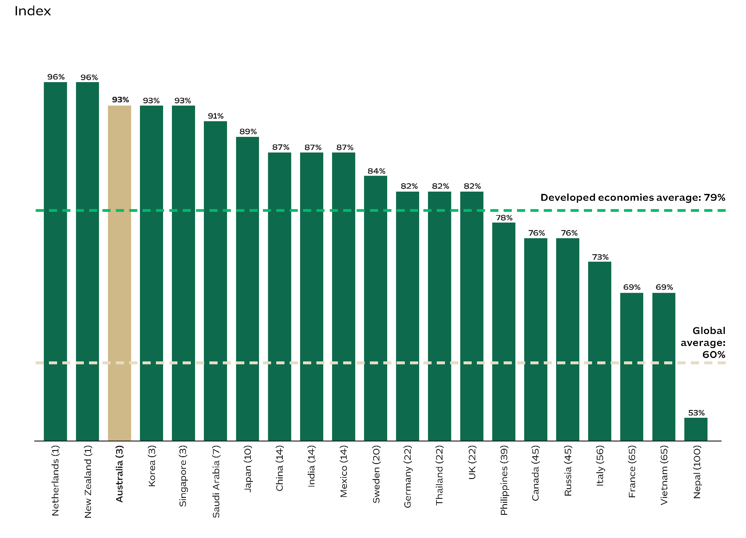

**Note: 1.** Across 163 economies.

**Sources:** United Nations Economic and Social commission for Asia and the Pacific, 2024, Trade Digitalization Index: A new tool for assessing the global state of play in the digitalization of trade procedures, accessed on 25 February 2024; Austrade.

A global hub with diverse connections

Australians are known for being open and welcoming. According to the European Institute of Business Administration (INSEAD), Australia is ranked 6th globally in terms of tolerance towards migration. Australia ranks 3rd in the OECD for our high proportion of foreign-born citizens, who account for 29% of Australia’s population – double the average ratio for OECD countries. Our multicultural and diaspora communities boost Australian trade through their linguistic abilities and connections to international markets.

Figure 31 – Foreign-born population across OECD countries, 2000 and 2022¹

The bar chart shows the percentage of foreign-born population across OECD countries in 2000 and 2022 (the number in brackets is the ranking in 2022). The information is as follows:
Mexico (38) 1% in 2022, 0.5% in 2000; Japan (37) 2.2% in 2022, 1.2% in 2000; Korea (35) 3.5% in 2022, 0.4% in 2000; Chile (29) 7.5% in 2022, 1.2% in 2000; Denmark (24) 11% in 2022, 5.6% in 2000; France (20) 12.7% in 2022, 10.1% in 2000; US (18) 14% in 2022, 10.5% in 2000; OECD average 14% in 2022, 9.7% in 2000; UK (17) 14.3% in 2022, 7.9% in 2000; Netherlands (16) 14.5% in 2022, 9.8% in 2000; Spain (14) 15.6% in 2022, 3.6% in 2000; Norway (13) 16.6% in 2022, 6.5% in 2000; Germany (12) 16.8% in 2022, 12.5% in 2000; Belgium (11) 18.4% in 2022, 10.1% in 2000; Israel² (10) 19.1% in 2022, 32.7% in 2000; Sweden (8) 20.1% in 2022, 11.1% in 2000; Ireland (7) 20.3% in 2022, 8.1% in 2000; Austria (6) 20.6% in 2022, 10.8% in 2000; Canada (5) 22% in 2022, 17.4% in 2000; New Zealand (4) 27.4% in 2022, 17.2% in 2000; Australia (3) 29.3% in 2022, 23.2% in 2000; Switzerland (2) 30.7% in 2022, 21.6% in 2000; and Luxembourg (1) 49.8% in 2022, 32.5% in 2000.


**Notes: 1.** Data refers to 2000 or the closest available year, and to 2022 or the most recent available year. The OECD information is the simple average based on rates presented. For Japan and Korea, the data refers to the foreign population rather than the foreign-born population. **2.** Israel’s high fertility rate and lower net migration rate reduced its percentage of foreign-born population.

**Sources:** Organisation for Economic Co-operation and Development, 2023, International Migration Outlook 2023; Austrade.

Foreign investment reaches A$4.7 trillion

Australia is a standout destination for global investors. Since 2003, the stock of FDI in Australia has risen by an average of 7.1% each year. Other forms of foreign investment – including portfolio investments – have grown by 8% per year. This strong growth has resulted in the value of foreign investment in Australia reaching A$4.7 trillion. Confidence in our economy means Australia has bucked global trends. When FDI in Australia surged by 9% in 2022, the total stock of global FDI dipped by 6%.Over the past two decades, foreign investment has had a growing role in Australia’s economy. As a percentage of GDP, the stock of foreign investment has grown from 129% in 2003 to 181% in 2023.

Figure 32 – Total foreign investment stock in Australia, 2003 to 2023

The graph plots the foreign investment stock in Australia by type (direct and other) from the 2003 to 2023, expressed in billions of Australian dollars. The information is as follows: In 2003, A$317 billion for direct investment, A$753 billion of other, given a total of $1069 billion. The total represents 129% of GDP. In 2004, A$401 billion for direct investment, A$835 billion of other, given a total of $1236 billion. The total represents 138% of GDP. In 2005, A$370 billion for direct investment, A$968 billion of other, given a total of $1338 billion. The total represents 139% of GDP. In 2006, A$420 billion for direct investment, A$1174 billion of other, given a total of $1594 billion. The total represents 153% of GDP. In 2007, A$486 billion for direct investment, A$1314 billion of other, given a total of $1800 billion. The total represents 159% of GDP. In 2008, A$490 billion for direct investment, A$1388 billion of other, given a total of $1878 billion. The total represents 152% of GDP. In 2009, A$525 billion for direct investment, A$1472 billion of other, given a total of $1998 billion. The total represents 158% of GDP. In 2010, A$552 billion for direct investment, A$1517 billion of other, given a total of $2069 billion. The total represents 152% of GDP. In 2011, A$586 billion for direct investment, A$1568 billion of other, given a total of $2154 billion. The total represents 147% of GDP. In 2012, A$629 billion for direct investment, A$1690 billion of other, given a total of $2319 billion. The total represents 153% of GDP. In 2013, A$680 billion for direct investment, A$1918 billion of other, given a total of $2598 billion. The total represents 165% of GDP. In 2014, A$754 billion for direct investment, A$2143 billion of other, given a total of $2897 billion. The total represents 179% of GDP. In 2015, A$843 billion for direct investment, A$2335 billion of other, given a total of $3178 billion. The total represents 194% of GDP. In 2016, A$905 billion for direct investment, A$2445 billion of other, given a total of $3350 billion. The total represents 197% of GDP. In 2017, A$960 billion for direct investment, A$2512 billion of other, given a total of $3472 billion. The total represents 193% of GDP. In 2018, A$1046 billion for direct investment, A$2638 billion of other, given a total of $3684 billion. The total represents 194% of GDP. In 2019, A$1091 billion for direct investment, A$2907 billion of other, given a total of $3998 billion. The total represents 200% of GDP. In 2020, A$1074 billion for direct investment, A$3039 billion of other, given a total of $4113 billion. The total represents 208% of GDP. In 2021, A$1115 billion for direct investment, A$3108 billion of other, given a total of $4223 billion. The total represents 192% of GDP. In 2022, A$1215 billion for direct investment, A$3450 billion of other, given a total of $4665 billion. The total represents 188% of GDP. In 2023, A$1251 billion for direct investment, A$3479 billion of other, given a total of $4730 billion. The total represents 181% of GDP. 

**Note: 1.** Other investment is the balance of total investment less direct investment. As such, it represents portfolio investment, financial derivatives and other investment categories from Australian Bureau of Statistics (ABS) source data.

**Sources:** ABS, 2024, Balance of payments, Table 15; ABS, 2024, Australian national accounts: national income, expenditure and product, Table 3; United Nations Conference on Trade and Development, 2024, Data Centre – Foreign direct investment: Inward and outward flows and stock, annual; Austrade.

Australia attracts investors from America, Europe and Asia

Investment in Australia arrives from around the world. Since 2013, FDI has risen by 17% per year from Canada, 8% per year from Japan, 7% per year from China and 5% per year from Singapore. The US, the UK and Japan are Australia's leading investors, accounting for 18%, 13% and 12% of the total stock of FDI respectively. Investment from other parts of Asia is also increasing, with ASEAN countries boosting their investments in Australia by 5% per year since 2013. The total FDI stock from ASEAN members has now reached A$61 billion. As a bloc, ASEAN countries are now the 5th-largest source of FDI in Australia, led by Singapore and Malaysia.

Figure 33 – Australia's main sources of foreign direct investment stock, 2013–2023

The table shows Australia’s main sources of foreign direct investment stock.
The information in the table is: 1) US $152 billion in 2013, $187 billion in 2022, $210 billion in 2023, 17.8% share in 2021, 12.5% change 2020 - 2021, 3.3% CAGR 2011-2021, 8% of GDP in 2021. 2) UK $79 billion in 2013, $136 billion in 2022, $150 billion in 2023, 12.7% share in 2021, 10.5% change 2020 - 2021, 6.6% CAGR 2011-2021, 5.7% of GDP in 2021. 3) Japan $68 billion in 2013, $134 billion in 2022, $141 billion in 2023, 11.9% share in 2021, 5.5% change 2020 - 2021, 7.6% CAGR 2011-2021, 5.4% of GDP in 2021. 4) Canada $17 billion in 2013, $83 billion in 2022, $82 billion in 2023, 6.9% share in 2021, -1.6% change 2020 - 2021, 17% CAGR 2011-2021, 3.1% of GDP in 2021. 5) China $23 billion in 2013, $47 billion in 2022, $47 billion in 2023, 3.9% share in 2021, -0.5% change 2020 - 2021, 7.1% CAGR 2011-2021, 1.8% of GDP in 2021. 6) Netherlands $30 billion in 2013, $60 billion in 2022, $46 billion in 2023, 3.9% share in 2021, -23.5% change 2020 - 2021, 4.4% CAGR 2011-2021, 1.7% of GDP in 2021. 7) Bermuda $10 billion in 2013, $46 billion in 2022, $45 billion in 2023, 3.9% share in 2021, -0.6% change 2020 - 2021, 16.3% CAGR 2011-2021, 1.7% of GDP in 2021. 8) Singapore $23 billion in 2013, $40 billion in 2022, $39 billion in 2023, 3.3% share in 2021, -1.8% change 2020 - 2021, 5.4% CAGR 2011-2021, 1.5% of GDP in 2021. 9) Germany $13 billion in 2013, $21 billion in 2022, $22 billion in 2023, 1.8% share in 2021, 2.6% change 2020 - 2021, 4.9% CAGR 2011-2021, 0.8% of GDP in 2021. 10) Virgin Islands, British value not presented, $22 billion in 2022, $22 billion in 2023, 1.8% share in 2021, -0.5% change 2020 - 2021, value not presented, 0.8% of GDP in 2021. 11) Hong Kong SAR $8 billion in 2013, $18 billion in 2022, $17 billion in 2023, 1.4% share in 2021, -5.8% change 2020 - 2021, 7.6% CAGR 2011-2021, 0.6% of GDP in 2021. 12) Malaysia $9 billion in 2013, $13 billion in 2022, $15 billion in 2023, 1.3% share in 2021, 14% change 2020 - 2021, 5.1% CAGR 2011-2021, 0.6% of GDP in 2021. 13) France $6 billion in 2013, $12 billion in 2022, $14 billion in 2023, 1.2% share in 2021, 21.2% change 2020 - 2021, 10.1% CAGR 2011-2021, 0.6% of GDP in 2021. 14) Switzerland $19 billion in 2013, $14 billion in 2022, $14 billion in 2023, 1.2% share in 2021, -0.6% change 2020 - 2021, -3% CAGR 2011-2021, 0.5% of GDP in 2021. 15) Sweden $1 billion in 2013, $7 billion in 2022, $8 billion in 2023, 0.7% share in 2021, 7.3% change 2020 - 2021, 19.1% CAGR 2011-2021, 0.3% of GDP in 2021. 16) Ireland $0 billion in 2013, $8 billion in 2022, $8 billion in 2023, 0.6% share in 2021, -8.1% change 2020 - 2021, 35.3% CAGR 2011-2021, 0.3% of GDP in 2021. Other economies $183 billion in 2013, $300 billion in 2022, $302 billion in 2023, 25.6% share in 2021, 0.7% change 2020 - 2021, 5.1% CAGR 2011-2021, 11.5% of GDP in 2021. FDI stock – all economies $643 billion in 2013, $1147 billion in 2022, $1180 billion in 2023, 100% share in 2021, 3% change 2020 - 2021, 6.3% CAGR 2011-2021, 45% of GDP in 2021. OECD $413 billion in 2013, $700 billion in 2022, $732 billion in 2023, 62% share in 2021, 4.5% change 2020 - 2021, 5.9% CAGR 2011-2021, 27.9% of GDP in 2021. APEC $312 billion in 2013, $542 billion in 2022, $571 billion in 2023, 48.4% share in 2021, 5.3% change 2020 - 2021, 6.2% CAGR 2011-2021, 21.8% of GDP in 2021. EU (excl. UK) $69 billion in 2013, $132 billion in 2022, $121 billion in 2023, 10.2% share in 2021, -8.8% change 2020 - 2021, 5.7% CAGR 2011-2021, 4.6% of GDP in 2021. ASEAN $37 billion in 2013, $59 billion in 2022, $61 billion in 2023, 5.1% share in 2021, 2.3% change 2020 - 2021, 5% CAGR 2011-2021, 2.3% of GDP in 2021. FDI stock as a percentage of GDP 40.9%in 2013, 46.2% in 2022, and 45.0% in 2023.


**Notes: ASEAN =** The Association of Southeast Asian Nations. **CAGR =** compound annual growth rate. **SAR =** Special administrative region of China.

**Sources:** Australian Bureau of Statistics (ABS), 2024, International Investment Position, Australia: Supplementary Statistics 2023, Table 2; ABS, 2024, Australian National Accounts: National Income, Expenditure and Product, Table 3; Austrade.

The trillion-dollar trading nation

Australia has a globalised economy: today, our international trade is worth almost half of Australia’s GDP. The Asia¹ and Oceania regions account for around three-quarters of Australia’s two-way trade in goods and services, and most regional trade benefits from bilateral and multilateral trade agreements. China accounts for 26% of Australia’s bilateral trade, followed by Japan (12%), the US (8%) and Korea (6%), while 15% is with ASEAN countries. Australia also nurtures trade relations with other traditional partners, with the EU and the UK representing 11% of our total trade.

Figure 34 – Australia’s exports and imports of goods and services

The table show Australian exports and imports of goods and services by economy (or market). The information in the table is:1) China A$267 billion in 2020-21, A$283.4 billion in 2021-22, A$316.9 billion in 2022-23, represented 12.4% of GDP, represented 25.7% of total trade in 2022-23, grew at 10.2% 5-year CAGR.  2) Japan A$67 billion in 2020-21, A$117.3 billion in 2021-22, A$143.4 billion in 2022-23, represented 5.6% of GDP, represented 11.6% of total trade in 2022-23, grew at 13.1% 5-year CAGR.  3) US A$67.8 billion in 2020-21, A$76.4 billion in 2021-22, A$94.6 billion in 2022-23, represented 3.7% of GDP, represented 7.7% of total trade in 2022-23, grew at 6.3% 5-year CAGR.  4) Korea A$39.4 billion in 2020-21, A$68.6 billion in 2021-22, A$77.6 billion in 2022-23, represented 3% of GDP, represented 6.3% of total trade in 2022-23, grew at 8.2% 5-year CAGR.  5) Singapore A$28.6 billion in 2020-21, A$46.5 billion in 2021-22, A$50.9 billion in 2022-23, represented 2% of GDP, represented 4.1% of total trade in 2022-23, grew at 12.8% 5-year CAGR.  6) India A$27.1 billion in 2020-21, A$46.5 billion in 2021-22, A$45 billion in 2022-23, represented 1.8% of GDP, represented 3.6% of total trade in 2022-23, grew at 9.1% 5-year CAGR.  7) Taiwan A$17.1 billion in 2020-21, A$33.9 billion in 2021-22, A$41.5 billion in 2022-23, represented 1.6% of GDP, represented 3.4% of total trade in 2022-23, grew at 21.1% 5-year CAGR.  8) Malaysia A$21.2 billion in 2020-21, A$26.8 billion in 2021-22, A$35.3 billion in 2022-23, represented 1.4% of GDP, represented 2.9% of total trade in 2022-23, grew at 10.5% 5-year CAGR.  9) Germany A$23.7 billion in 2020-21, A$25.5 billion in 2021-22, A$34.3 billion in 2022-23, represented 1.3% of GDP, represented 2.8% of total trade in 2022-23, grew at 4% 5-year CAGR.  10) New Zealand A$20.9 billion in 2020-21, A$24.6 billion in 2021-22, A$30.8 billion in 2022-23, represented 1.2% of GDP, represented 2.5% of total trade in 2022-23, grew at 4.6% 5-year CAGR.  11) Thailand A$22.2 billion in 2020-21, A$26.4 billion in 2021-22, A$28.9 billion in 2022-23, represented 1.1% of GDP, represented 2.3% of total trade in 2022-23, grew at 5% 5-year CAGR.  12) Vietnam A$28.8 billion in 2020-21, A$22.2 billion in 2021-22, A$28.7 billion in 2022-23, represented 1.1% of GDP, represented 2.3% of total trade in 2022-23, grew at 0.6% 5-year CAGR.  13) UK A$14.1 billion in 2020-21, A$18.4 billion in 2021-22, A$26.2 billion in 2022-23, represented 1% of GDP, represented 2.1% of total trade in 2022-23, grew at 9.6% 5-year CAGR.  14) Indonesia A$15.8 billion in 2020-21, A$22 billion in 2021-22, A$25.7 billion in 2022-23, represented 1% of GDP, represented 2.1% of total trade in 2022-23, grew at 14.1% 5-year CAGR.  15) Hong Kong SAR A$11.2 billion in 2020-21, A$14 billion in 2021-22, A$13.5 billion in 2022-23, represented 0.5% of GDP, represented 1.1% of total trade in 2022-23, grew at -6.3% 5-year CAGR.  Other economies A$157.7 billion in 2020-21, A$200.6 billion in 2021-22, A$240.4 billion in 2022-23, represented 9.4% of GDP, represented 19.5% of total trade in 2022-23, grew at 8.6% 5-year CAGR.  Total all economies1 A$829.3 billion in 2020-21, A$1053.1 billion in 2021-22, A$1233.6 billion in 2022-23, represented 48.1% of GDP, represented 100% of total trade in 2022-23, grew at 9.1% 5-year CAGR.  APEC² A$618.2 billion in 2020-21, A$788.5 billion in 2021-22, A$928.7 billion in 2022-23, represented 36.2% of GDP, represented 75.3% of total trade in 2022-23, grew at 9.6% 5-year CAGR.  RCEP³ A$506.1 billion in 2020-21, A$645.5 billion in 2021-22, A$757.4 billion in 2022-23, represented 29.5% of GDP, represented 61.4% of total trade in 2022-23, grew at 10.3% 5-year CAGR.  ASEAN⁴ A$109.1 billion in 2020-21, A$150.6 billion in 2021-22, A$185.2 billion in 2022-23, represented 7.2% of GDP, represented 15% of total trade in 2022-23, grew at 11% 5-year CAGR.  EU plus UK A$106.7 billion in 2020-21, A$119 billion in 2021-22, A$137.2 billion in 2022-23, represented 5.4% of GDP, represented 11.1% of total trade in 2022-23, grew at 5.2% 5-year CAGR. 

**Notes: 1.** The region includes the Middle East region as defined by Australia’s Department for Foreign Affairs and Trade (DFAT). For more information visit their website (www.dfat.gov.au/trade/resources/trade-statistics/Pages/trade-time-series-data). **2.** Totals may not always add up exactly due to rounding. Refer to the DFAT website (www.dfat.gov.au/trade/Pages/trade-and-investment) for more information. **3.** Asia Pacific Economic Cooperation. **4.** Regional Comprehensive Economic Partnership, which is a free trade agreement with 14 Asia-Pacific countries. **5.** Association of Southeast Asian Nations. **CAGR =** compound annual growth rate. **SAR =** Special administrative region of China.

**Sources:** Department of Foreign Affairs and Trade, 2024, Trade time series data accessed 23 April 2024; Australian Bureau of Statistics, 2024, Australian National Accounts: National Income, Expenditure and Product, Table 3; Austrade.

An open trading economy for services

Australia is more open to trade in services than most wealthy economies. In 2022, the OECD assessed Australia to be less restrictive in services trade when compared to the average among its 38 member countries. Australia has several standout service sectors with our freight transportation ranked 2nd in openness and air transport ranked 5th-least restrictive. Openness is powering Australia’s recovery in two-way trade in services, which grew by 49% in 2022 and by 32% in 2023 to reach A$226 billion.

Figure 35 – Services trade restrictiveness index¹ by sector, Australia vs OECD average in 2022²

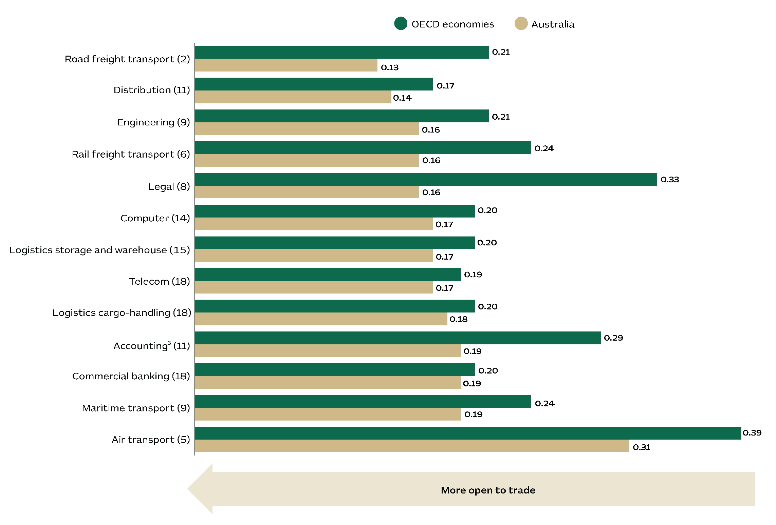

**Notes: 1.** Unweighted STRI average of 38 OECD countries. **2.** The number in brackets indicates Australia’s global ranking across 38 OECD countries. **3.** Different countries have different accounting standards, making it challenging for businesses to comply with all regulatory environments. This complexity could potentially lead to increased costs or legal issues, thereby affecting trade.

**Sources:** Australian Bureau of Statistics, 2024, Balance of Payments and International Investment Position; Austrade; Organisation for Economic Co-operation and Development, 2023, Services Trade Restrictiveness Index, accessed April 2024; Austrade.

Abundant energy and resources

Australia is the 2nd-largest exporter of energy and resources in the world. We lead the world in iron ore exports, which are now worth over US$90 billion and account for a remarkable 40% of Australia’s energy and resources exports. With the largest identified reserves of iron ore – including magnetite and high-grade hematite – Australia is perfectly positioned to drive the production of green steel. Australia is also the top exporter of liquefied natural gas (LNG), with US$50 billion worth of exports that account for 43% of global trade in LNG. Australia’s abundant resources, advanced infrastructure, and commitment to sustainable practices make us an ideal destination for investment in energy and resources.

Figure 36 – Energy and resources exports by economy in 2023

The graph presents the Energy and resources exports by economy in 2023. The information presents is as follows: 
US (ranked #1) US$400 billion; Australia (ranked #2) US$251 billion; China (ranked #3) US$220 billion; Canada (ranked #4) US$194 billion; Netherlands (ranked #5) US$163 billion; Norway (ranked #6) US$131 billion; Germany (ranked #7) US$123 billion; India (ranked #8) US$120 billion; Brazil (ranked #9) US$112 billion; Belgium (ranked #10) US$81 billion; Malaysia (ranked #11) US$71 billion; Japan (ranked #12) US$70 billion; France (ranked #13) US$68 billion; Kazakhstan (ranked #14) US$65 billion; and UK (ranked #15) US$64 billion.

**Notes: 1.** The energy and resources sector include the following codes from the UN Harmonised Commodity Classification: 26, 27, 28, 72, 74, 75, 76, 78, 79, 80, and 81. **2.** The number in brackets shows the region rank amongst 95 economies. **3.** Values are reported by the exporting country.

**Sources:** United Nations, 2024, UN Comtrade Trade Database, data accessed 4 June 2024; US Department of the Interior, 2024, Mineral Commodity Summaries; Austrade.

Agrifood exports grow in global and premium markets

There is strong global demand for Australian produce. The value of our agrifood exports is forecast to reach A$72 billion in 2023-24 with growth being supported by Australia’s efficient and tech-friendly farming industry. Around three-quarters of our agriculture exports come from a combination of beef (which will likely top A$11.3 billion in 2023-24), wheat, cotton, canola, sheep meat, sugar, barley, wool, forest products, wine, fruit, lentils, tree nuts, grain sorghum and cheese. Australia’s agrifood exports will continue to benefit from growing middle class populations in Asia, including Southeast Asia. Consumers in these markets will be increasingly willing to pay a premium for Australia’s high agricultural standards and clean, green produce.

Figure 37 – Australia’s major agricultural products, 2023–24E

The figure has one graph and one table. 
The table shows Australia agrifood production in 2023-24 by commodity, while the graph plots Australian major agricultural exports by commodity.
The table’s information (production) is: Cattle and calves² A$11.6 billion; Wheat A$10.1 billion; Fruit and nuts A$6.5 billion; Milk³ A$6.0 billion; Vegetables A$5.8 billion; Canola A$3.9 billion; Poultry A$3.8 billion; Nursery A$3.5 billion; Barley A$3.4 billion; Cotton lint⁴ A$3.0 billion; Lambs⁵ A$3.0 billion; Wool⁶ A$2.9 billion; Forestry products A$2.3 billion; Sugar⁷ A$2.2 billion; Pigs⁵ A$1.7 billion;  Total farm, fisheries and forestry products A$85.9 billion.
The information in the graph ( exports) is: Beef A$11.3 billion; Wheat  A$9.7 billion; Cotton¹ A$4.5 billion; Canola A$3.8 billion; Sheep Meat A$3.3 billion; Sugar A$3.2 billion; Barley  A$3.0 billion; Wool A$3.0 billion; Forest exports A$2.9 billion; Wine A$1.9 billion; Fruit A$1.8 billion; Lentils A$1.5 billion; Tree nuts A$0.9 billion; Grain sorghum A$0.9 billion; and Cheese A$0.9 billion. 

**Notes: 1.** Excludes cotton waste and linters. **2.** Includes dairy cattle. Excludes skin and hide values. **3.** Milk intake by factories and valued at the farm gate. **4.** Value delivered to gin. **5.** Excludes skin and hide values. **6.** Shorn, dead and fellmongered wool, and wool exported on skins. **7.** Cut for crushing.

**E** = ABARES estimate.

**Sources:** Australian Bureau of Agricultural and Resource Economics and Sciences, 2024, Agricultural commodities – Statistical Tables 13 and 17; Austrade.

A growth market for international travellers

Australia offers unique and diverse tourism experiences. Global travellers come to Australia to dive on the Great Barrier Reef, explore remote areas, and interact with one of the world's oldest continuing cultures. Tourism Research Australia (TRA)¹ predicts international visitor spending will return to pre-COVID levels by 2024. Total visitor spending – which includes domestic tourism – is expected to grow by an average rate of 6% per year to reach A$223 billion by 2028. Confidence in the future of Australian tourism remains strong. TRA reports that the tourism investment pipeline² exceeded A$56 billion in 2022-23, marking a 27% increase from the previous year.³

Figure 38 – Tourism investment pipeline² in Australia by sector and financial year³

The graph plots Tourism investment pipeline in Australia by sector and financial year.
In 2021-22, the investment was A$16.7 billion in the aviation sector, $16.1 billion in the arts, recreational and business services and $11.5 billion for accomodation, a total of $44.3 billion. 
In 2022-23, the investment was A$18.8 billion in the aviation sector, $25.1 billion in the arts, recreational and business services and $12.2 billion for accommodation, a total of $56.1 billion. 

**Notes: 1.** Tourism Research Australia (TRA) is Australia’s official provider of tourism statistics. **2.** Includes domestic and foreign investment. **3.** The financial year starts in July and ends in June.

**Source:** Tourism Research Australia, 2024, Tourism Investment Monitor 2022–23.

Chapter 5 – High quality of life

An attractive place to live and work

Our cities are not only well-organised but also compare favourably with major cities in the Asian region on costs, according to Mercer's 2022 Cost of Living Index.

Australia is a prosperous society where wealth is more evenly distributed when compared with our peers. We have one of the highest levels of median wealth globally, with nearly 6 million households earning annual incomes exceeding US$75,000 from a population nearing 27 million. This number is expected to rise to 7 million by 2030 as our economy outpaces our peers.

Australia's top-notch healthcare system is renowned for excellent public and private hospitals, world-class medical professionals, and effective public health programs. Government spending on healthcare reached US$131 billion in 2023. This places Australia as the 5th-highest globally in terms of healthcare spending per person, and 6th-highest in absolute terms.

Above all, Australians are happy people. In 2023, the World Happiness Index ranked Australia as the happiest country in the Asia and Oceania regions. Many believe that the Happiness Index is a more comprehensive indicator than traditional economic measurements like GDP. This is because it takes a holistic approach to measuring well-being. This Happiness Index is affected by factors such as mental and physical health, social connections, income inequality and environmental quality.

Today, Australia's lifestyle, attitudes and values make us an attractive destination for global companies that want to relocate employees and their families to the Asia-Pacific region.

Top marks for talent attraction

Australia is a magnet for talented workers. The OECD ranks Australia 4th out of 38 countries when it comes to talent attractiveness. This index takes into account variables such as career opportunities, income, tax structure, skills development prospects, inclusivity and quality of life. These qualities set Australia apart, making it easy for investors to attract and retain the best global professionals and ensure strong support for investment plans in Australia.

Figure 39 – Talent attractiveness

The bar chart shows the Talent Attractiveness Index in 2023. The chart shows the economy, its global ranking, and its talent attractiveness value according to the index. The figures are:
New Zealand (ranked #1) index value 0.64; Sweden (ranked #2) index value 0.62; Switzerland (ranked #3) index value 0.62; Australia (ranked #4) index value 0.62; Norway (ranked #5) index value 0.61; Luxembourg (ranked #6) index value 0.59; UK (ranked #7) index value 0.59; US (ranked #8) index value 0.58; Netherlands (ranked #9) index value 0.57; Canada (ranked #10) index value 0.57; Finland (ranked #14) index value 0.55; Germany (ranked #15) index value 0.55; France (ranked #17) index value 0.54; Japan (ranked #22) index value 0.5; Spain (ranked #23) index value 0.5; Korea (ranked #25) index value 0.5; Italy (ranked #31) index value 0.44; Mexico (ranked #36) index value 0.36; Türkiye (ranked #37) index value 0.33; and Costa Rica (ranked #38) index value 0.32.


**Note:** The number in brackets indicates the economy’s ranking across 38 economies.

**Sources:**  Organisation for Economic Co-operation and Development, 2024, data provided by the International Migration Division of the OECD; Austrade.

Australia's dynamic cities

Australia’s lifestyle cities are a source of competitive advantage among investment destinations. Our clean, safe and well organised urban centres, as well as our relaxed, outdoor lifestyle are ideal for solo migrants and executives who bring their families to Australia. Best of all, our prosperity delivers a high standard of living – without making us a high-cost country. Mercer's 2022 Cost of Living Index reports that Australia’s state capitals are generally more affordable than major cities in the Asia region. The fact that our cities are family-friendly and affordable makes Australia a top choice when investors are looking to relocate employees.

Figure 40 – Cost of living: Global city rankings, 2023

The image has a map and a table, both showing the cost of living in selected cities. The image is based on the 2023 global rankings in the Mercer cost of living index. 
The map shows the Asian region. It contains the following information (city then rank): Hong Kong SAR # 1; Singapore # 2; Tokyo # 19; Beijing # 13; Shanghai # 12; Shenzhen # 20; Seoul # 16; Taipei # 57; Dubai # 18; Sydney # 56; Melbourne # 71; Brisbane # 82; Perth # 107; Dhaka # 154; Adelaide # 106; Canberra # 94; Bangkok # 105; Manila # 133; Mumbai # 147; Hanoi # 156; and New Delhi # 169.
The table contain other global rankings, which are located outside the region shown in the map: Zurich, Switzerland ranked #3; New York City, US ranked #6; Los Angeles, US ranked #11; San Francisco, US ranked #14; London, UK ranked #17; Dubai, UAE ranked #18; Paris, France ranked #35; Munich, Germany ranked #38; Buenos Aires, Argentina ranked #45; Lagos, Nigeria ranked #47; Milan, Italy ranked #49; and Toronto, Canada ranked #90.

**Notes: 1.** The Mercer Cost of Living Index measures the cost of sending an employee overseas. The index covers more than 200 goods and services, in addition to currency fluctuations, cost inflation and accommodation instability. If a country lacks infrastructure or public services, the index reflects the costs of additional compensation a company may need to provide to their employees. This includes the cost of providing security. Australian cities are cost-effective for expatriates owing to high quality infrastructure and public services. **2.** A higher ranking means a higher cost of living. For example, Hong Kong has the highest cost of living across the 227 cities.

**Sources:** Mercer, 2024, Cost of Living Index; Austrade.

A nation of high-income households

Australian households have a high level of disposable income. The Economist Intelligence Unit (EIU) estimates that nearly 6 million Australian households have an annual income that exceeds US$75,000, which is the 6th-highest globally. And the EIU predicts a bright future for Australia, forecasting more than 7 million high-income households by 2030 as Australia’s consumer economy continues to expand.

Figure 41 – Number of households with disposable income of more than US$75,000 per annum (selected economies)¹

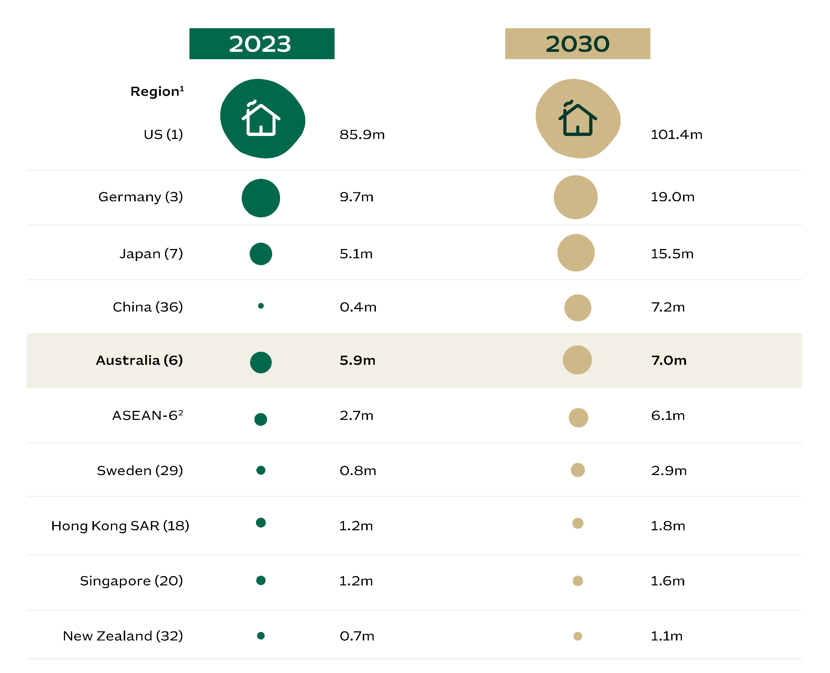

**Notes: 1.** The number in brackets indicates the economy’s ranking in 2023 among 59 economies. **2.** Association of Southeast Asian Nations (ASEAN). The forecast includes Indonesia, Malaysia, Philippines, Singapore, Thailand and Vietnam.

**Sources:** Economist Intelligence Unit, 2024, Number of households with disposable income of more than US$75,000 per annum, accessed during March 2024; Austrade.

No worries, we’re happy!

Australia was the happiest country in the Asia and Oceania regions and the 9th globally in 2023, according to a World Happiness Index. This is due to multiple factors: high incomes, a sense of personal freedom, our spirit of generosity, trust in institutions and income equality. Australia’s lifestyle, attitudes and values can be core considerations for global companies that want to relocate employees and families into the Asia-Pacific region.

Figure 42 – Happiness Index and GDP per capita, 2023

The image has a table and a graph. The table’s columns are the economy, the happiness index in 2023, the world ranking and the Asia-Pacific ranking. 
The information in the table is: Finland index = 7.7 world rank =1 regional rank =na; Denmark index = 7.5 world rank =3 regional rank =na; Australia index = 7 world rank =9 regional rank =1; Luxembourg index = 7 world rank =10 regional rank =na; New Zealand index = 7 world rank =12 regional rank =2; Canada index = 6.8 world rank =17 regional rank =na; United Kingdom index = 6.7 world rank =26 regional rank =na; Singapore index = 6.7 world rank =28 regional rank =5; United States index = 6.5 world rank =34 regional rank =na; Vietnam index = 6.3 world rank =44 regional rank =7; and Korea index = 6.1 world rank =55 regional rank =12.
The graph plots the happiness index against the GDP per capita on a logarithmic scale. A straight line displays the relationship, the greater the GDP per capita, the greater the happiness. The information (country, happiness, GDP) is:  Afghanistan index = 1.4 GDP per capita log = 7.3; Australia index = 7 GDP per capita log = 10.8; Bangladesh index = 4.1 GDP per capita log = 8.8; Brazil index = 6.6 GDP per capita log = 9.6; Canada index = 6.8 GDP per capita log = 10.8; China index = 6.1 GDP per capita log = 9.9; Ethiopia index = 4.1 GDP per capita log = 7.8; Finland index = 7.7 GDP per capita log = 10.8; Gambia index = 4.7 GDP per capita log = 7.7; Germany index = 6.8 GDP per capita log = 10.9; Honduras index = 5.9 GDP per capita log = 8.7; Hong Kong SAR index = 5.3 GDP per capita log = 11; India index = 4.7 GDP per capita log = 8.9; Indonesia index = 5.7 GDP per capita log = 9.5; Iran index = 5 GDP per capita log = 9.7; Ireland index = 6.8 GDP per capita log = 11.7; Japan index = 5.9 GDP per capita log = 10.7; Lebanon index = 3.6 GDP per capita log = 9.5; Lux. index = 7 GDP per capita log = 11.6; Mexico index = 7 GDP per capita log = 9.9; Mozambique index = 5.7 GDP per capita log = 7.1; Nepal index = 5.4 GDP per capita log = 8.3; New Zealand index = 7 GDP per capita log = 10.7; Nigeria index = 4.9 GDP per capita log = 8.5; Rwanda index = 3.3 GDP per capita log = 7.7; Sierra Leone index = 3.5 GDP per capita log = 7.4; Singapore index = 6.7 GDP per capita log = 11.6; South Africa index = 5.1 GDP per capita log = 9.5; Korea index = 6.1 GDP per capita log = 10.7; Sri Lanka index = 3.6 GDP per capita log = 9.4; Switzerland index = 7 GDP per capita log = 11.2; Tanzania index = 4 GDP per capita log = 7.9; Thailand index = 6.3 GDP per capita log = 9.8; Türkiye index = 5.5 GDP per capita log = 10.4; UAE index = 6.7 GDP per capita log = 11.2; UK index = 6.7 GDP per capita log = 10.8; US index = 6.5 GDP per capita log = 11.1; Vietnam index = 6.3 GDP per capita log = 9.4; Zambia index = 3.7 GDP per capita log = 8.1; Zimbabwe index = 3.6 GDP per capita log = 7.7.


**Notes: 1.** The scale is in natural logarithm, while the GDP per capita is in terms of purchasing power parity (PPP) adjusted to constant 2017 international dollars. **2.** Excludes the Middle East region.

**Sources:** Helliwell, J. F., Layard, R., Sachs, J. D., De Neve, J.-E., Aknin, L. B., & Wang, S. Eds. 2024, World Happiness Report 2024, accessed April 2024; Austrade.

Strong commitment to a superb healthcare system

Australia has a high-quality healthcare system that includes good hospitals (public and private), world-class medical professionals and effective public health programs. Following average annual growth of 6% over the past five years, government spending on healthcare reached US$131 billion in 2023, placing Australia as the 6th-highest globally. Taking into account the size of our population, Australia ranks 5th in the world in terms of government healthcare expenditure per capita.

Figure 43 – Government healthcare expenditure per capita, 2023

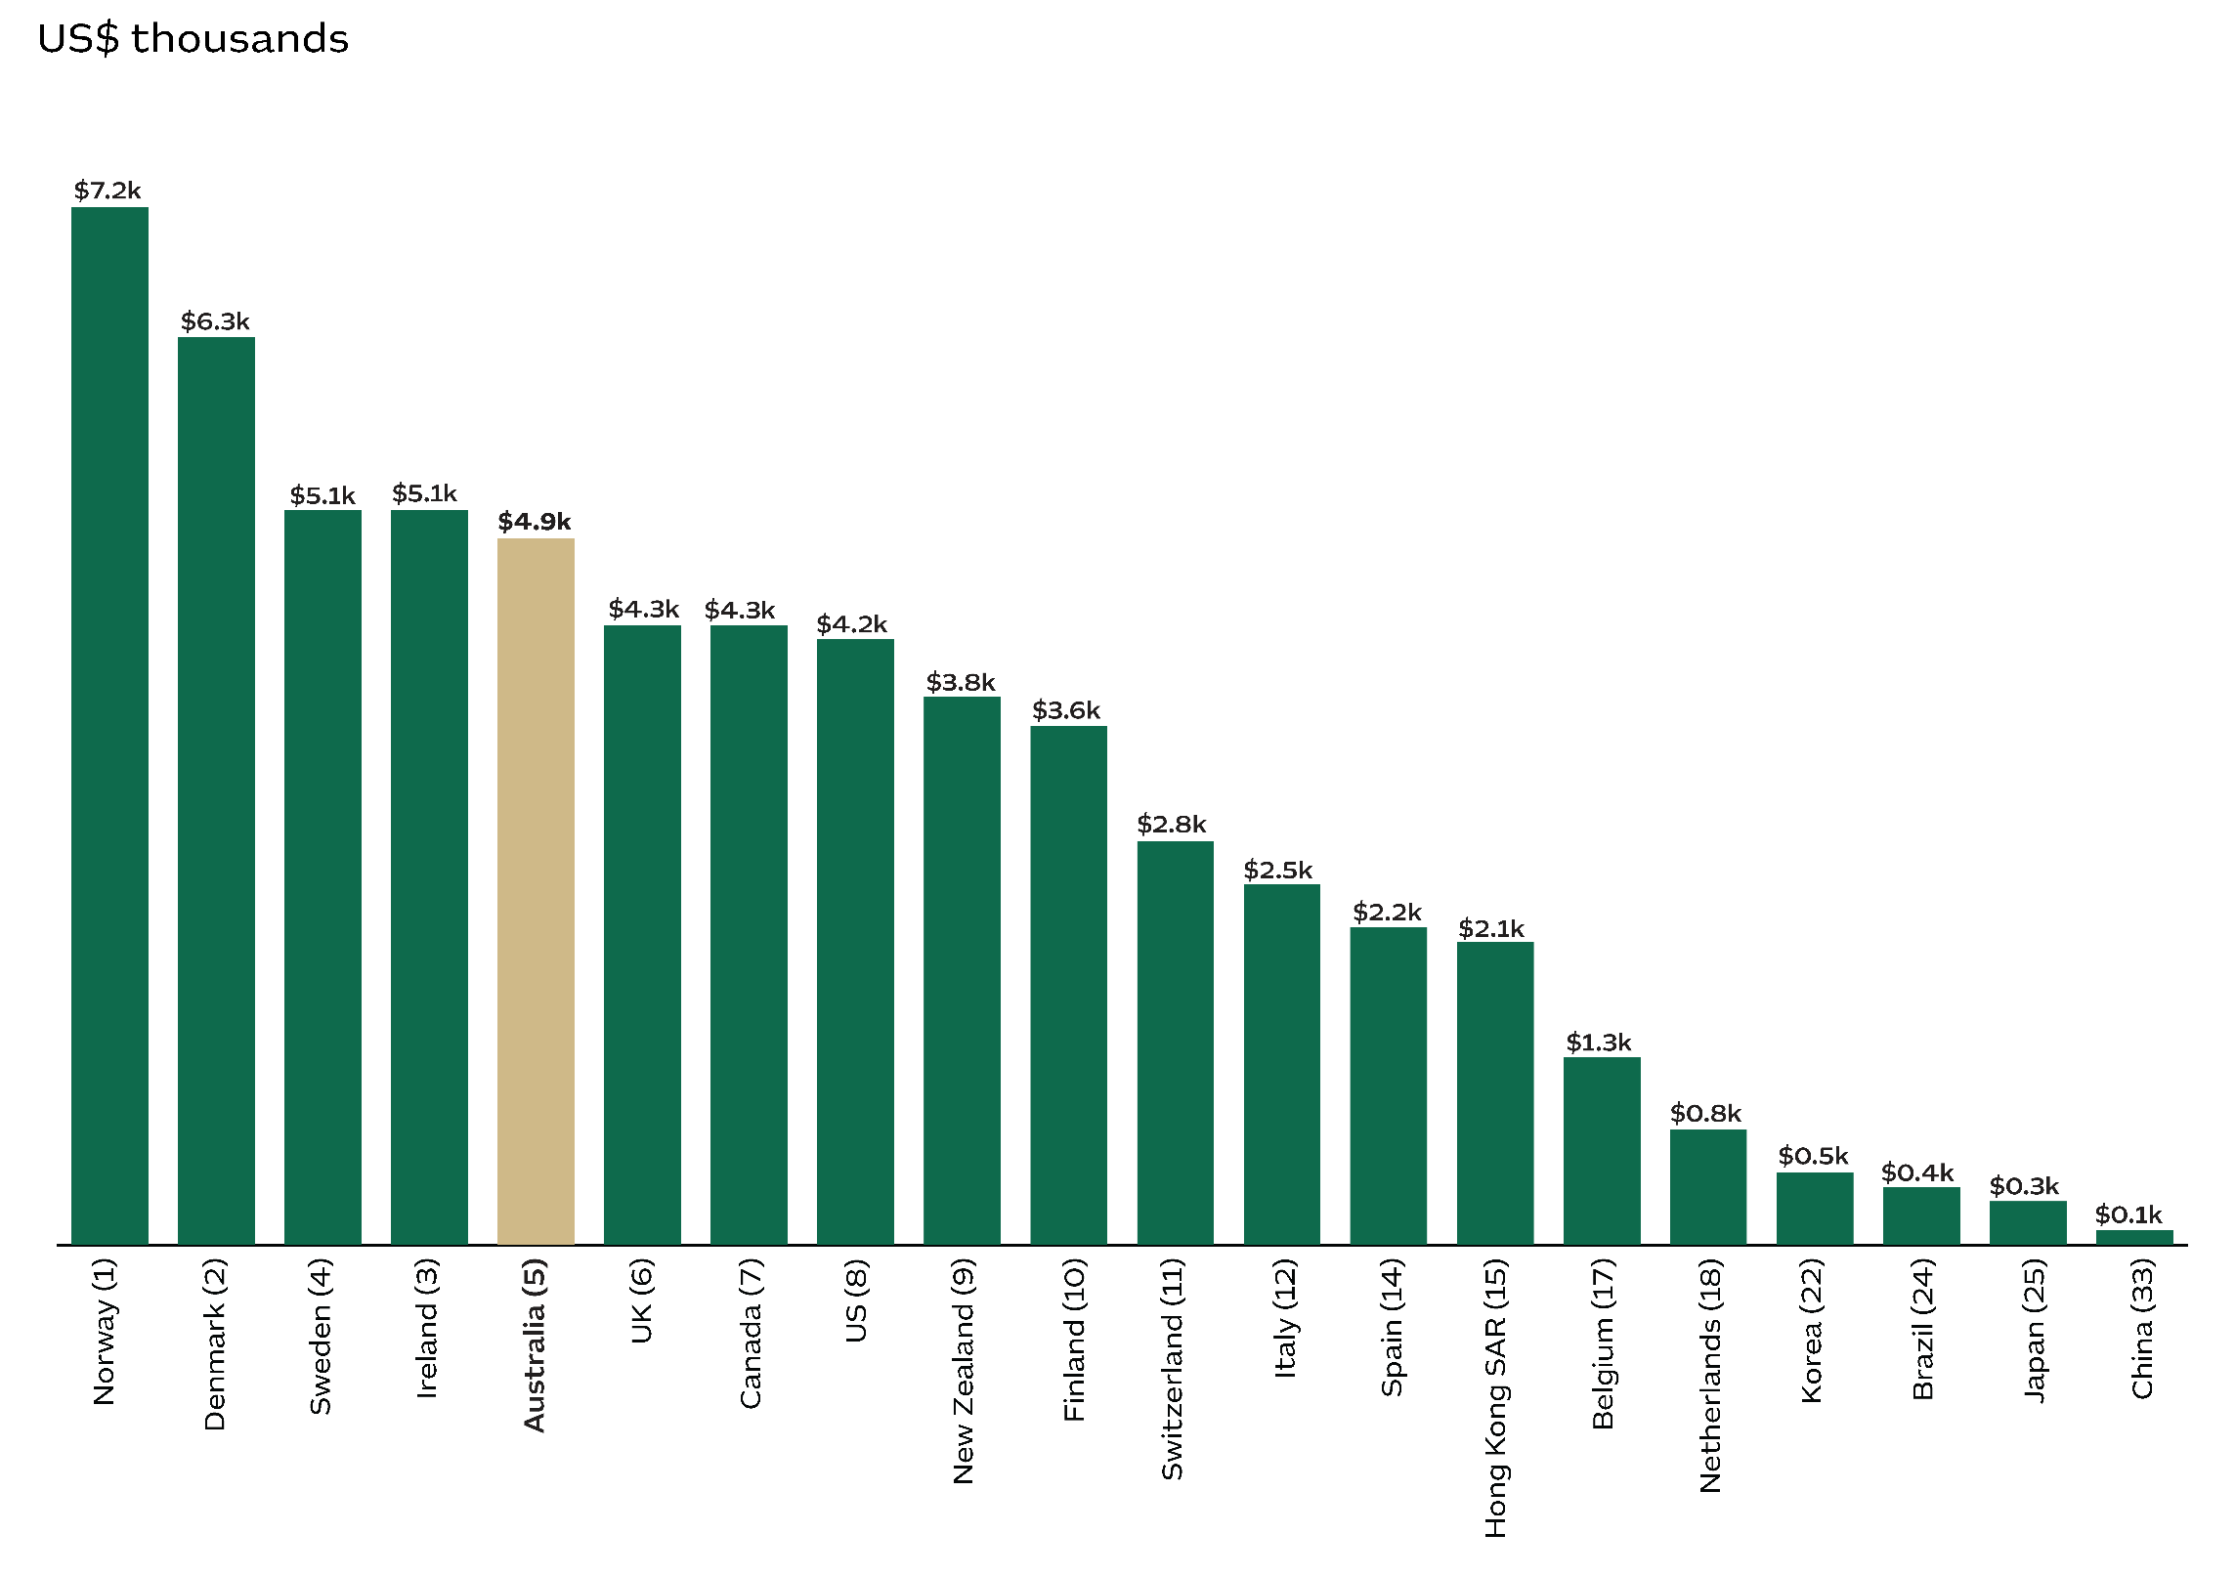

**Sources:** Economic Intelligence Unit, 2024, Viewpoint database; International Monetary Fund, 2024, World Economic Outlook, October 2023 database; accessed in April 2024; Austrade.