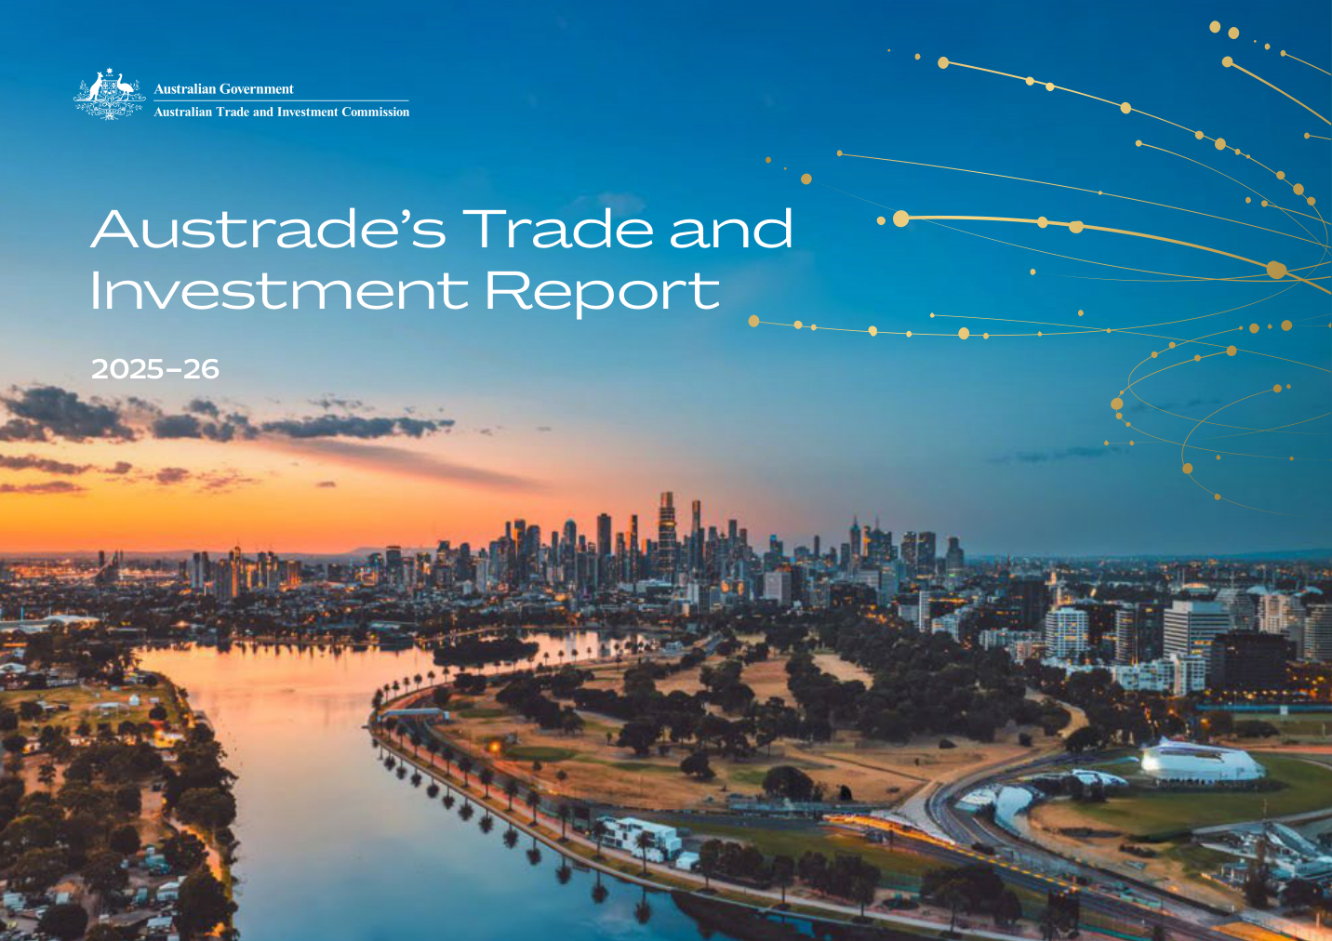

Disclaimer This document has been prepared by the Commonwealth of Australia represented by the Australian Trade and Investment Commission (Austrade). All dollar amounts included refer to Australian Dollars (AUD) unless otherwise stated.
Austrade has exercised due care and skill in preparing and compiling the information and data in this document. Austrade, its employees and advisers disclaim all liability, including liability for negligence and for any loss, damage, injury, expense or cost incurred by any person as a result of accessing, using or relying on any of the information or data in this document to the maximum extent permitted by law.
Austrade recommends the person exercise their own skill and care, including obtaining professional advice, in relation to their use of the information in this document for their purposes. The Australian Government does not endorse any company or activity referred to in the document and does not accept responsibility for any losses suffered in connection with any company or its activities.
Acknowledgement of Country
In the spirit of reconciliation, we acknowledge the Traditional Custodians of country throughout Australia and their connections to land, sea and community. We pay our respect to their elders past and present and extend that respect to all Aboriginal and Torres Strait Islander peoples today.
Copyright © Commonwealth of Australia 2026
The material in this document is licensed under a Creative Commons Attribution – 4.0 International licence (CC BY licence), except for:
any third-party material
any material protected by a trademark
any images and photographs.
More information on this CC BY licence is set out at the Creative Commons website: https://creativecommons.org/licenses/by/4.0/legalcode.
Attribution
Before reusing any part of this document, including reproduction, public display, public performance, distribution, dissemination, communication, or importation, you must comply with the Attribution requirements under the CC BY licence. Enquiries about this licence and any use of this document can be sent to: advisory@austrade.gov.au. Use of the Coat of Arms The terms of use for the Coat of Arms are available from the It’s an Honour website (www.itsanhonour.gov.au). Publication date: October 2026

Contents
Trade foreword 2
Investment foreword 3
Austrade’s year in review 5
- Driving Australia’s economic prosperity 5
- Advancing outcomes through partnerships and agreements 7
- Deepening engagement with Southeast Asia and South Asia 9
Trade 11
- Top sectors and markets for Austrade-facilitated export deals 14
Investment 15
- Top sectors and markets for Austrade-facilitated investment projects 19
Trade case studies 21
Investment case studies 25
How can Austrade help? 29
- Australian businesses 29
- International investors 29

Trade Foreword
Australian exporters are competing in a more contested and less predictable global economy.
The opportunities are substantial, but so is the competition. Austrade’s role is clear: to help Australian businesses identify the markets where they can compete, connect with the right buyers and partners, and turn international opportunity into commercial success.
In 2025–26, Australian exporters working with Austrade secured 2,404 export deals valued at $8.8 billion, an increase of 26 per cent on the previous year. These results reflect both the capability of Australian businesses and the practical value of Austrade’s advice, market intelligence, commercial connections and international network.
Diversification was a particular focus. Through the $55 million Accessing New Markets Initiative (ANMI), Austrade worked alongside industry and exporters to pursue opportunities in new and emerging markets. Southeast Asia and South Asia were particularly strong, together accounting for almost 1,000 Austrade-facilitated export deals worth more than $3 billion. Market access matters, but access alone does not create an export outcome. Businesses need to know where demand exists, how to compete and who to engage.
Austrade helps close that gap, working with exporters, buyers and partners across Australia and overseas to turn trade relationships and free trade agreements into commercial outcomes. We achieve stronger outcomes when the Commonwealth, states and territories, industry and Austrade’s international network work together. That collaboration helps buyers identify Australian capability and provides exporters with more coordinated support at home and abroad. The priority now is to help more Australian businesses build export capability, diversify into new markets and grow internationally, while focusing Austrade’s effort where it can deliver the greatest impact.
I want to thank our Trade team across Australia and our international network for the judgement, expertise and commitment they bring to this work, and our partners across government and industry for their collaboration. Above all, I want to acknowledge the Australian exporters whose ambition, investment and persistence drive these results. As Austrade enters its fifth decade, our task remains unchanged: helping more Australian businesses succeed internationally.
Jason Verspuy
General Manager, Trade

Investment Foreword
Austrade’s investment story is younger than its trade story – the Investment Promotion Program was not established until 1987, a year after this agency was founded.
Forty years on, it is central to how Australia funds its future, financing the infrastructure and assets that will define our economy for decades to come. What has not changed is our conviction that the capability an investor brings matters as much as the capital they commit.
2025–26 provided strong evidence of that conviction. Austrade facilitated 115 investment outcomes worth $15.4 billion, supporting 19,093 Australian jobs – a record result against a challenging global backdrop. $9 billion of that, across 62 projects, backed our decarbonisation priorities; a further $5 billion, across 53 projects, strengthened economic security. Our pipeline now holds more than $200 billion in future opportunity. Those numbers reflect a shift in who we are engaging, and what we are prioritising. Alongside the corporate investors we have long worked with, we are increasingly engaging sovereign wealth funds, pension funds, private equity and venture capital – institutional capital that brings a long-term perspective to the opportunities shaping Australia’s future.
Our discipline is to prioritise the quality of capital and capability over the sheer volume of deals. Delivering that requires collaboration: through the National Investment Forum, we worked with every state and territory this year to present investors with a single, coordinated Team Australia approach.
Looking ahead, decarbonisation and economic security remain our two priority areas, and increasingly they intersect. None of this occurs in isolation from the trade work elsewhere in this report – investment follows trust, and trust is built deal by deal, long before any investment decision is made. Forty years in, our trade and investment functions remain two halves of the same story.
I am proud of what the Investment team delivered this year, grateful to the many partners and investors whose collaboration and confidence underpin these outcomes, and excited by the opportunities ahead as we continue to attract the capital and capability that will shape Australia’s future.
Peter Horn
General Manager, Investment


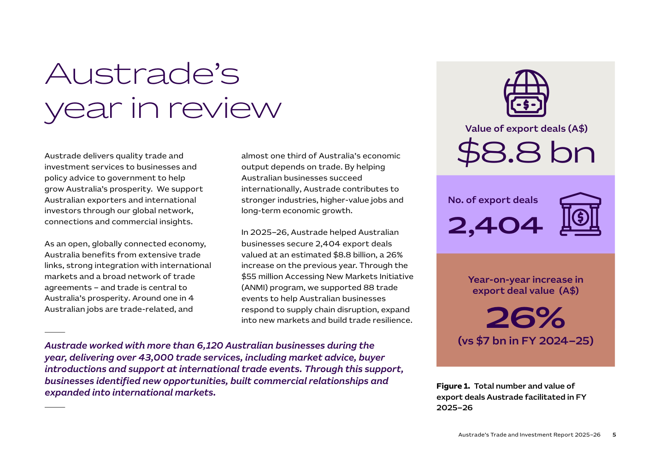
Austrade’s year in review – Trade
Austrade delivers quality trade and investment services to businesses and policy advice to government to help grow Australia’s prosperity. We support Australian exporters and international investors through our global network, connections and commercial insights.
As an open, globally connected economy, Australia benefits from extensive trade links, strong integration with international markets and a broad network of trade agreements. Trade is central to Australia’s prosperity. Around one in 4 Australian jobs are trade-related, and almost one third of Australia’s economic output depends on trade. By helping Australian businesses succeed internationally, Austrade contributes to stronger industries, higher-value jobs and long-term economic growth.
In 2025–26, Austrade helped Australian businesses secure 2,404 export deals valued at an estimated $8.8 billion, a 26% increase on the previous year. Through the $55 million Accessing New Markets Initiative program, Austrade supported 88 trade events to help Australian businesses respond to supply chain disruption, expand into new markets and build trade resilience.
Austrade worked with more than 6,120 Australian businesses during the year, delivering over 43,000 trade services, including market advice, buyer introductions and support at international trade events. Through this support, businesses identified new opportunities, built commercial relationships and expanded into international markets.
Trade results 2025–26
Total number and value of export deals facilitated in FY2025-26
Value of export deals (A$) | $8.8 billion
Number of export deals | 2,404
Year-on-year increase in export deal value | 26% (vs $7 bn in FY2024-25)
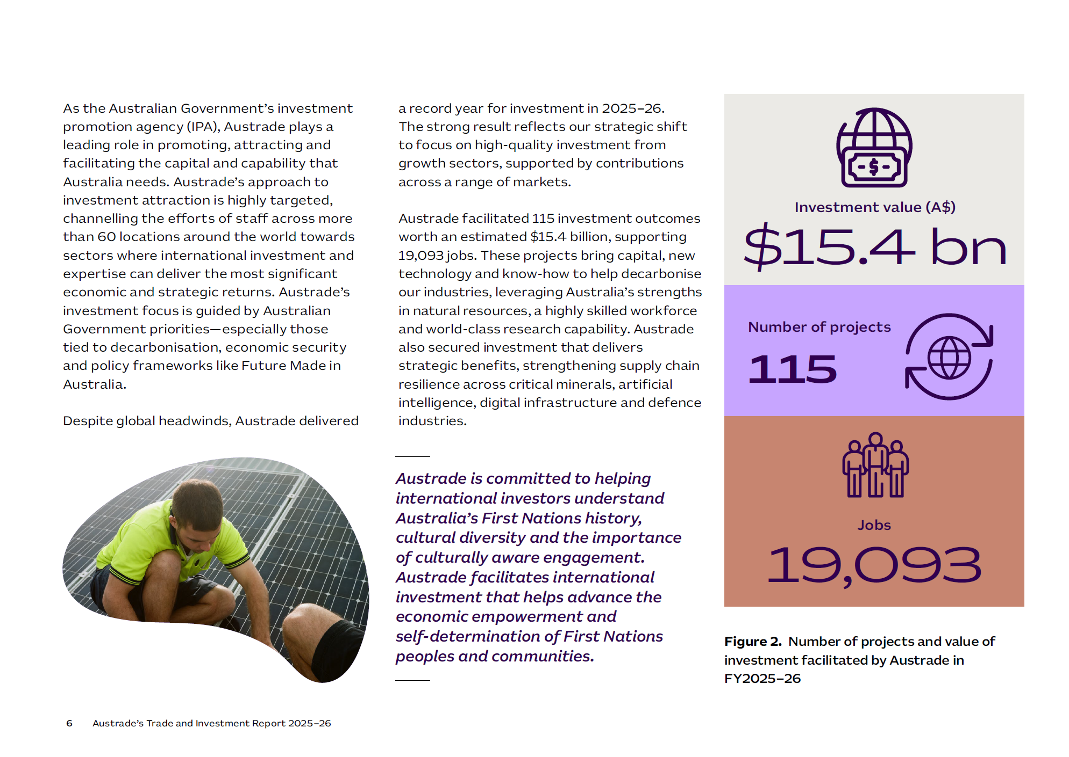
Austrade’s year in review – Investment
As the Australian Government’s investment promotion agency (IPA), Austrade plays a leading role in promoting, attracting and facilitating the capital and capability that Australia needs. Austrade’s approach to investment attraction is highly targeted, channelling the efforts of staff across more than 60 locations around the world towards sectors where international investment and expertise can deliver the most significant economic and strategic returns. Austrade’s investment focus is guided by Australian Government priorities, especially those tied to decarbonisation, economic security and policy frameworks such as Future Made in Australia.
Despite global headwinds, Austrade delivered a record year for investment in 2025–26. The strong result reflects Austrade’s strategic shift to focus on high-quality investment from growth sectors, supported by contributions across a range of markets. Austrade facilitated 115 investment outcomes worth an estimated $15.4 billion, supporting 19,093 jobs. These projects bring capital, new technology and know-how to help decarbonise Australian industries, leveraging Australia’s strengths in natural resources, a highly skilled workforce and world-class research capability. Austrade also secured investment that delivers strategic benefits, strengthening supply-chain resilience across critical minerals, artificial intelligence, digital infrastructure and defence industries.
Austrade is committed to helping international investors understand Australia’s First Nations history, cultural diversity and the importance of culturally aware engagement. Austrade facilitates international investment that helps advance the economic empowerment and self-determination of First Nations people and communities.
Investment results 2025–26
Total number of projects and value of investment facilitated by Austrade in FY2025-26
Investment value (A$) | $15.4 billion
Number of projects | 115
Jobs | 19,093

Advancing outcomes through partnerships and agreements
Australia has a broad network of free trade agreements (FTAs) with some of the world’s largest economies. Our new FTAs and bilateral partnerships continue to open doors and remove barriers to international trade and investment. These include:
- The Comprehensive Economic Partnership Agreement (CEPA) with the United Arab Emirates (UAE), which entered into force in October 2025
- The Australia-European Union Free Trade Agreement (A-EU FTA), negotiations for which concluded in March 2026. Once in force, the agreement will enable 98 per cent of the current value of Australia’s exports to enter the European Union duty- free.

Austrade in action: Helping trade agreements unlock global investment
Austrade is leveraging major trade agreements and economic partnerships to translate policy settings into tangible investment outcomes. Australia and the European Union’s two-way investment stock reached $1.5 trillion in 2025, and the UAE is already Australia’s largest investment partner in the Middle East, with $26.5 billion in two-way investment in 2025.
The UAE CEPA and the A-EU FTA continue to build on existing investment relationships and provide a platform for Austrade to further scale investor engagement. From an investment perspective, both agreements improve certainty and reduce barriers for international investors. When in force, the A-EU FTA will provide greater predictability for EU investors and raise foreign investment screening thresholds. It will support investment in sectors such as renewable energy and critical minerals.
The UAE CEPA is already strengthening investment flows through 5 dedicated Investment Cooperation MOUs. These agreements provide a practical framework for progressing priority investments, alongside improved labour mobility and alignment with priority sectors such as clean energy. Austrade is using these frameworks to deepen engagement with global investors and convert interest into commercial outcomes.

Austrade in action: New export markets delivered commercial results
Within months of the Australia UAE-CEPA entering into force on 1 October 2025, Australian exporters were already securing new business. At Gulfood 2026 in Dubai, First Nations-owned Kakadu Organics used CEPA’s tariff-free access to secure its first buyers in the Gulf, providing an early example of new market access translating into commercial opportunity. CEPA improved access to Australia’s largest trade and investment partner in the Middle East. It is Australia’s first trade agreement to include a dedicated chapter on First Nations trade and investment. Austrade helped businesses translate new market access into commercial outcomes by providing advice, connecting exporters with buyers at major events such as Gulfood and supporting Australian businesses in international markets.
Austrade also helped exporters prepare for opportunities under the Australia–European Union Free Trade Agreement by building awareness of future market opportunities and helping businesses position themselves to compete when the agreement enters into force. The agreement will provide improved access to a market of around 450 million consumers across 27 countries.

Deepening engagement with Southeast Asia and South Asia
Austrade continues to strengthen Australia’s economic engagement in high-growth markets, including Southeast Asia and South Asia. We support the Government’s broader objective of building economic resilience through diversification and outward investment. Leveraging these partnerships, Austrade is working with exporters, investors and businesses to identify opportunities, build commercial relationships and support two-way investment in priority sectors.

Austrade in action: Export deals grew across global markets
Austrade’s diversification efforts delivered some of the strongest results in 2025–26. The Australia–Southeast Asia Business Exchange (A-SEABX) and South Asia Business Exchange (SABX) created new commercial opportunities across two of the world’s fastest-growing regions.
• Southeast Asia recorded 659 Austrade-facilitated export deals valued at $1.6 billion.
• South Asia recorded 333 Austrade-facilitated export deals valued at $1.5 billion.
Austrade supported this expansion through targeted market development programs, tailored exporter support and an expanded network of in-market advisers.

Austrade in action: Delivering strategic outbound investment into Southeast Asia
Austrade supports Australian businesses with inward and outward investment, particularly across Southeast Asia and the Pacific.
Together with Export Finance Australia and the Department of Foreign Affairs and Trade (DFAT), Austrade is helping to grow Australian investment in Southeast Asia through the Southeast Asia Investment Deal Teams. The Deal Teams’ unique capabilities – drawn from the 3 participating agencies – support institutional and corporate investors to invest in the region. This work supports the implementation of Invested: Australia’s Southeast Asia Economic Strategy to 2040, developed by Australia’s Special Envoy for Southeast Asia, Mr Nicholas Moore AO.
During 2025–26, 20 outcomes were achieved totalling $3.6 billion. Over the life of the program, Deal Teams have supported 27 investments into Southeast Asia, totalling $4 billion.
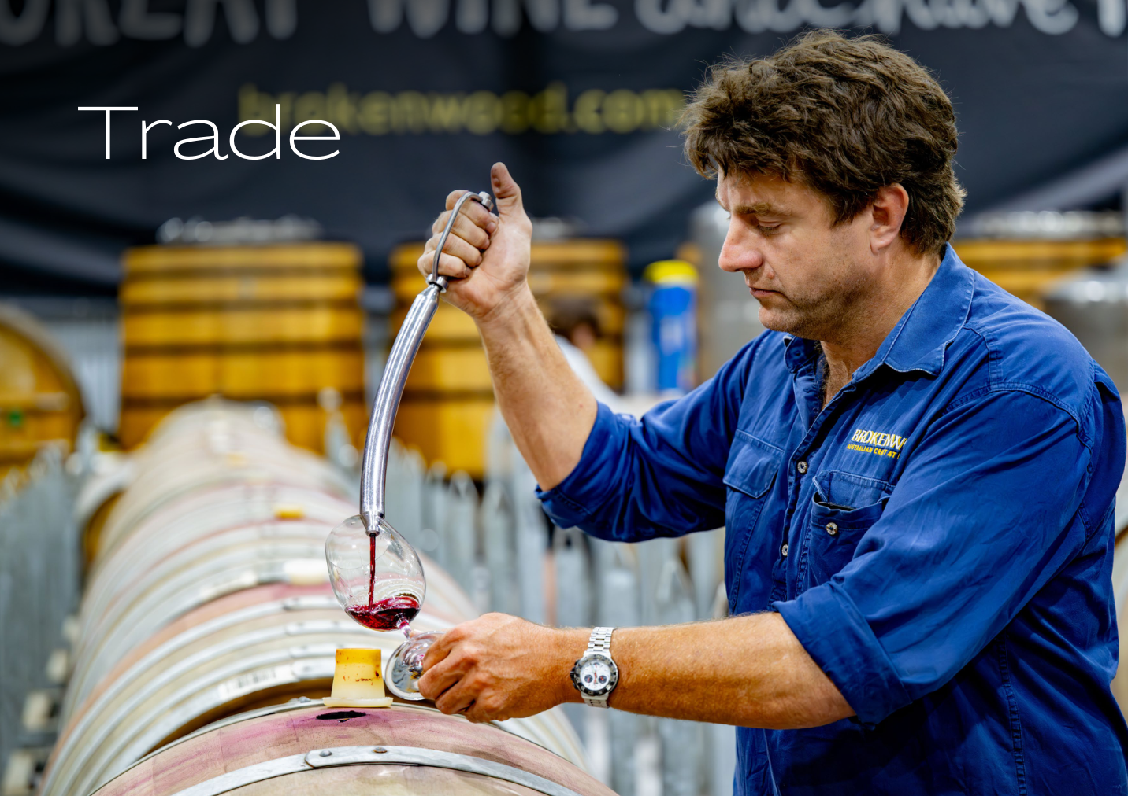
Trade
Austrade helps Australian businesses succeed internationally by overcoming the practical challenges of exporting and connecting Australian capability with global opportunities.
Through its global network, Austrade provides market intelligence and practical in-market support that helps businesses identify opportunities, understand overseas markets and build trusted commercial relationships. This support includes tailored advice, buyer introductions, trade missions and support to help businesses make the most of Australia’s free trade agreements, enabling them to enter new markets, secure export deals and grow exports. Austrade helps Australian businesses succeed internationally by overcoming the practical challenges of exporting and connecting Australian capability with global opportunities.
Exporting businesses are, on average, more productive, employ more people and pay higher wages than businesses that do not export.
Trade impacts
- Grow export markets - Through the Accessing New Markets Initiative, Austrade partnered with 40 industry peak bodies to deliver 88 trade events.
- Build exporter capability -Almost 250,000 users accessed the Go Global Toolkit and Trade Resilience Service, an increase of 15% on the previous year.
- Invest in future growth -More than 2,200 businesses received Export Market Development Grants. The average grant value increased to $54,000, more than double the value of recent rounds.

Top sectors for Austrade-facilitated export deals
Sector | Number of export deals | Value
Agribusiness & Food | 755 | $1.7 billion
Consumer & Retail | 78 | $444 million
Defence, Advanced Manufacturing & Space | 197 | $2 billion
Education | 829 | $1.3 billion
Energy | 44 | $66 million
Health | 93 | $1 billion
Infrastructure | 155 | $544 million
Resources | 87 | $809 million
Services | 16 | $322 million
Technology | 208 | $692 million
Figures may not add to totals due to rounding.

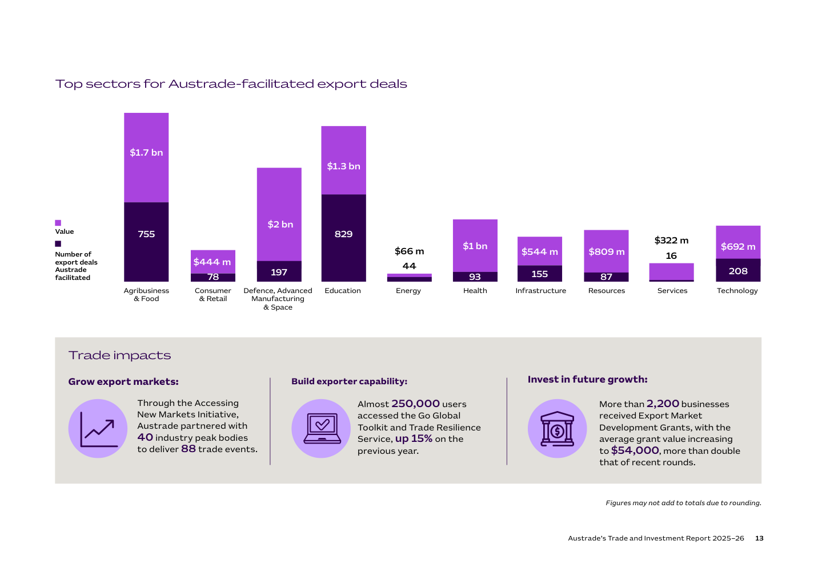

Trade highlights 2025–26
Top markets for Austrade-facilitated export deals
Region | Number of export deals | Trade value
Southeast Asia | 659 | $1.6 billion
Mainland China, Hong Kong and Taiwan | 439 | $2.1 billion
Americas | 342 | $1.3 billion
South Asia | 333 | $1.5 billion
Northeast Asia | 210 | $528 million
Middle East and Africa | 189 | $686 million
Pacific | 139 | $157 million
United Kingdom and Europe | 93 | $982 million
Top 5 markets
Market | Trade value | Export deals
China | $1.9 billion | 238
India | $1.2 billion | 235
United States | $1 billion | 177
Japan | $441 million | 142
Philippines | $196 million | 139
The top 5 markets are ranked by the number of export deals facilitated by Austrade.
Figures may not add to totals due to rounding.
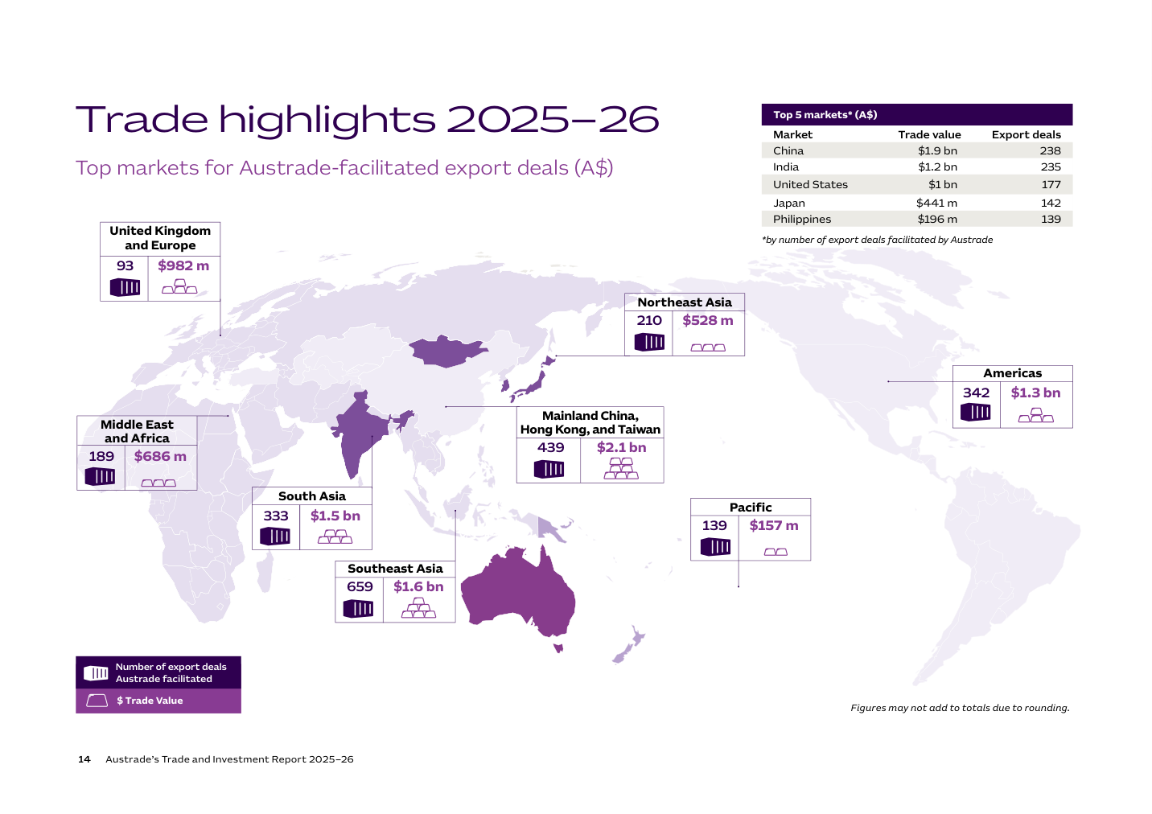
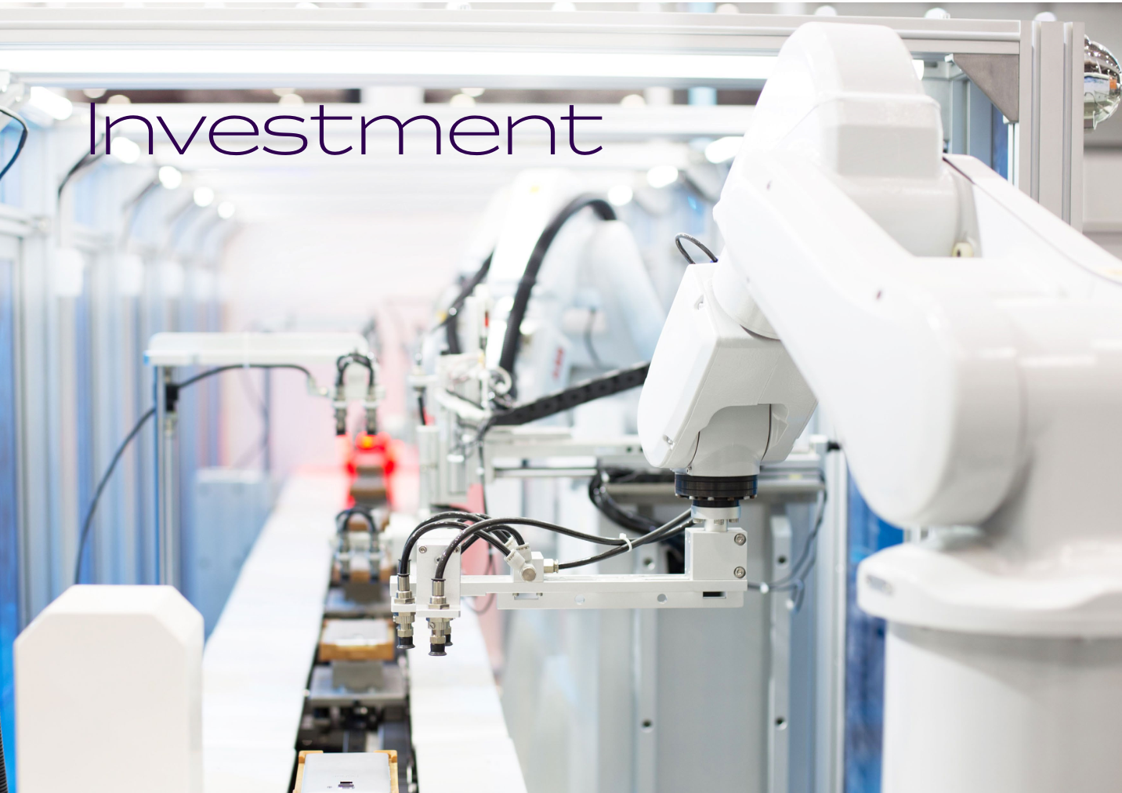
Investment
Over the past 10 years, international investment has supported nearly 400,000 Australian jobs. Beyond capital and jobs, these investments have helped deliver infrastructure, drive innovation and bring new capabilities that enable Australian industries to grow.
Austrade channels the efforts of staff across more than 60 locations around the world towards sectors where international investment and expertise can yield the most significant economic and strategic returns. We also support Australian businesses to expand internationally, particularly in Southeast Asia, the Pacific and other markets where strong export opportunities exist. In addition to outward investment by Australian corporates, Austrade also supports two- way investment by institutional investors, reflecting the growing importance and opportunity this pool of capital presents to the Australian economy.
Working hand-in-hand with state and territory governments, we streamline investment processes for overseas investors—guiding them through regulatory landscapes, helping identify optimal sites and connecting them with essential partners, including industry stakeholders, the Investor Front Door and financial entities such as Commonwealth special investment vehicles.
Austrade plays a broader system role by generating commercial insights from engagement with global firms and feeding these into policy development across government, helping to improve the overall investment climate. We coordinate nationally through mechanisms such as the National Investment Forum, aligning Commonwealth, state and territory efforts and promoting a 'Team Australia' approach to investment attraction.
Investment impacts
Austrade continues to attract international investment that delivers on our national priorities. The transition to net zero is one of the defining economic opportunities of our time. In 2025–26, Austrade facilitated 62 investment outcomes valued at $9 billion supporting our decarbonisation priorities. These investments help Australia turn its renewable energy advantages into investable industries that drive decarbonisation. Austrade facilitated 53 outcomes valued at $5 billion that support the Australian Government’s economic security agenda. Austrade plays a pivotal role in securing this future by targeting international investment in key industries – from advanced manufacturing and critical minerals processing to critical technologies and defence innovation.
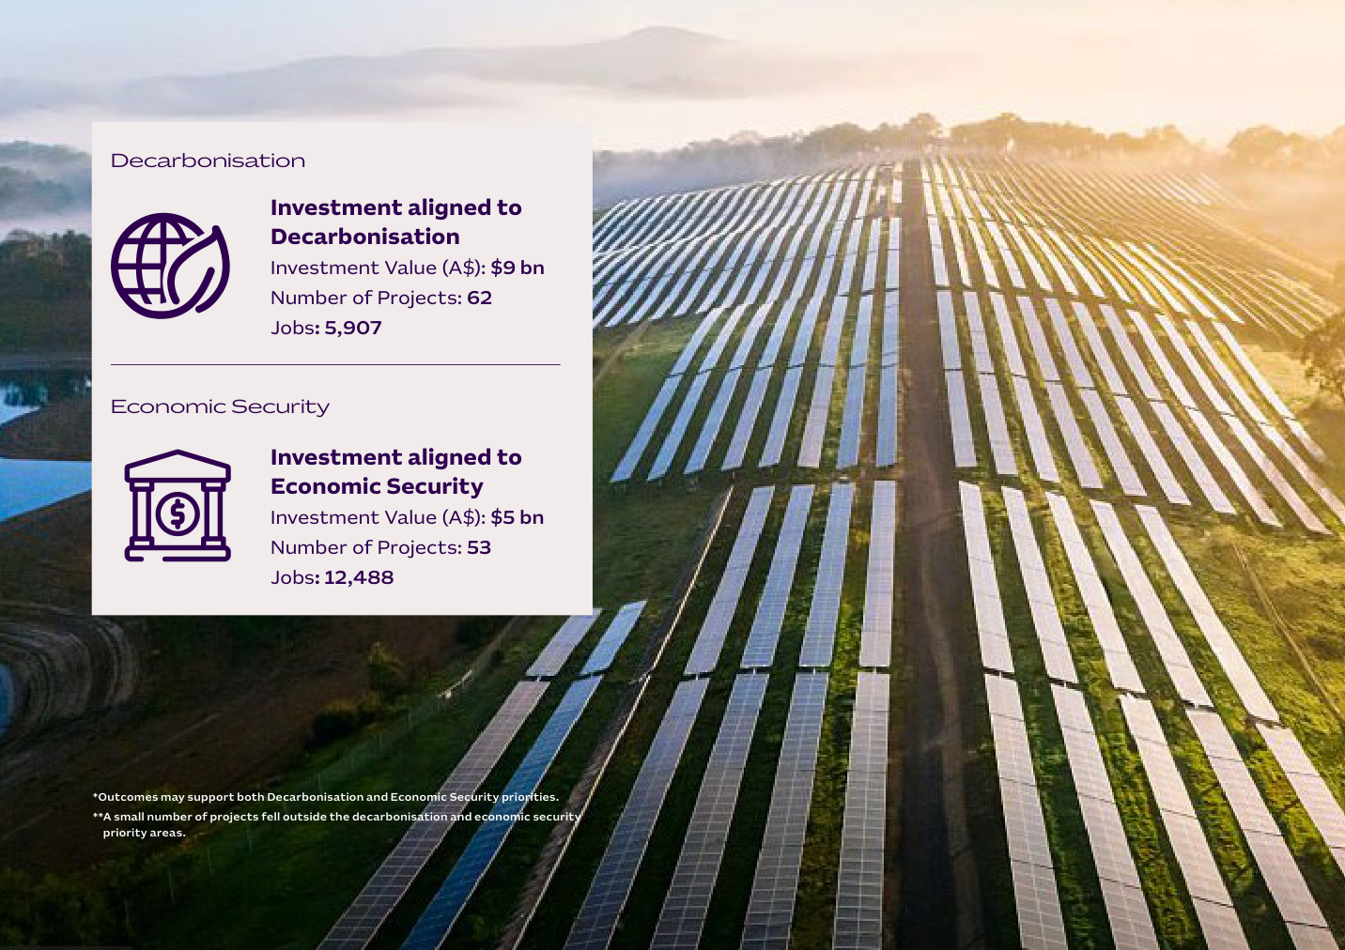

Australia’s National Investment Forum
Advancing our national approach to international investment attraction
Chaired by Austrade, the National Investment Forum (NIF) brings together state and territory investment promotion agencies to coordinate a national approach to international investment attraction and facilitation.
The Forum promotes a Team Australia approach to align investment priorities, strengthen investor services and build capability across agencies. The NIF enables state and territory partners to engage collectively with Commonwealth departments and agencies on topics of mutual priority. In 2025–26, discussions were facilitated with the Department of Industry, Science and Resources, the Investor Front Door, and the National Reconstruction Fund Corporation, among others.
Austrade delivers the Investment Practitioner Program to build capability through online modules, webinars and peer-based activities. In 2025–26, 64 staff members completed the program, including 29 staff from state and territory agencies.
This year, Austrade co-hosted a virtual meeting with the Western Australian Government. It also hosted an in-person meeting in Canberra with the Australian Capital Territory Government. Discussions at these meetings focused on sharpening Australia’s investment proposition in a competitive global environment. Our objectives are to align approaches to investor engagement and project delivery and share market intelligence and best practice.

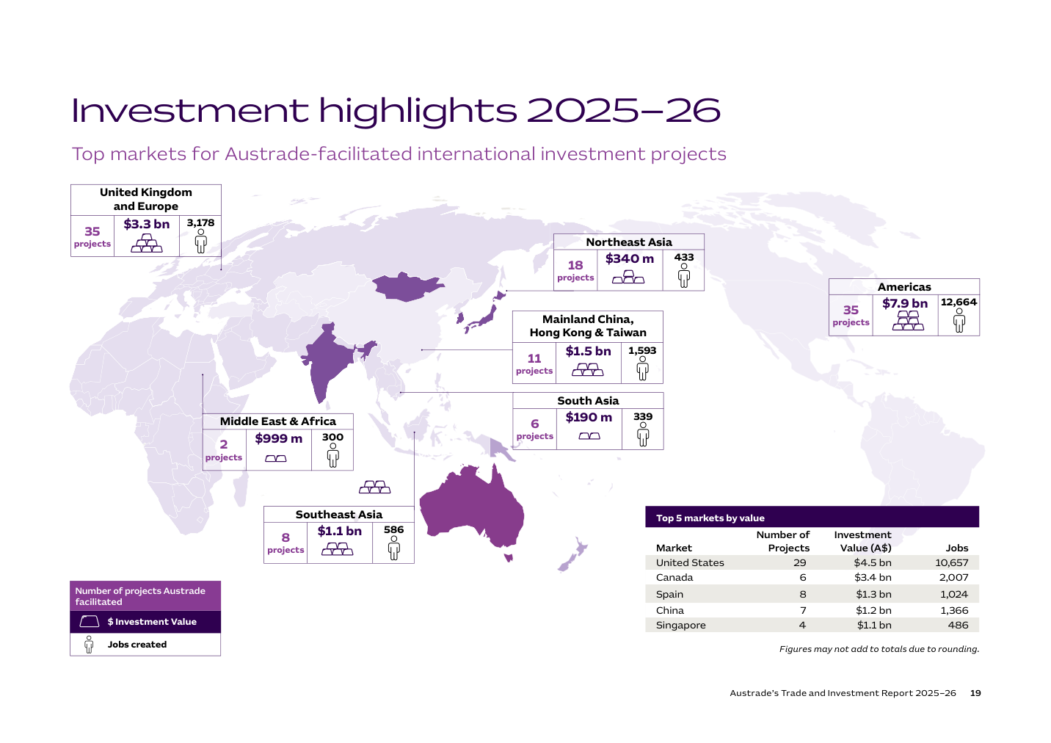

Investment highlights 2025–26
Top markets for Austrade-facilitated international investment projects
Region | Number of projects | Investment value | Jobs
Americas | 35 | $7.9 billion | 12,664
United Kingdom and Europe | 35 | $3.3 billion | 3,178
Northeast Asia | 18 | $340 million | 433
Mainland China, Hong Kong and Taiwan | 11 | $1.5 billion | 1,593
Southeast Asia | 8 | $1.1 billion | 586
South Asia | 6 | $190 million | 339
Middle East and Africa | 2 | $999 million | 300

Top 5 markets by investment value
Market | Number of projects | Investment value | Jobs
United States | 29 | $4.5 billion | 10,657
Canada | 6 | $3.4 billion | 2,007
Spain | 8 | $1.3 billion | 1,024
China | 7 | $1.2 billion | 1,366
Singapore | 4 | $1.1 billion | 486
Figures may not add to totals due to rounding.

Top sectors by value
Sector | Number of projects | Investment value (A$) | Jobs
Renewable Generation, Transmission & Storage | 25 | $7.6 billion | 4,207
Critical Technologies | 21 | $4.3 billion | 10,756
Circular Economy | 6 | $1 billion | 354
Critical Minerals | 15 | $415 million | 590
Net Zero Transport | 7 | $131 million | 1,034
Figures may not add to totals due to rounding.
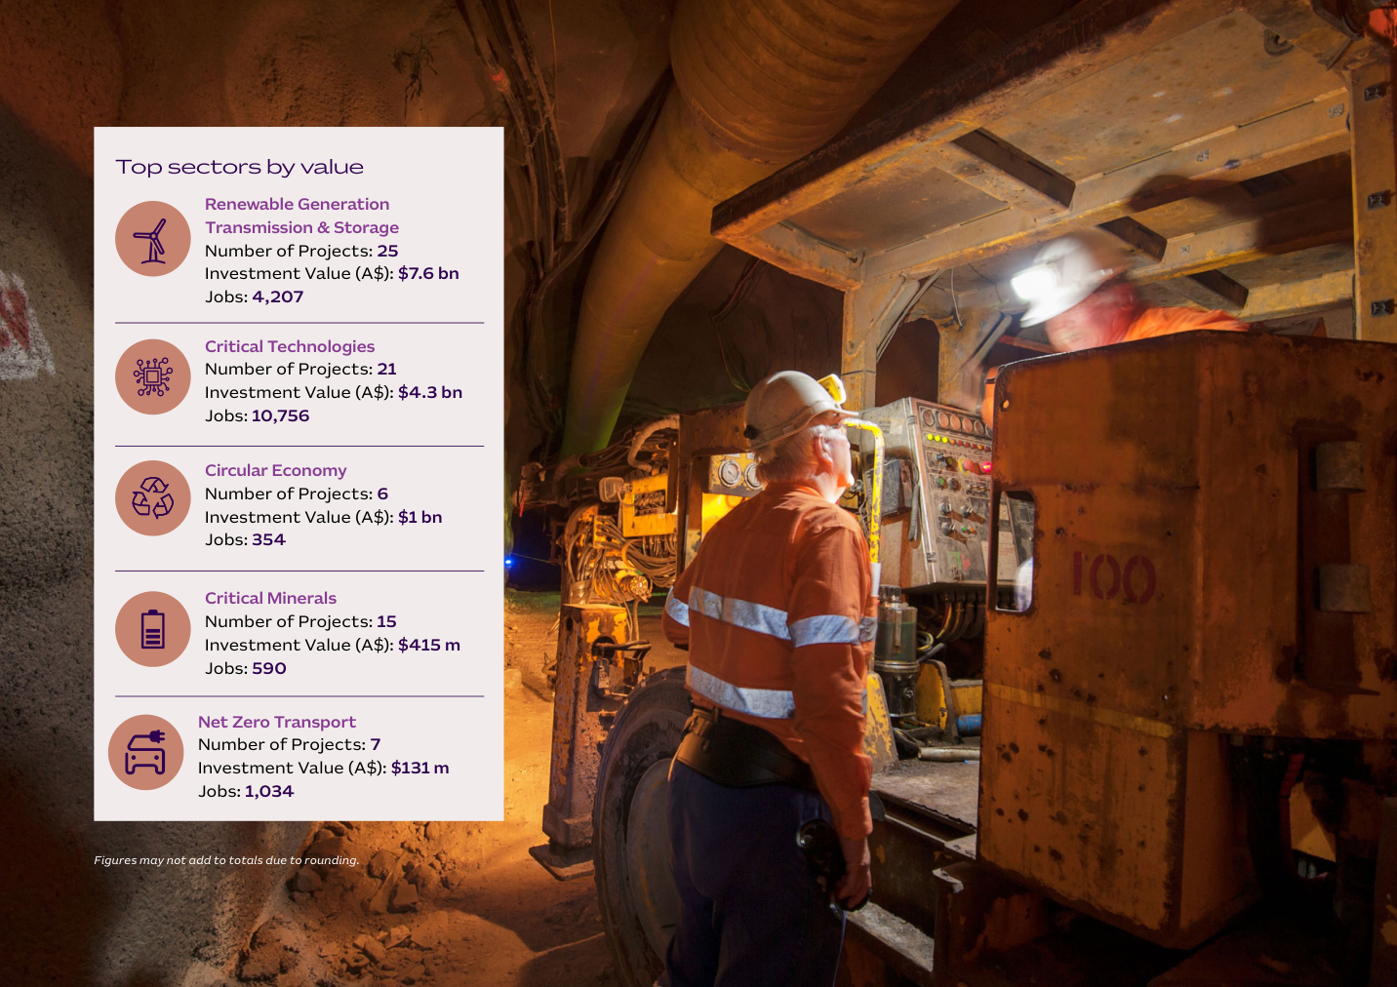
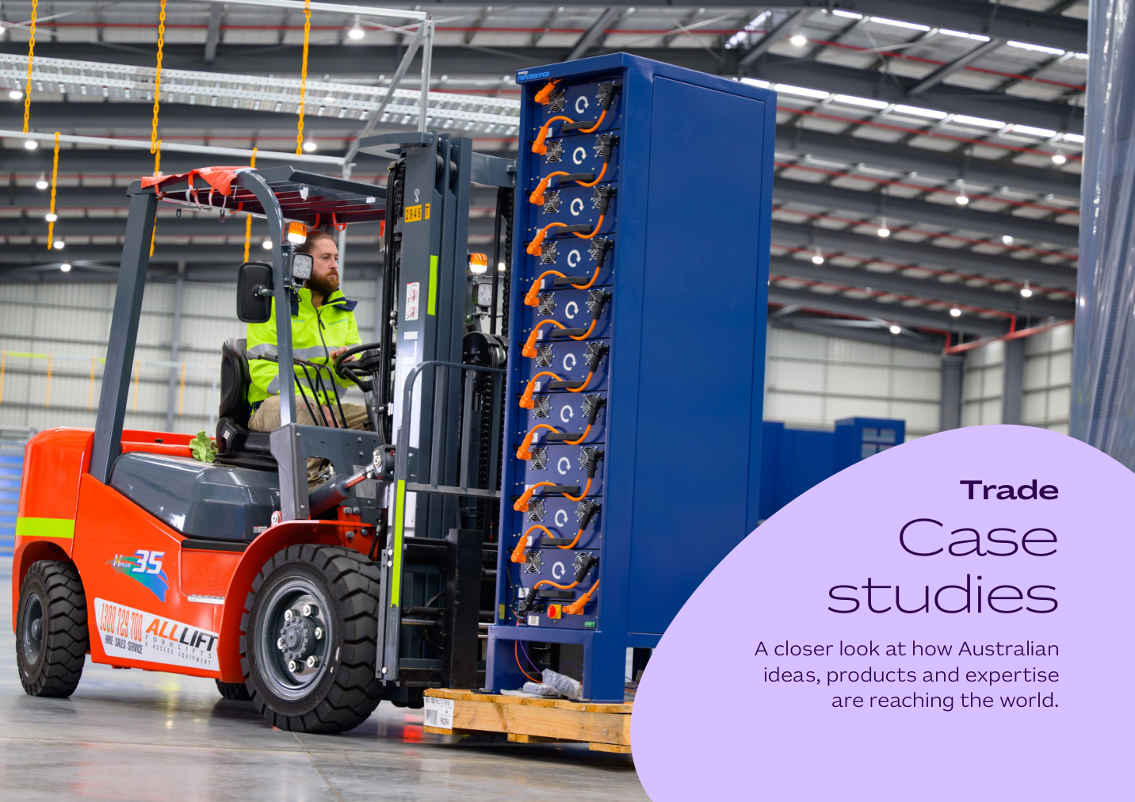
Melbourne Polytechnic expands transnational education in China
Sector: International Education | Market: Mainland China, Hong Kong and Taiwan
Melbourne Polytechnic is one of Victoria’s largest vocational and higher education providers. It offers more than 170 programs across VET, higher education and short courses. China is its most established international market, with engagement over more than 20 years. In 2026, Melbourne Polytechnic expanded its higher education partnerships with Xinxiang University and Zhengzhou Shengda University, supporting bachelor’s degree delivery in China.

Austrade’s impact
Austrade supported Melbourne Polytechnic’s expansion in China by advocating for high-quality Australian education providers and facilitating market access, partnerships and ongoing engagement. Austrade’s in-market insights and networks helped the institution navigate a complex regulatory environment and strengthen its long-term, relationship-led approach. This reinforced Melbourne Polytechnic’s position as a leading Australian provider of transnational education.
The model enables Chinese students to gain Australian qualifications without leaving home while supporting Australia’s international education objectives. It also creates scalable transnational education pathways in applied disciplines, including STEM and industry-linked programs.
“China has a very strong demand for high-quality, internationally recognised education, particularly education that is practical and linked to employment outcomes.”
Tim Gilbert, Vice President International Development, Melbourne Polytechnic

Australian energy modelling technology supports global net zero planning
Sector: Green Economy | Market: United Kingdom and Europe
Energy Exemplar is an Australian energy modelling company founded in Adelaide. From its origins in PhD research, it has grown into a global business with more than 700 employees and operations in over 90 countries. Its PLEXOS® platform helps governments, energy agencies and businesses model future energy scenarios.

Austrade’s impact
Austrade supported Energy Exemplar’s international growth by providing market connections, business facilitation and opportunities to build credibility with global stakeholders. Early support included access to Austrade’s overseas networks and meeting facilities, helping the company establish a presence in its priority markets. Austrade also connected Energy Exemplar with industry events and roadshows that expanded its international profile. These activities helped strengthen commercial relationships and supported the company’s growth from an emerging Australian innovator to a recognised global leader in energy modelling.
The Australia–European Union Free Trade Agreement (A-EU FTA) will further expand Energy Exemplar’s growth options. Today, its technology is helping organisations worldwide make informed decisions on complex energy transitions and net zero planning.
“Austrade helped us present ourselves as the company we aspired to be. Its networks, facilitation and global connections accelerated our growth trajectory.”
David Wilson, CEO, Energy Exemplar

Silicon Quantum Computing expands partnerships in Southeast Asia
Sector: Technology | Market: Southeast Asia
Silicon Quantum Computing is an Australian quantum computing company and a global pioneer in atomic-scale semiconductor manufacturing. Led by Professor Michelle Simmons AC, the company develops quantum computing systems by placing individual atoms in silicon with atomic (0.13 nanometre) precision. Its work builds on more than 25 years of technological leadership in quantum electronics and silicon manufacturing, enabling the delivery of quantum-enhanced AI and simulation systems to enterprises. The company represents Australia’s strength in deep technology, quantum commercialisation and advanced research capability.

Austrade’s impact
Austrade co-led the Australia–Southeast Asia Business Exchange (A-SEABX) mission to Tech Week Singapore with the Tech Council of Australia. The mission helped Australian AI and quantum companies build partnerships in Singapore and across the region. Austrade facilitated roundtables, speaking engagements and more than 60 business-matching meetings over two days. The Australia Pavilion attracted more than 2,000 visitors, including government representatives, investors and business partners. Austrade also promoted export support through the Go Global Toolkit (GGT), helping companies assess market opportunities, understand regulatory requirements and plan for international growth.
“Australia’s tech sector is powered by cutting-edge research, broad commercial expertise and a spirit of collaboration.”
Professor Michelle Simmons AC, CEO, Silicon Quantum Computing

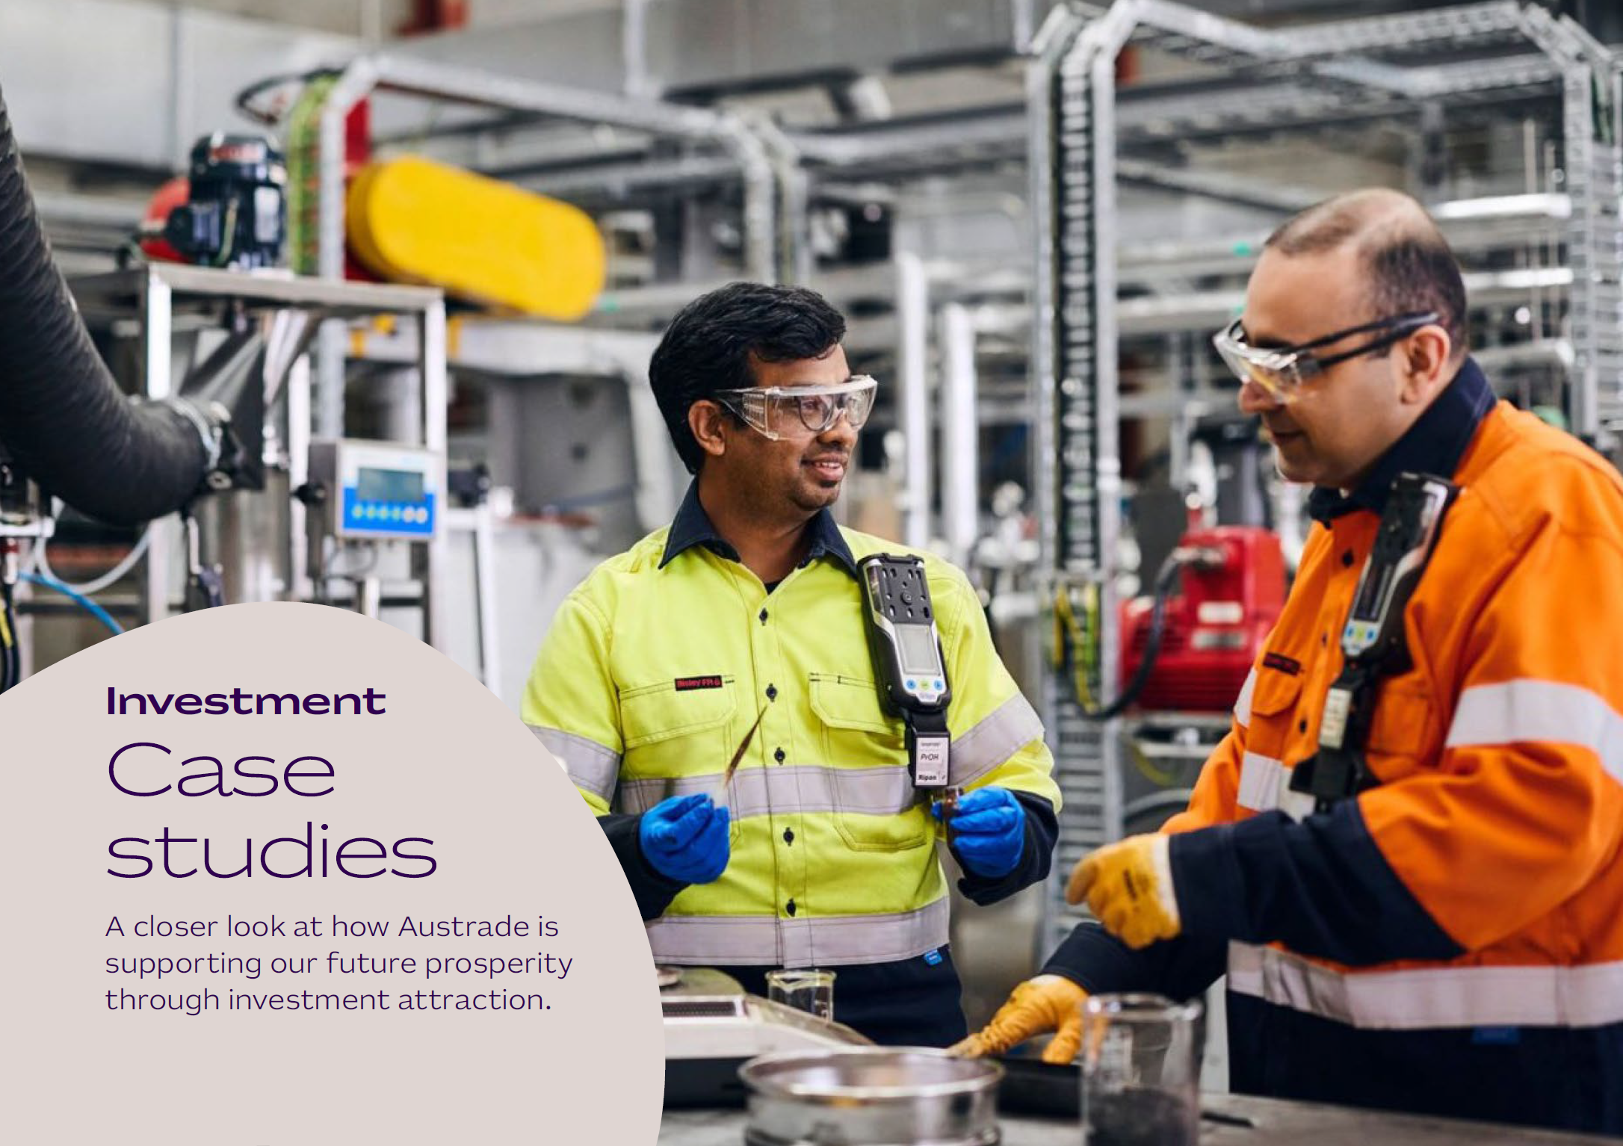
Australia-United States Critical Minerals Delegation
Securing global critical minerals supply chains
In September 2025, Austrade led a Critical Minerals Delegation to the United States that included 20 Australian companies. Delegates met with senior US government officials in Washington DC to discuss critical minerals priorities. Delegates also connected with investors in New York to position Australia as a secure and stable partner in future critical minerals supply chains.
Australia and the US signed a landmark Framework for Securing Supply in Critical Minerals and Rare Earths in October 2025. The agreement reinforces bilateral cooperation in support of defence and advanced technologies. The US and Australia committed to take measures to provide at least US$1 billion in financing for key critical minerals projects.
Momentum has continued to build since the Framework was signed. Australia and the US are delivering on commitments made in the White House, with more than $5 billion to back priority projects in Australia that support production of rare earths and critical minerals including nickel, cobalt, gallium, magnesium, vanadium and graphite.
Austrade’s work is supporting this momentum. Austrade facilitates commercial connections between Australian companies, international investors, leads trade missions and showcases investable opportunities. This work has built a strong pipeline of engagement, supporting more than 40 Australian critical minerals companies and over 100 international investors.
Austrade also launched the 2025 edition of the Australian Critical Minerals Prospectus, showcasing 78 projects across 60 companies. For the first time, the Prospectus includes midstream capabilities, with 29 investable projects. These projects highlight Australia’s growing capability in processing and refining materials, adding value beyond extraction and strengthening supply chains.

AWS
Expanding digital infrastructure and renewable energy investments in Australia
Amazon Web Services (AWS) is expanding its AI and cloud infrastructure footprint in Australia, investing $20 billion over 2025 to 2029. This builds on the $18.9 billion AWS has invested to build, maintain and operate Australian data centres since 2012.
‘We are proud to be expanding our world-class data centre infrastructure, bringing more renewable energy projects online, and supporting the country’s vision to be a global AI leader,’ says Matt Garman, CEO of Amazon Web Services. ‘AI is a once-in-a-generation transformation, and Amazon is pleased to be empowering all Australians to innovate at scale through this investment.’
To support its infrastructure expansion in Sydney and Melbourne, AWS is investing in new renewable energy projects across Victoria and New South Wales, bringing its total renewable energy portfolio in Australia to 20 projects. Once operational, these projects will provide 990 MW of new renewable energy capacity, enough to power the equivalent of more than half a million Australian households annually.
Since 2020, Amazon has invested an estimated $2.8 billion in renewable energy projects across Australia.
Octopus
Bolstering Australia’s renewable capacity through agrisolar innovation
Beginning in 2018, UK-based Octopus Group identified significant opportunities in Australia’s energy market transition, as power generators retire ageing coal-fired power stations.
‘Australia had compelling fundamentals for renewable energy,’ says Sam Reynolds, Chief Executive of Octopus Australia.
Octopus Australia’s Blind Creek Solar Farm and Battery project will combine a 300 megawatt (MW) solar farm with co-located 243 MW/486 megawatt hours (MWh) battery storage. This will deliver sufficient capacity to power up to 120,000 homes and businesses. The site also includes regenerative agriculture, with elevated panels enabling grazing and improved pasture conditions.
‘Agriculture and energy are 2 of the largest emitters in Australia,’ says Kelsey Richardson, ESG and Sustainability Analyst at Octopus. ‘On this one piece of land we are tackling both of those with clean energy and regenerative farming.’
When operational, the Blind Creek project could produce renewable energy to power a substantial number of homes and businesses.
Community engagement has been central to the project. Local landowners led early consultation and developed benefit-sharing arrangements with neighbouring properties, including the Bungendore Community Foundation. The project won the 2022 Clean Energy Council Community Engagement Award for its social licence model, benefit-sharing scheme and agrisolar design.
Austrade provided vital support, helping secure introductions that shaped the final investment decision.
‘Austrade … definitely opened those doors,’ says Reynolds. ‘We were a complete unknown, no one really knew Octopus. It was good to have that entry from Austrade to get things going.’

Austrade at a glance
We are the Australian Trade and Investment Commission (Austrade), and we are responsible for promoting Australian trade, investment and education to the world, as well as developing tourism policy for the country. Our purpose is to deliver quality trade and investment services to businesses and policy advice to government, to grow Australia’s prosperity. Our trade and investment services are centred on advice, connections and support. We help our clients achieve commercial outcomes by drawing on our expert knowledge, international networks, and strong relationships with international customers and decision-makers.

Australian businesses
Austrade is here to help Australian businesses go global. Whether you are a fintech startup, an agricultural producer or a manufacturer, we have the expertise, contacts and market intelligence to help you grow your business. Every year, we connect thousands of businesses to opportunities and partners around the world, with in-market and local language assistance. Contact us at austrade.gov.au or call 13 28 78.

International investors
Looking to invest in Australia? We’re here to help. We support international investors to establish and expand operations in Australia. Our experts in Australia and around the world can help you through every stage of your investment journey. We offer the latest industry insights, connections with key stakeholders and decision-makers and virtual or physical site visits to Australia. Thousands of international businesses have worked with us to tap into the Australian market – and you can too. Contact us at international.austrade.gov.au or call 13 28 78.

